Toby bluck

BLU16274423

Word Count

2503

SCDT41 CW2

Create a Software Artefact

Table of Contents

Requirements: 1

UML Diagrams: 2

Use Case - 2

Class Diagram – 3

Prototype code - 4

Program.cs 4

Application.cs 4

User.cs 4

Staff.cs 4

Receptionist.cs 4

DentistNurse.cs 4

Administrator.cs 4

GeneralFunctions.cs 4

DataSearching.cs 4

DataPrinting.cs 4

TreatmentRoom.cs 4

Patient.cs 4

DentalPractice.cs 4

Appointment.cs 4

Prototype functioning – 4

Testing – 4

Final Program code - 8

Program.cs 8

Application.cs 8

User.cs 8

Staff.cs 8

Receptionist.cs 8

DentistNurse.cs 8

Administrator.cs 8

GeneralFunction.cs 8

DataSearching.cs 8

DataPrinting.cs 8

DataIO.cs 8

TreatmentRooms.cs 8

Patient.cs 8

DentalPractice.cs 8

Appointment.cs 8

Final program functioning/End user documentation. 8

Admin 8

Practice menu 8

Receptionist 14

Patients 14

Appointment 15

Dentist/nurse 16

Evaluate the suitability of implemented techniques considering the effectiveness of solution against the original requirements 18

# Requirements:

MoSCoW Requirements extruded from the scenario –

***Must***

• Allow Administrators to create, edit and delete Dental Practices.

• Dental Practices are to consist of a Receptionist and many Treatment Rooms.

• Treatment Rooms are to consist of a Dentist and a Nurse.

• Allow Administrators to assign Staff (Receptionist, Dentist and Nurse) to Dental Practices.

• Allows Administrators to manage user credentials.

• Ensure Staff can only access information relating to their own location.

• Allow Receptionists to create, edit and delete Patients.

• Store the following information for patients:

- Name

- Gender

- Address

- Contact Number

• Allow Receptionists to create, edit and delete Appointments.

• Appointment to consist of a Patient, Date/Time, Treatment Room, a Treatment Type and Notes. (Dentist and Nurse information can be accessed from the Treatment Room.)

• Treatment Types are to consist of 3 bands:

- Band 1: £22.70 - check-up, scale and polish.

- Band 2: £62.10 - Fillings and repairs.

- Band 3: £269.30 - Crowns and Other.

• Allow ONLY Dentists and Nurses to leave notes on Appointments.

• When a Dentist or Nurse leaves a note, the user's name will be recorded as well as the time the note was made.

• Allow Staff to view Patient information and appointments.

***Should***

• When an Administrator removes a location, set associated staff to null locations.

• When staff with null locations log in, an error should be displayed preventing any further access to the system and prompting them to contact a system admin.

• Allow receptionists to transfer patients to a new location.

***Could***

• Provide an interface allowing Staff to search for Patients and Appointments.

• Allow Staff to summarize Notes for a given patient

# UML Diagrams:

Use Case - 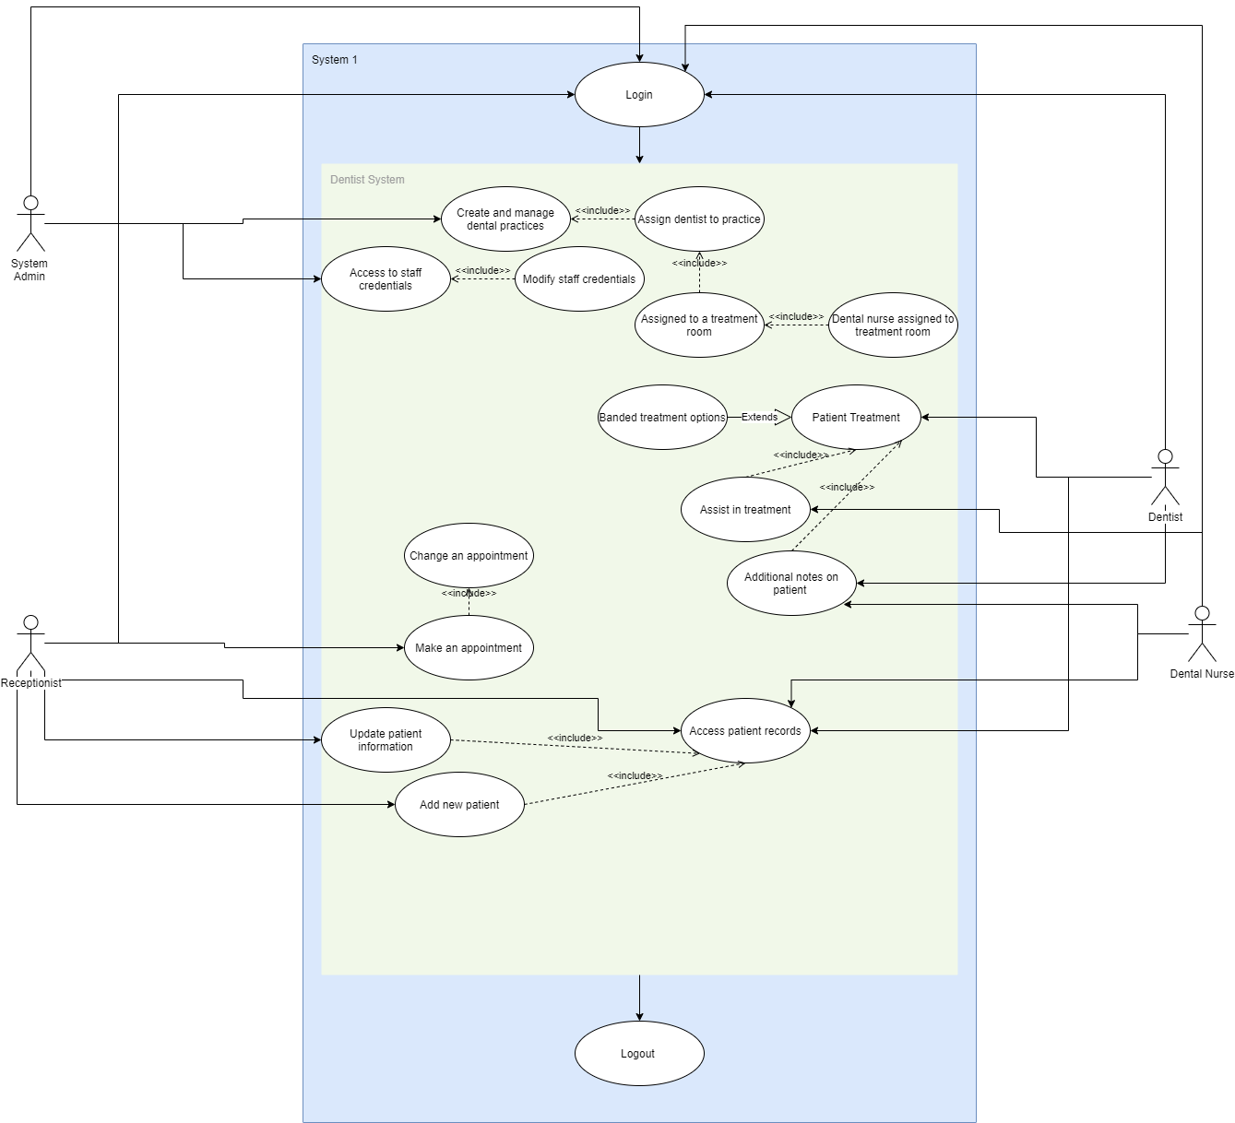

This use case was used to help with the gathering of requirements that are beneficial to the design. Furthermore, this allows us to get a basic context of the overall system and visually elaborates expected behaviour. Although this is simple it allows for basic information to be convey before development of the dentist system nor do this specify the overall order of the system presently. (UML - Use Case Diagrams - Tutorialspoint, n.d.)

## Class Diagram –

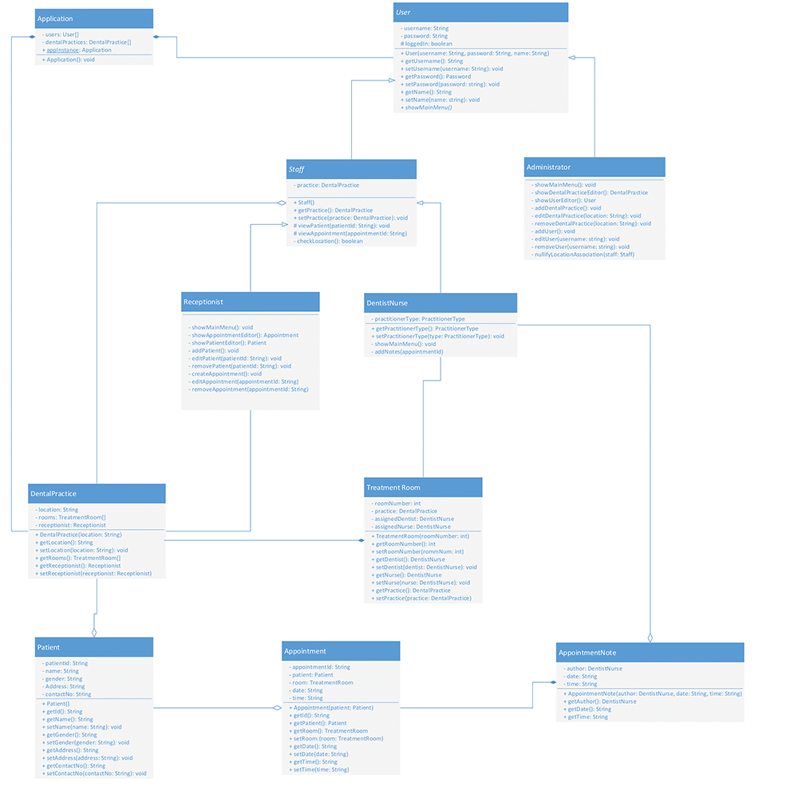

This class diagram shows the structure of the classes/classifiers within the system. This helps define the overall the relationships between the classes. The class name is defined first, then we add class attributes to it we specify the type of the attributes after the “:” then we moved onto the methods which specifies the operation within it per line. Linking the classes together will link relationship between one another such as: Receptionist is based off Staff which is based off User. (UML - Use Case Diagrams - Tutorialspoint, n.d.), (UML Class Diagram, n.d.)

# Prototype code -

## Program.cs

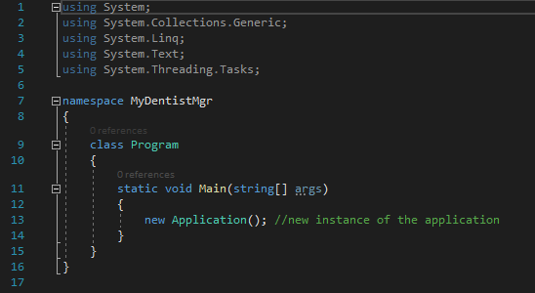

## Application.cs

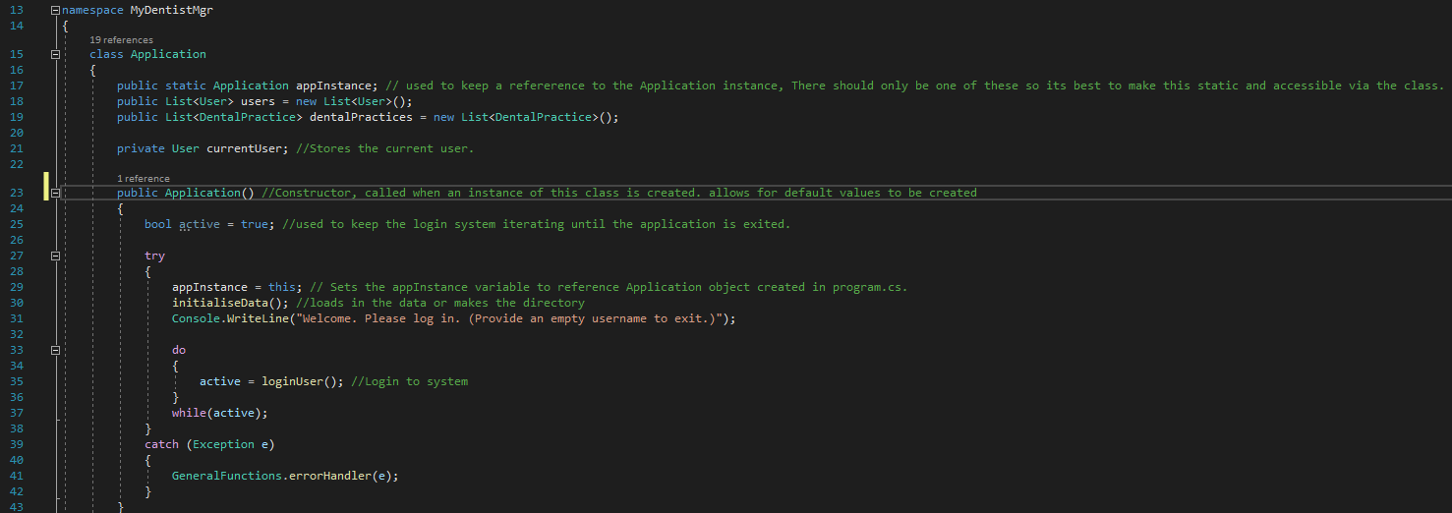

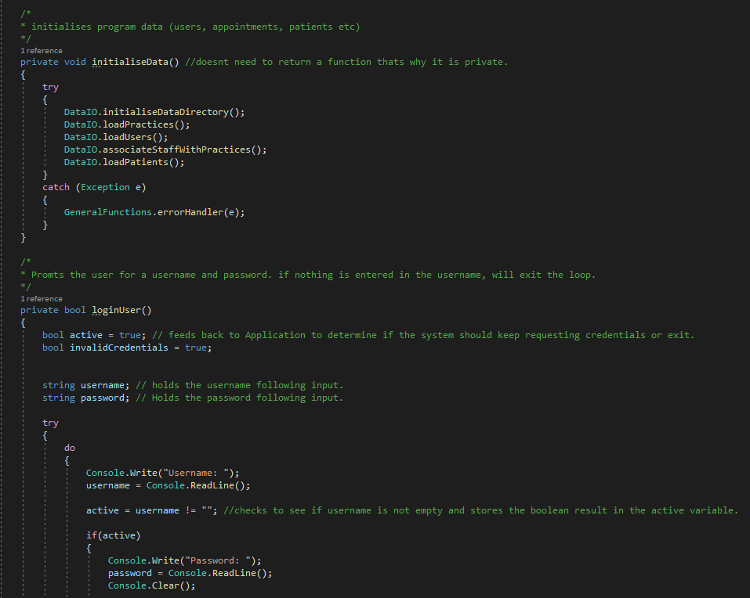

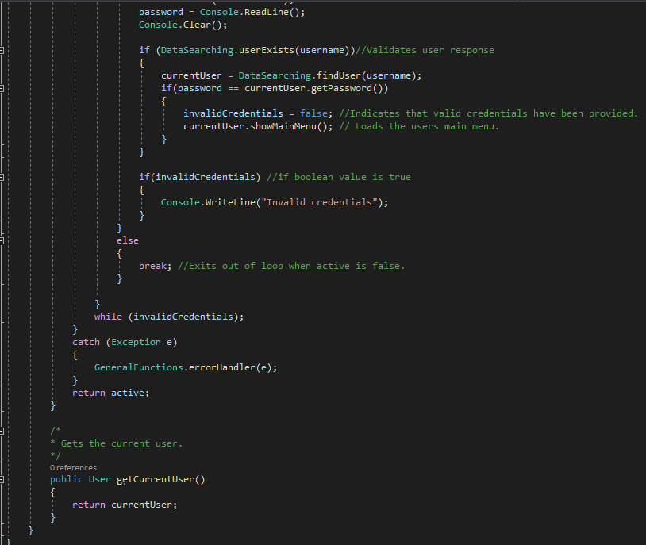

## User.cs

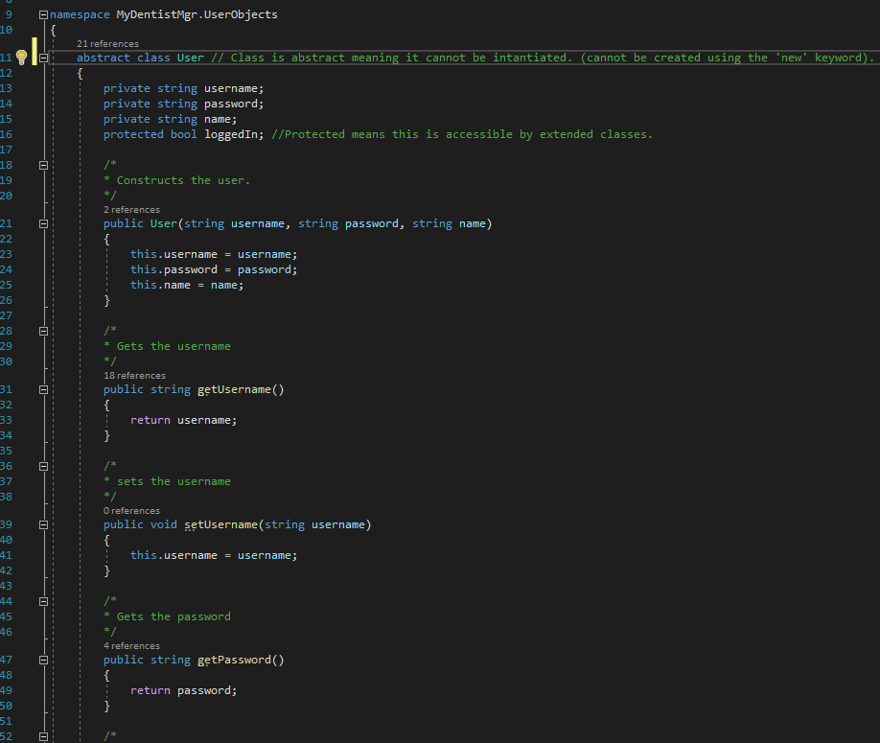

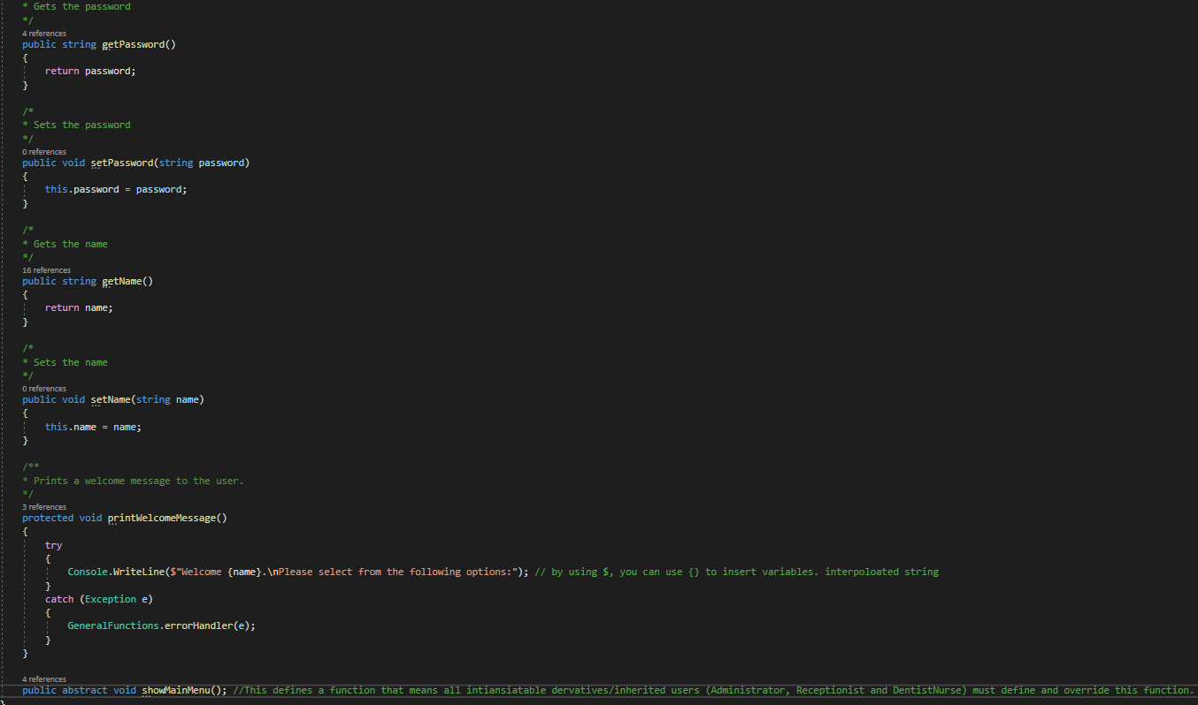

## Staff.cs

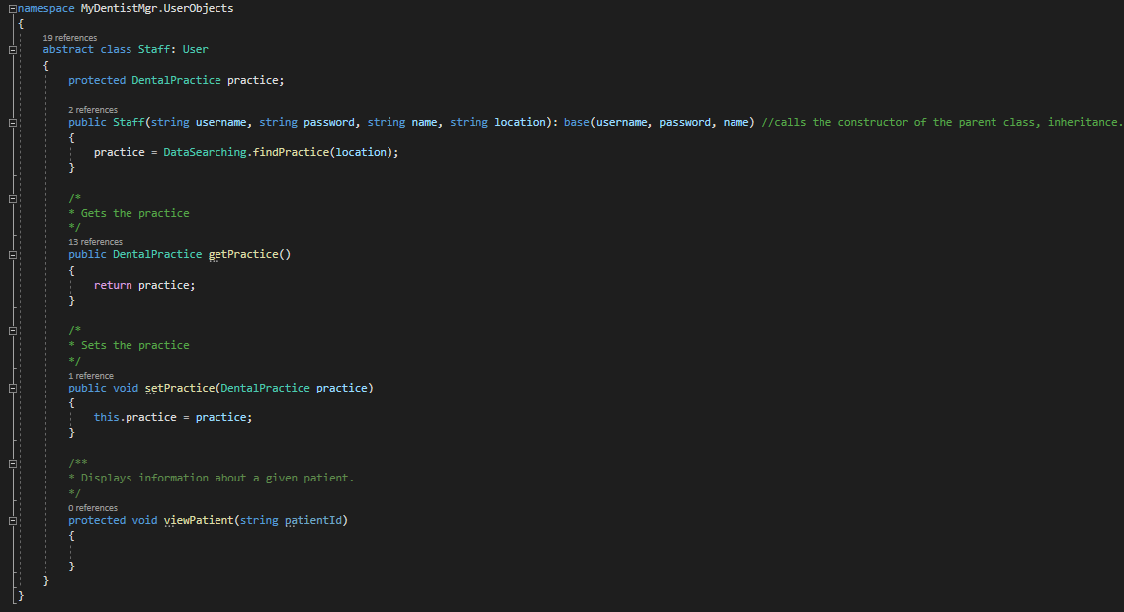

## Receptionist.cs

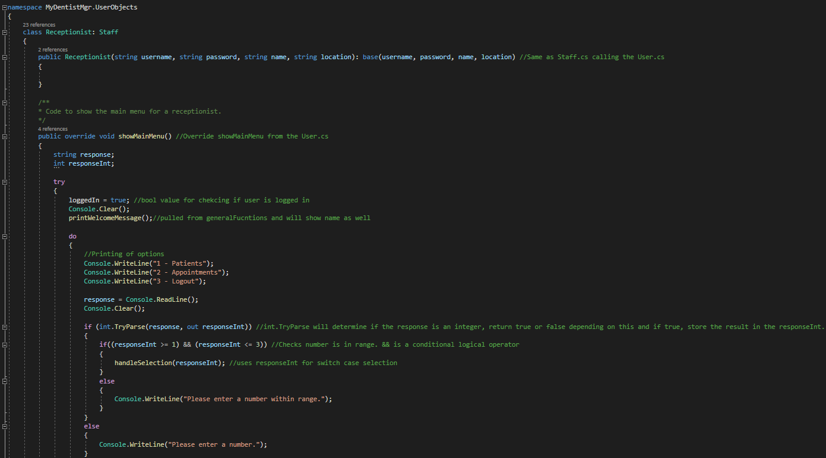

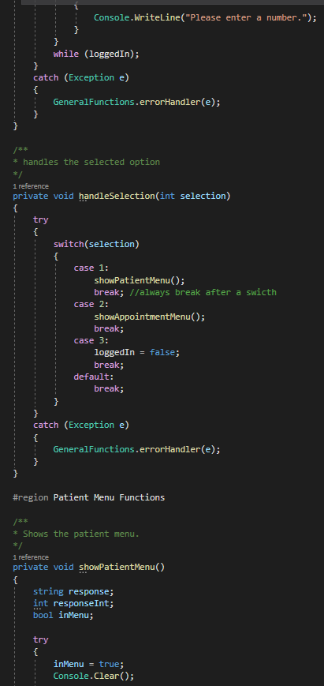

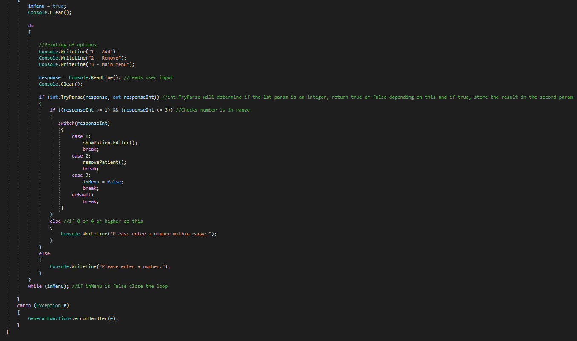

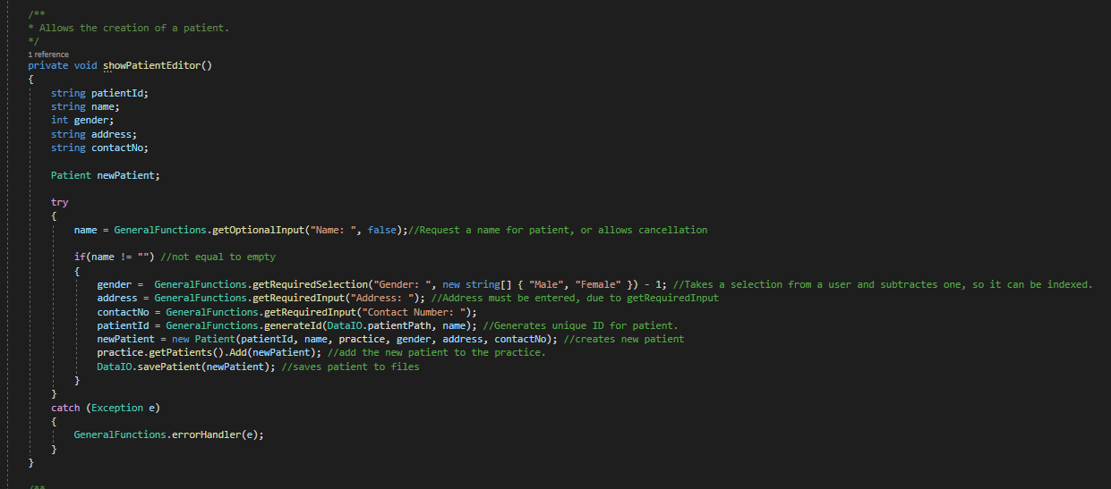

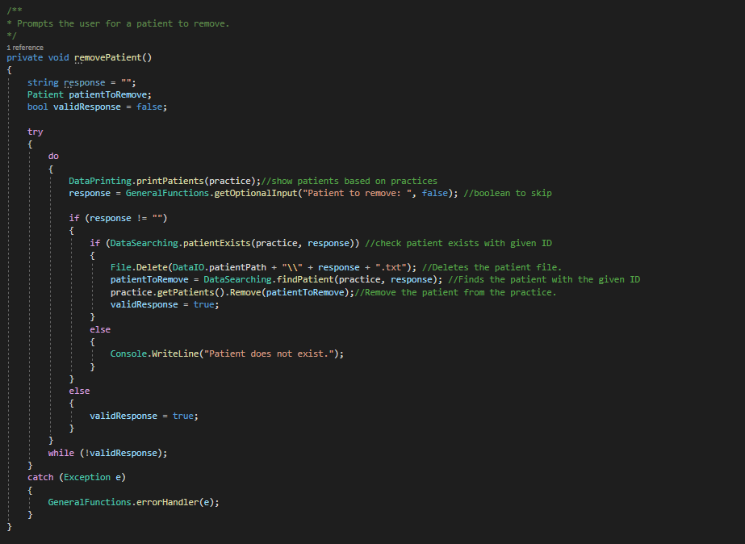

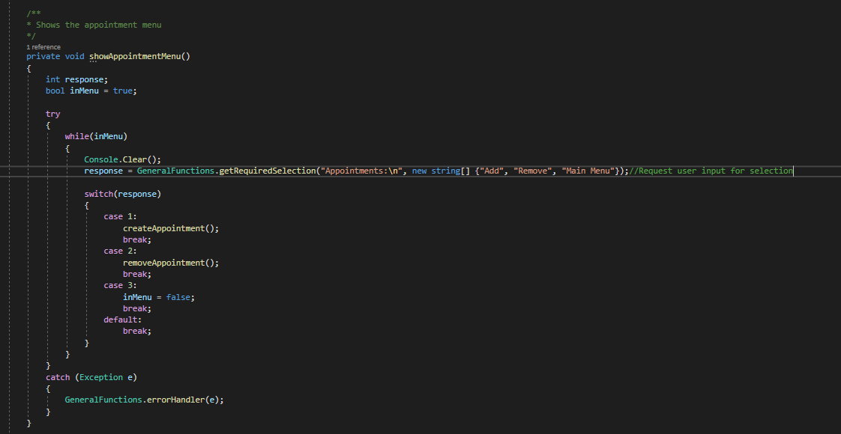

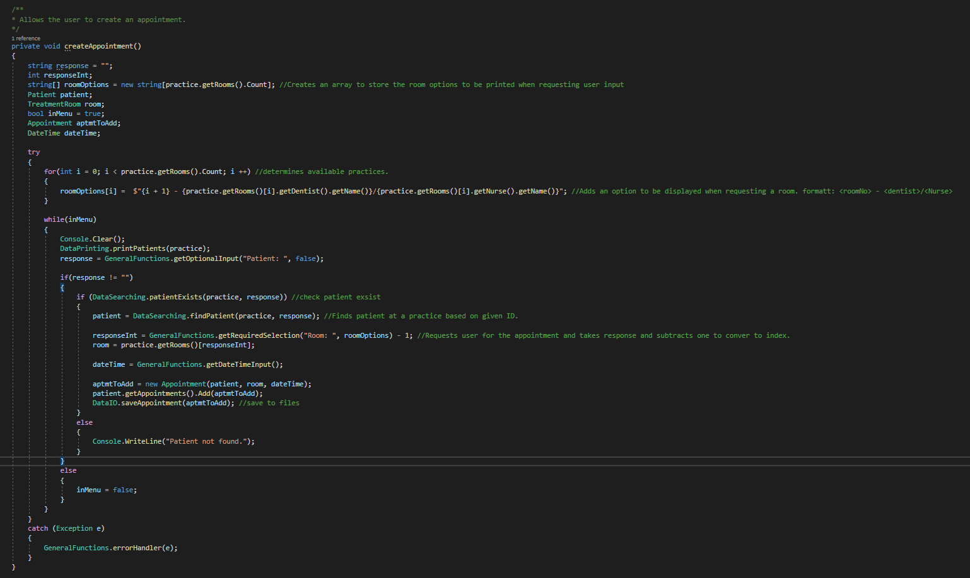

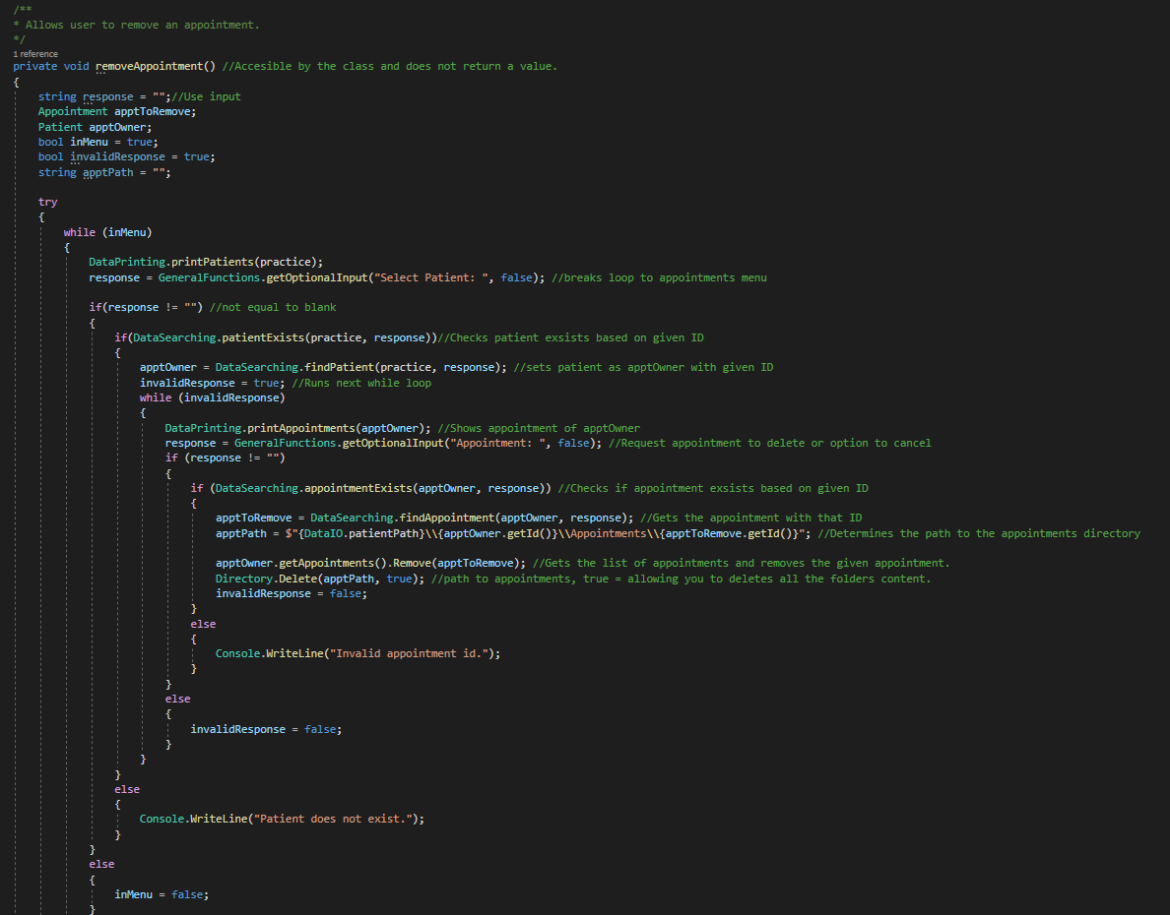

## DentistNurse.cs

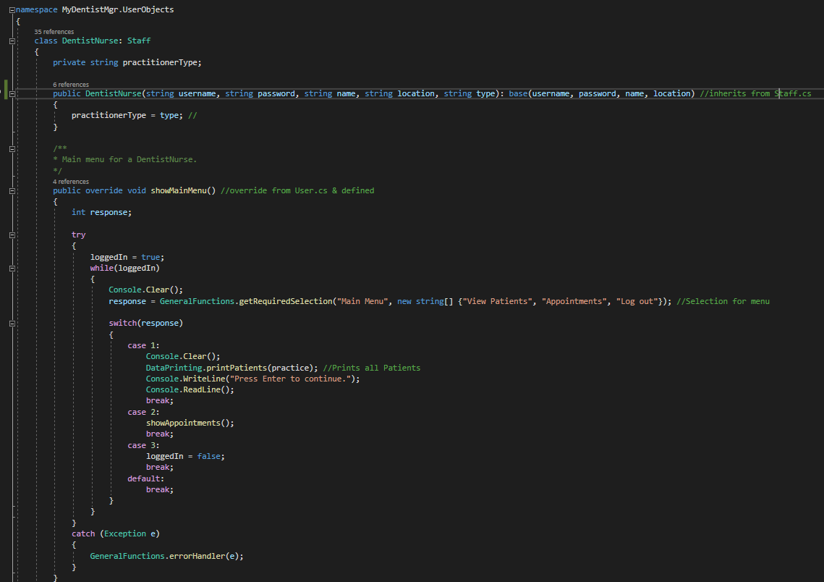

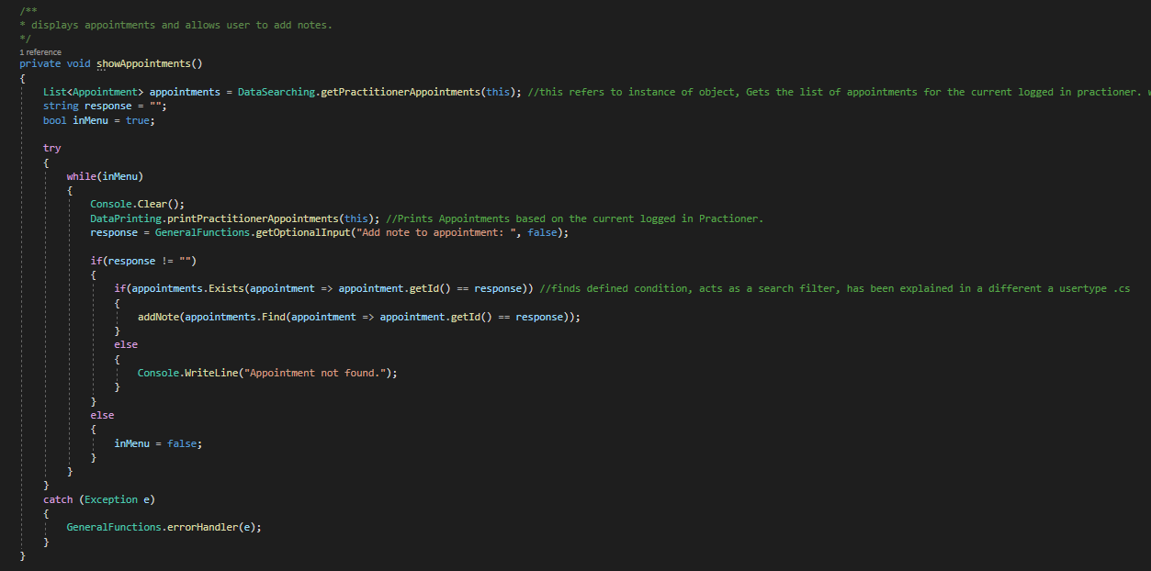

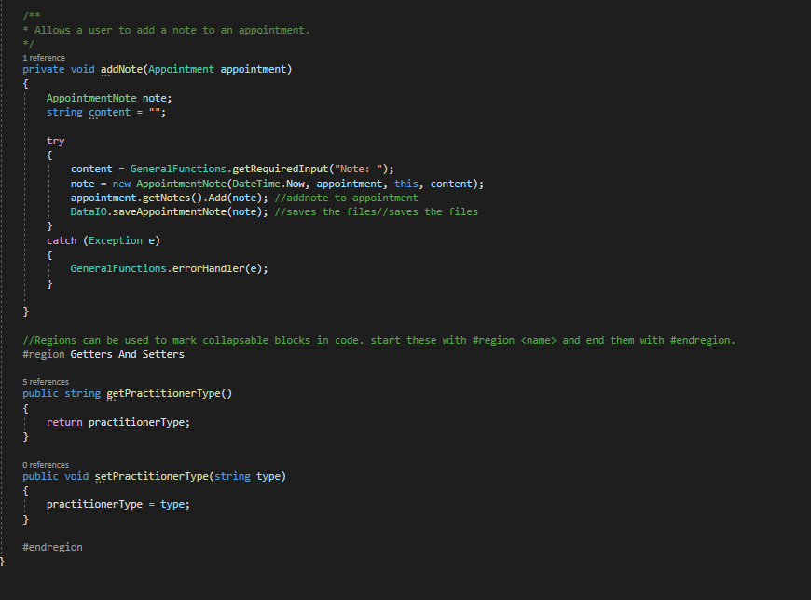

## Administrator.cs

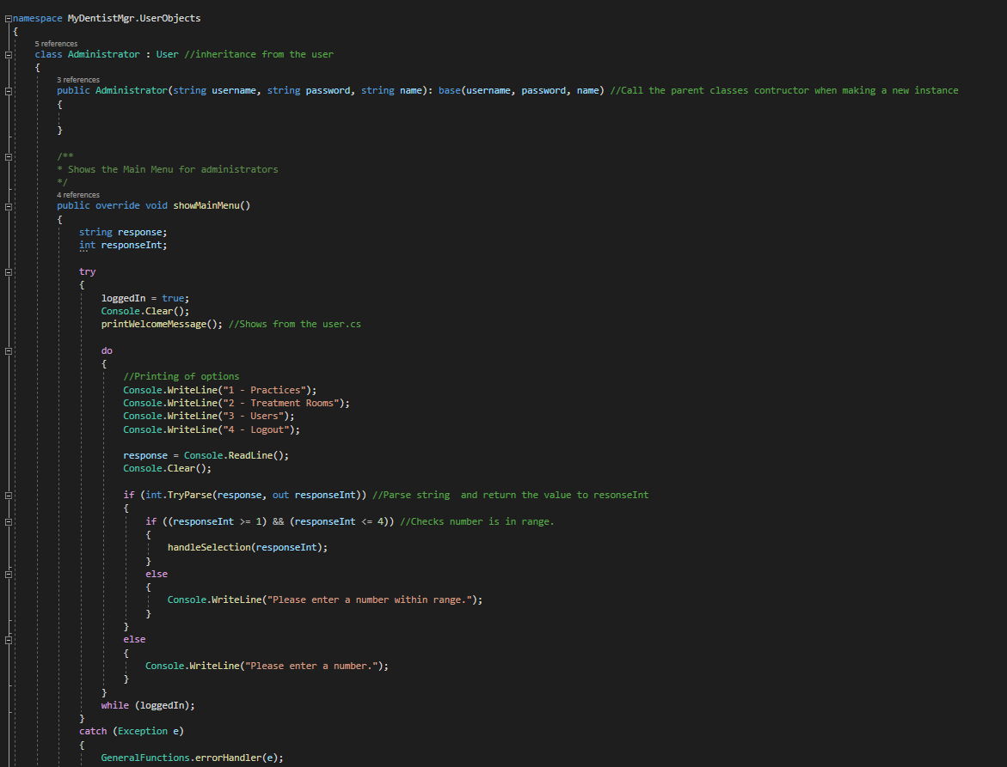

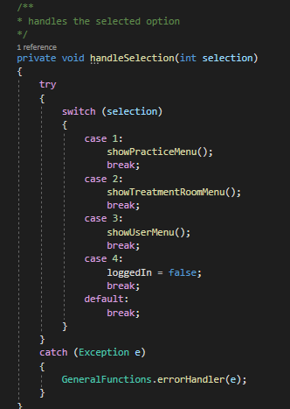

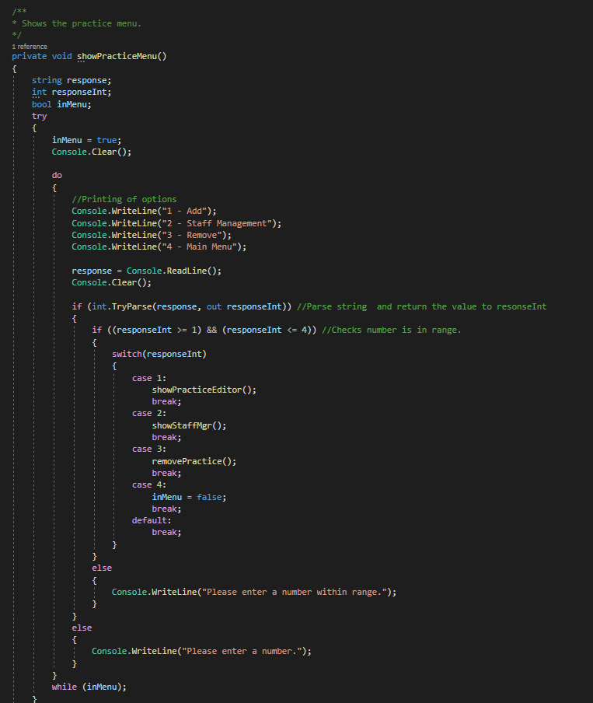

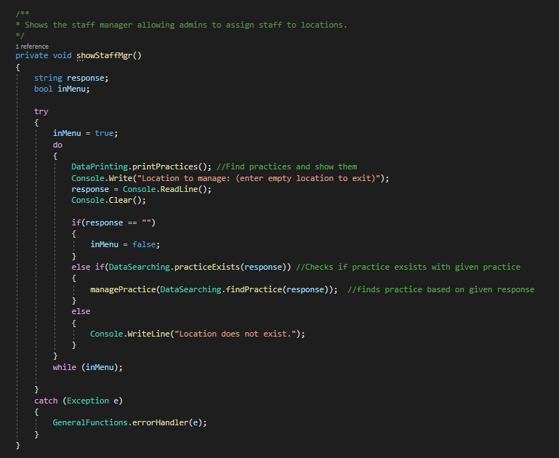

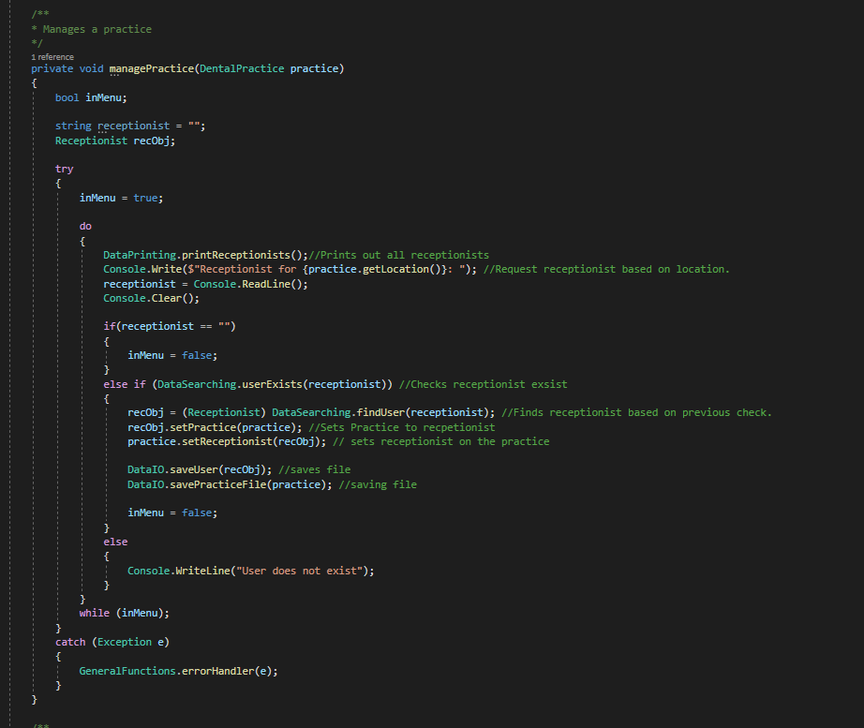

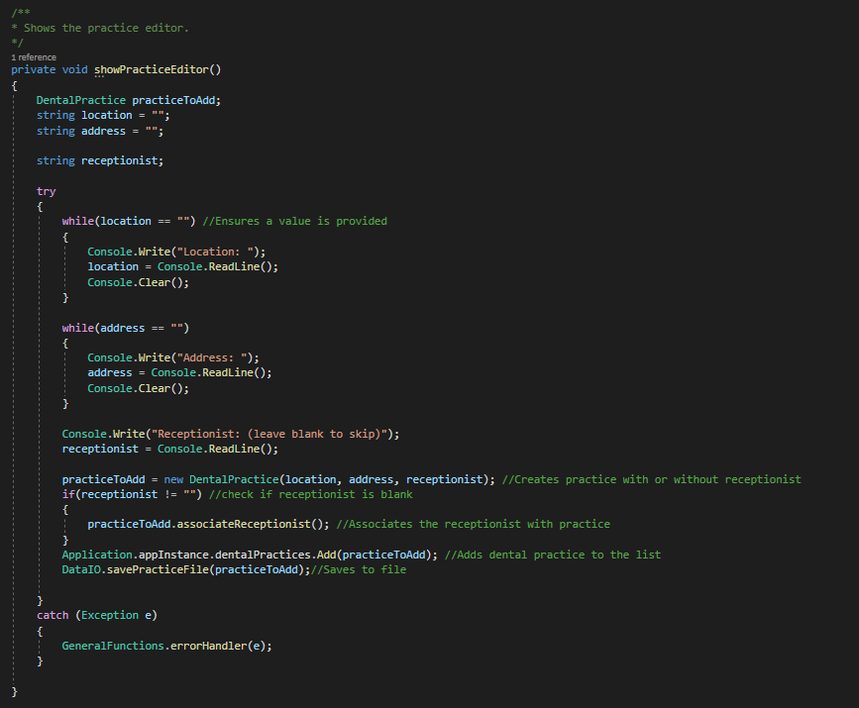

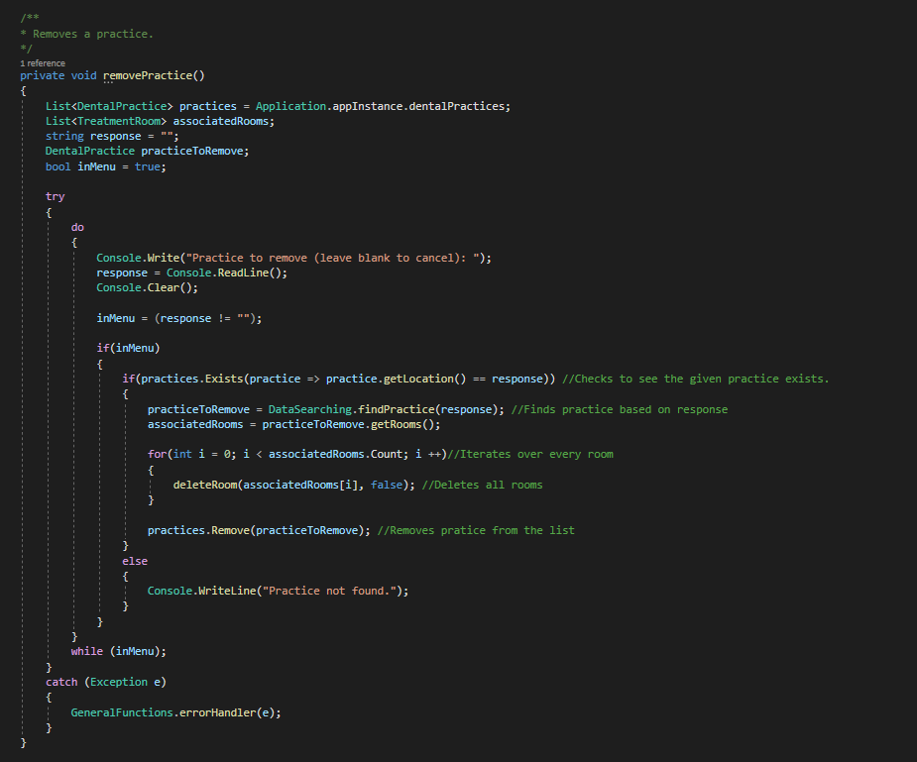

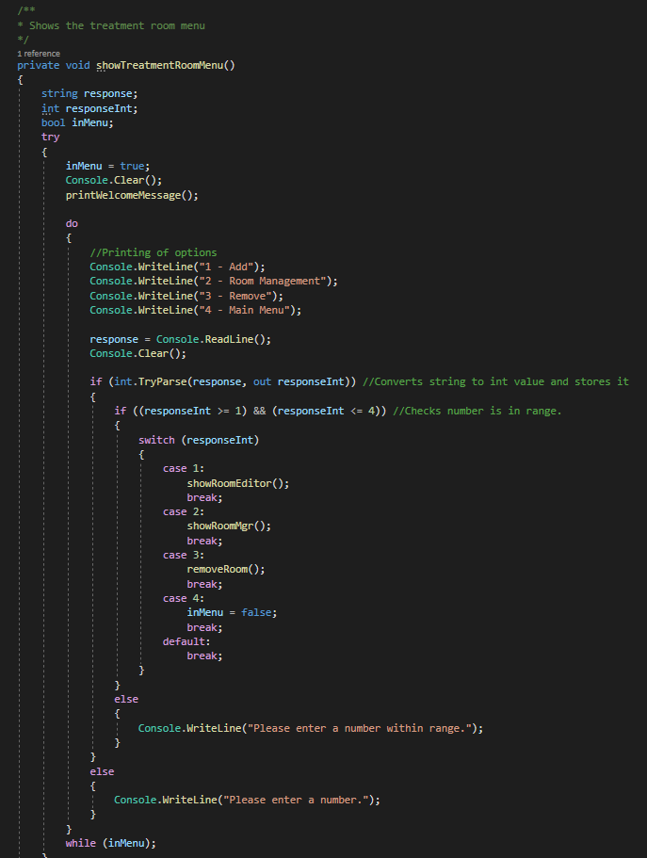

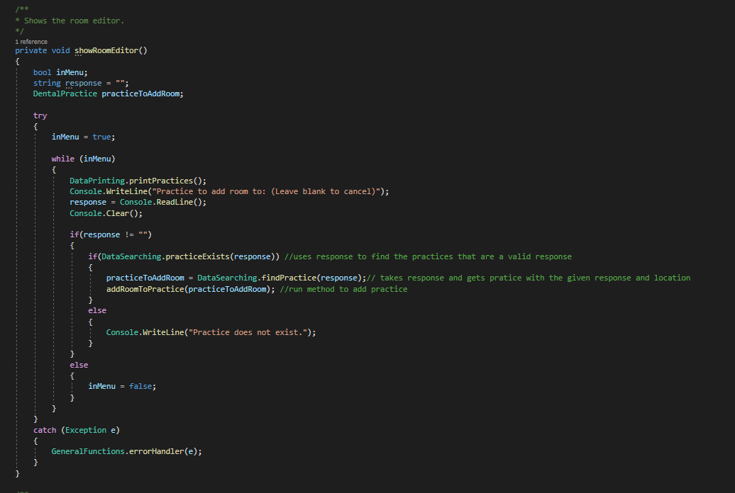

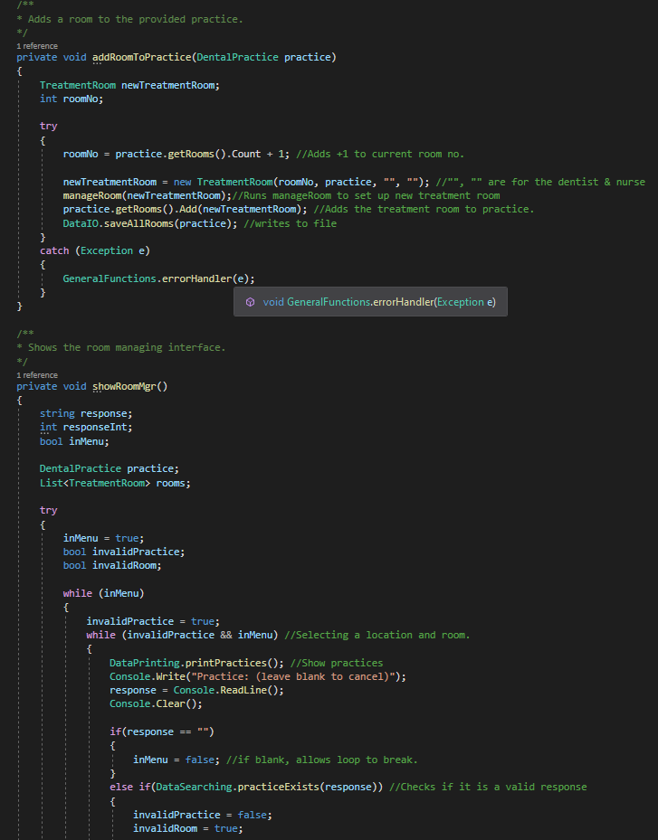

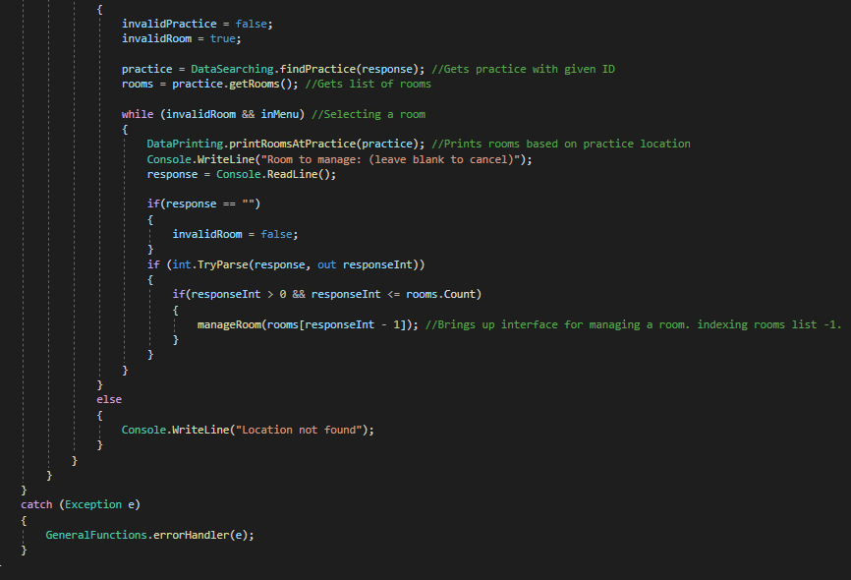

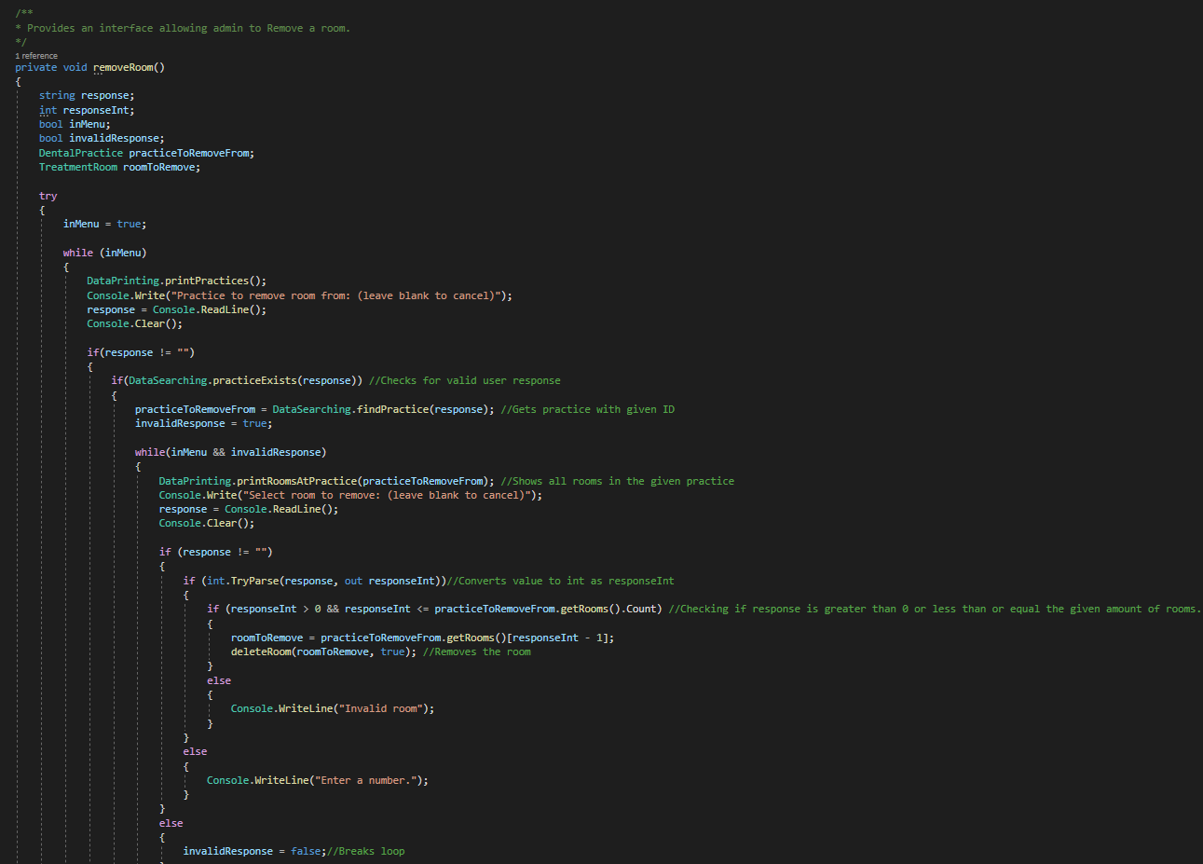

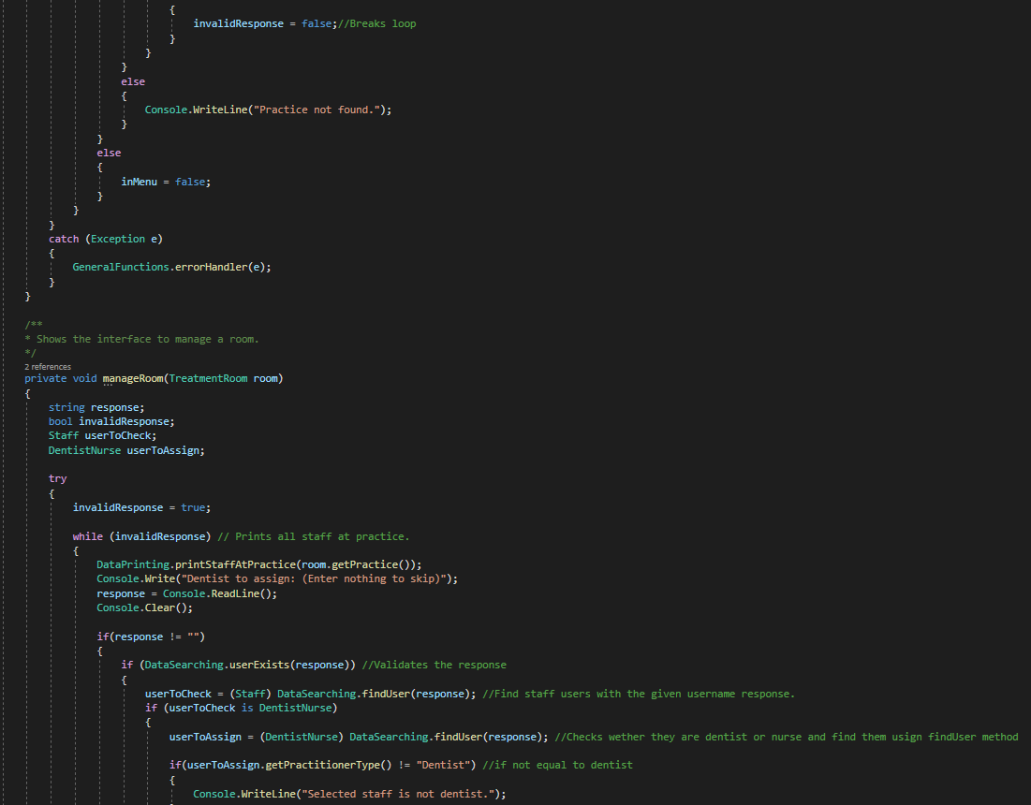

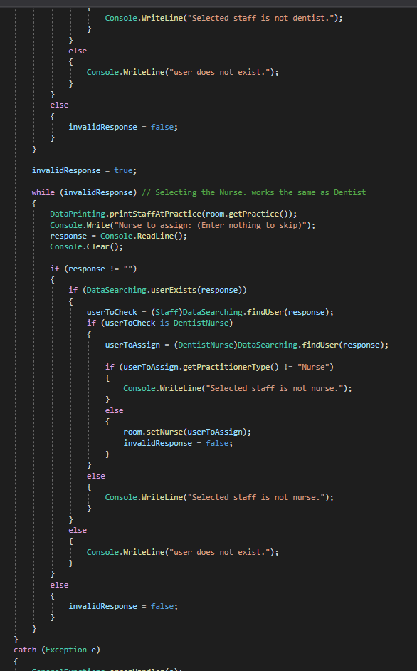

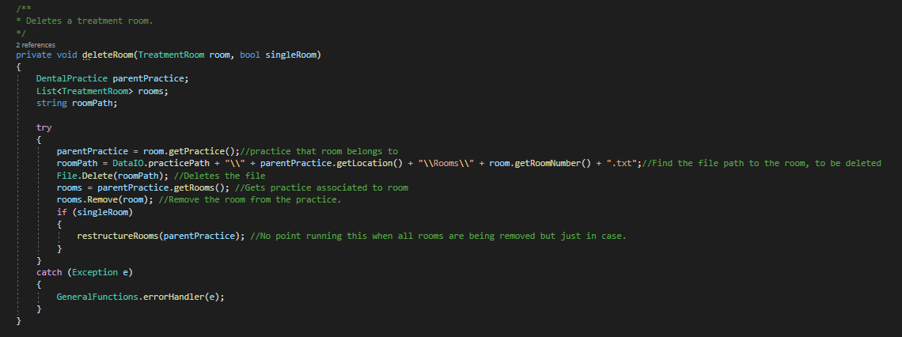

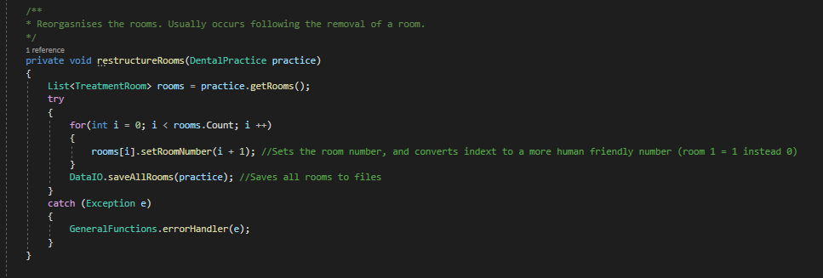

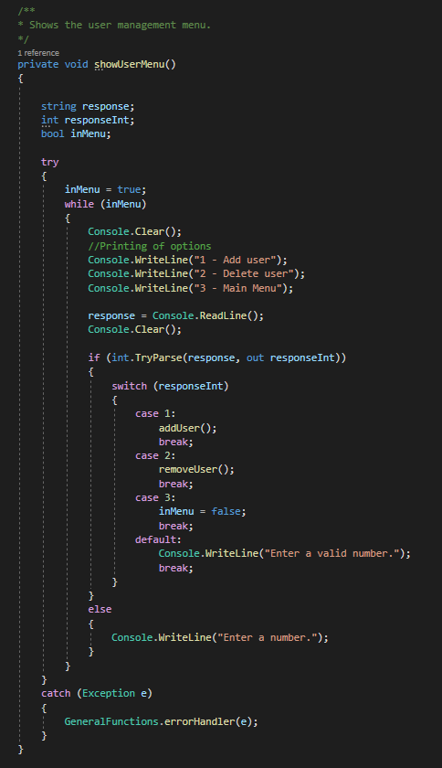

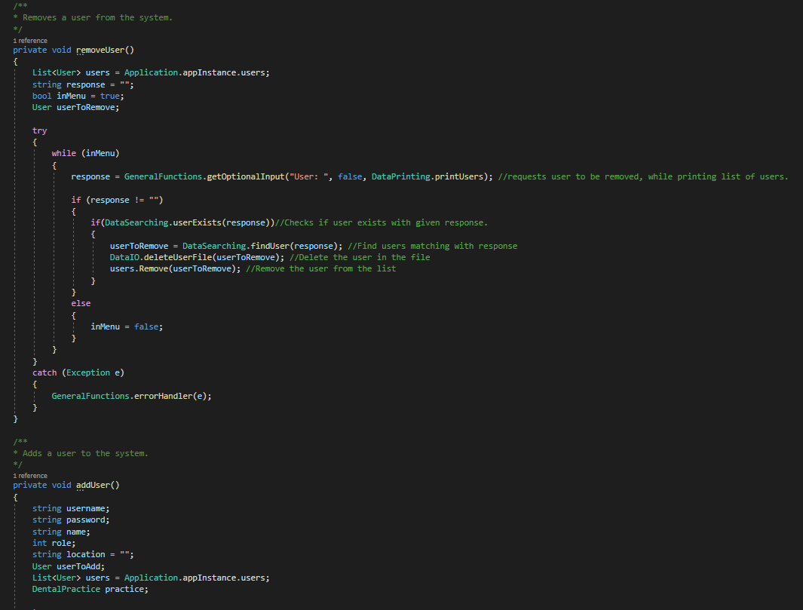

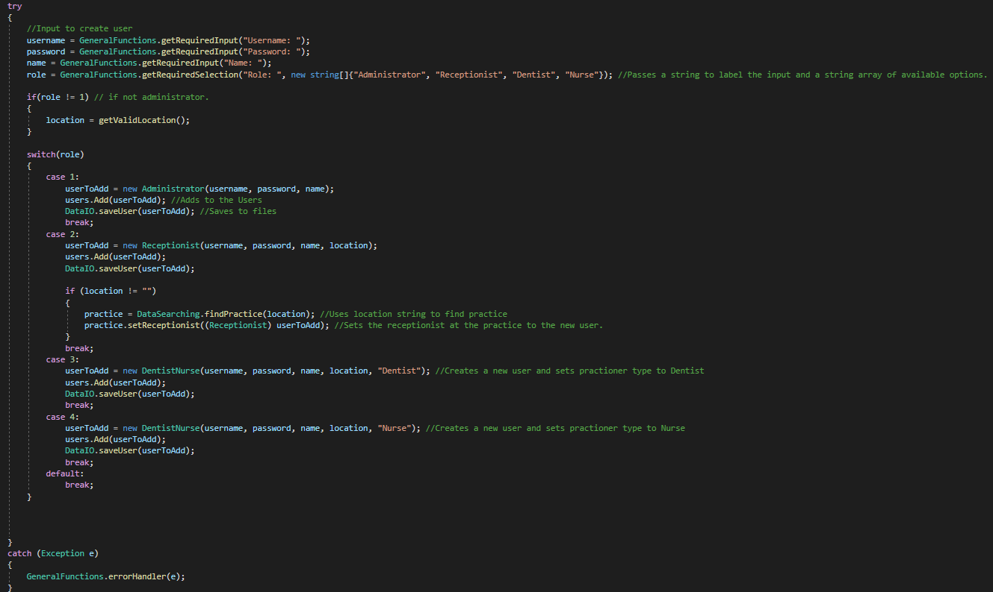

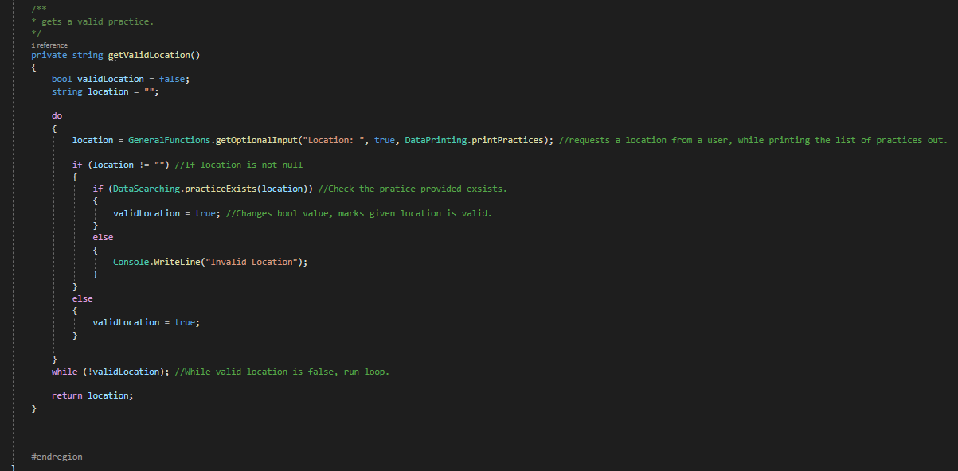

## GeneralFunctions.cs

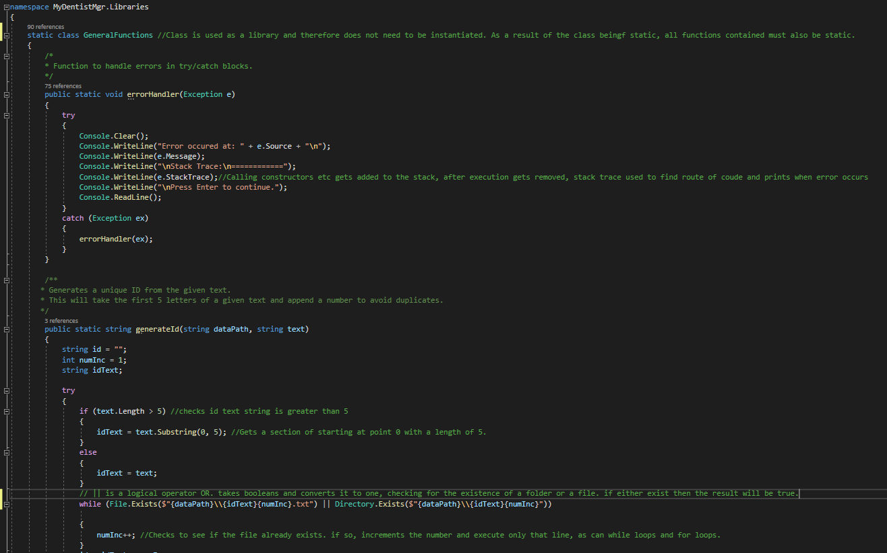

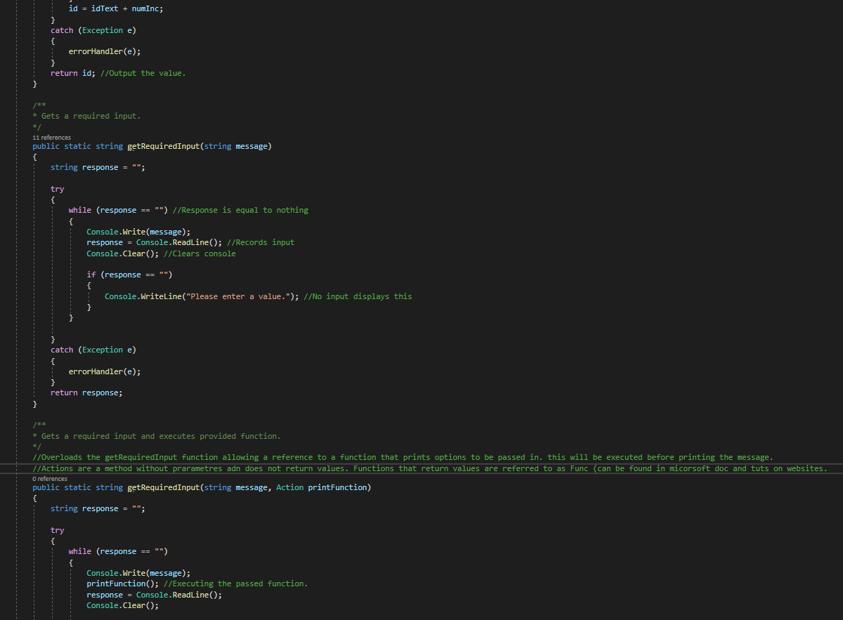

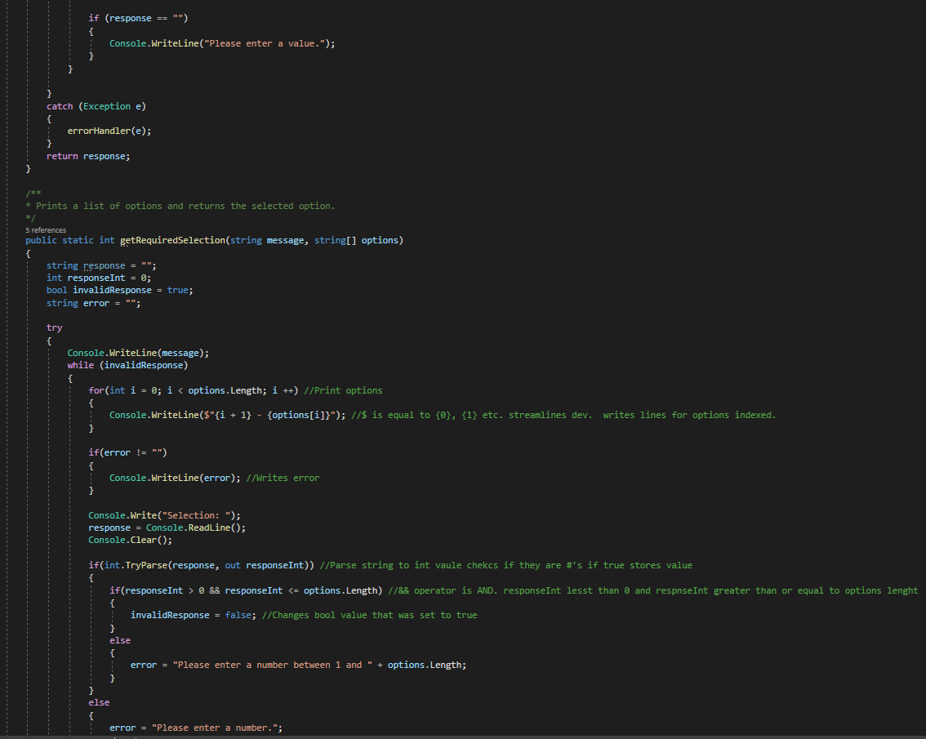

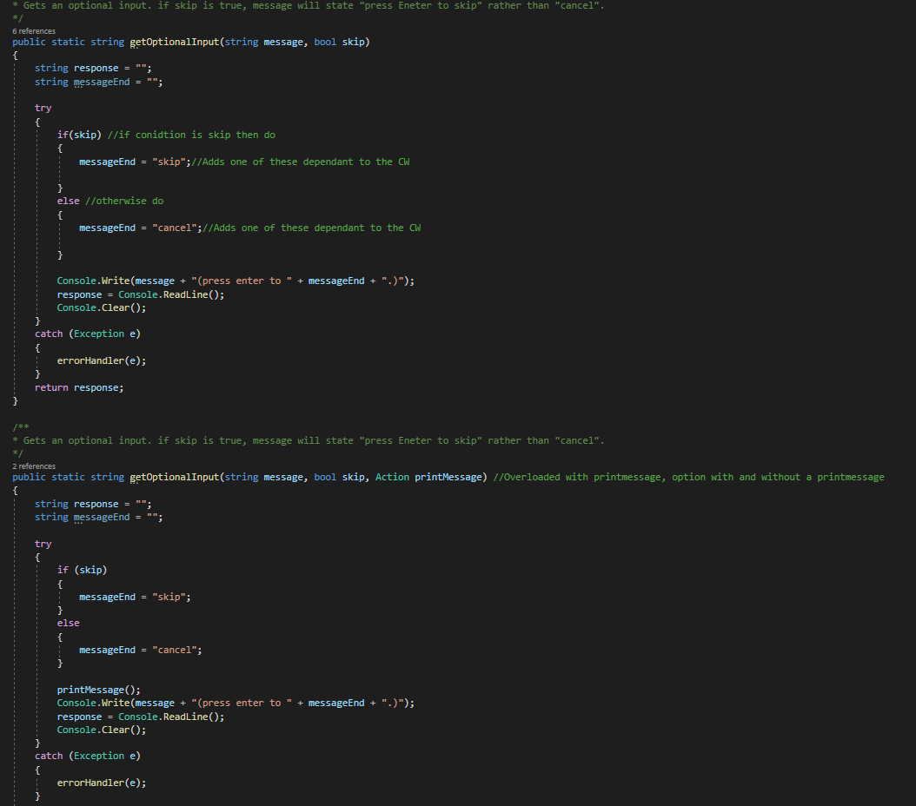

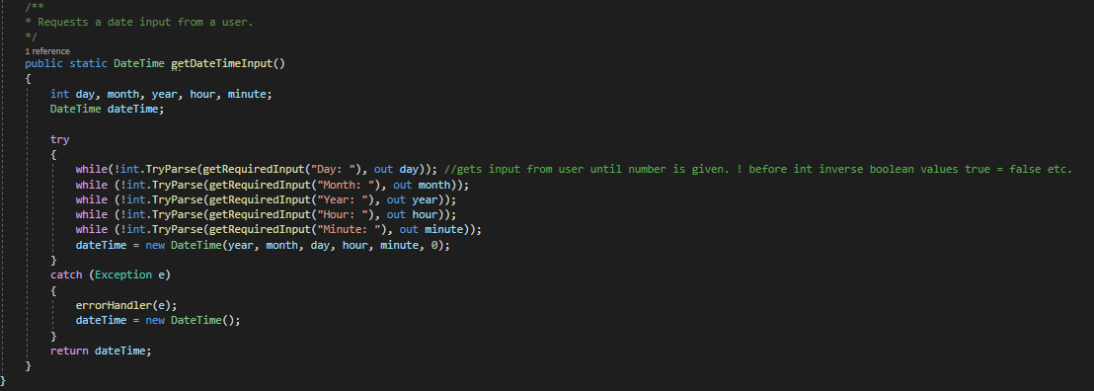

## DataSearching.cs

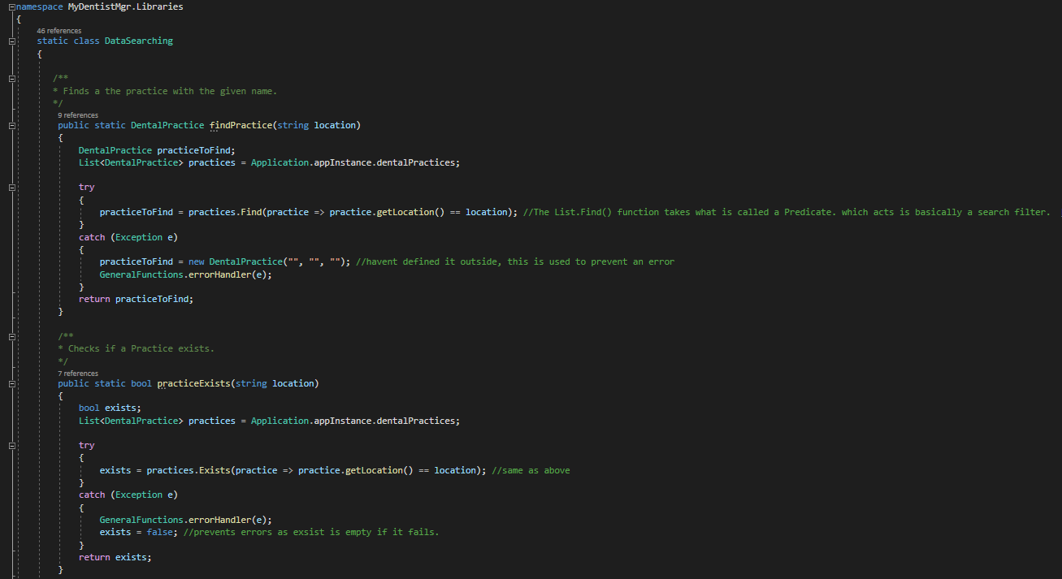

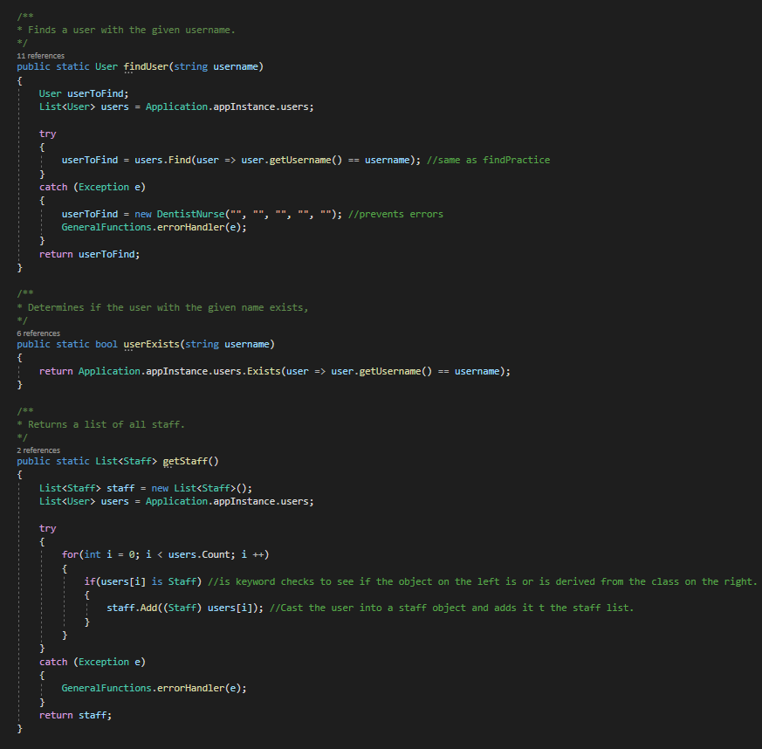

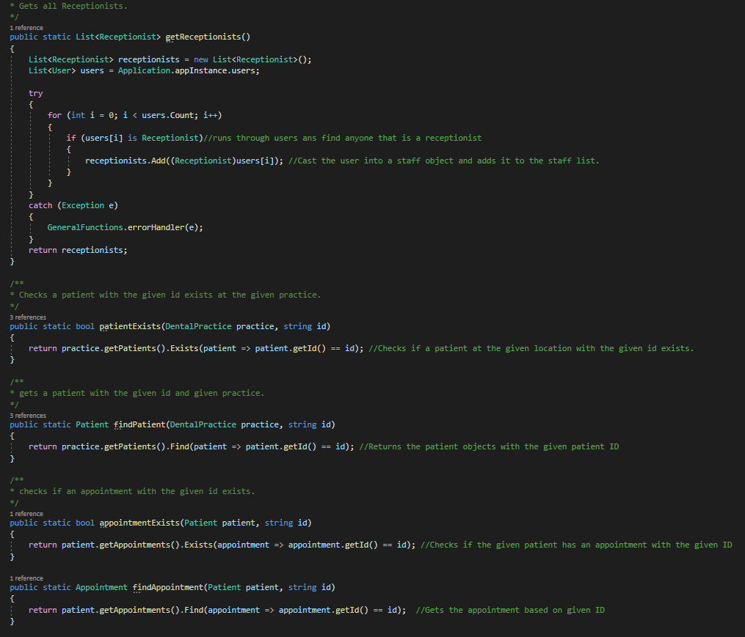

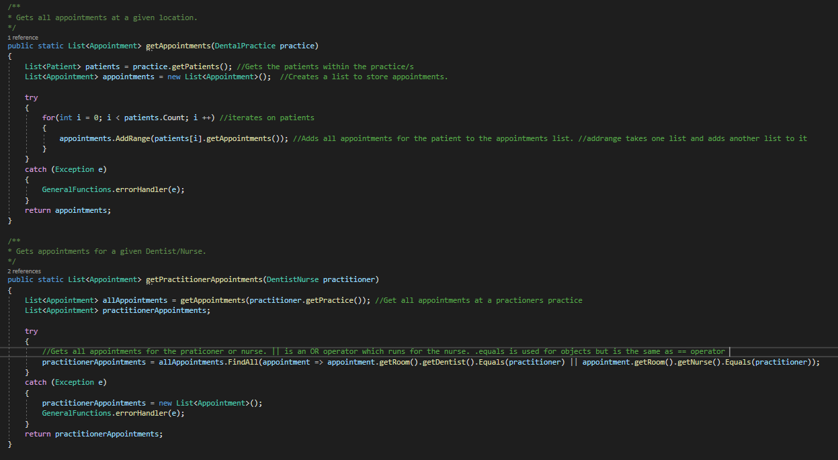

## DataPrinting.cs

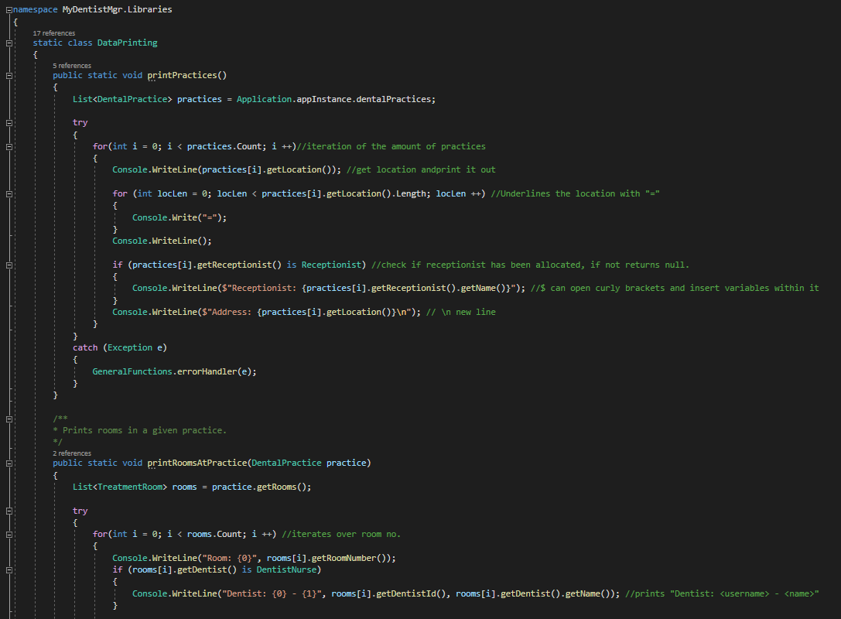

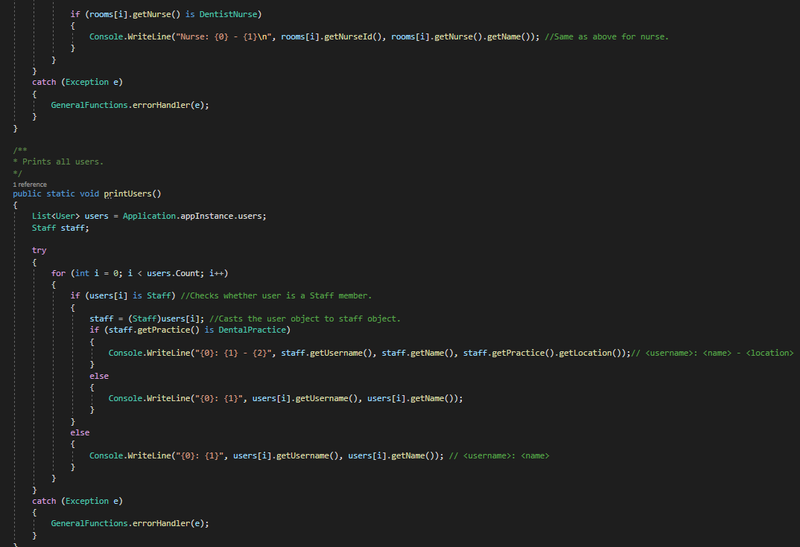

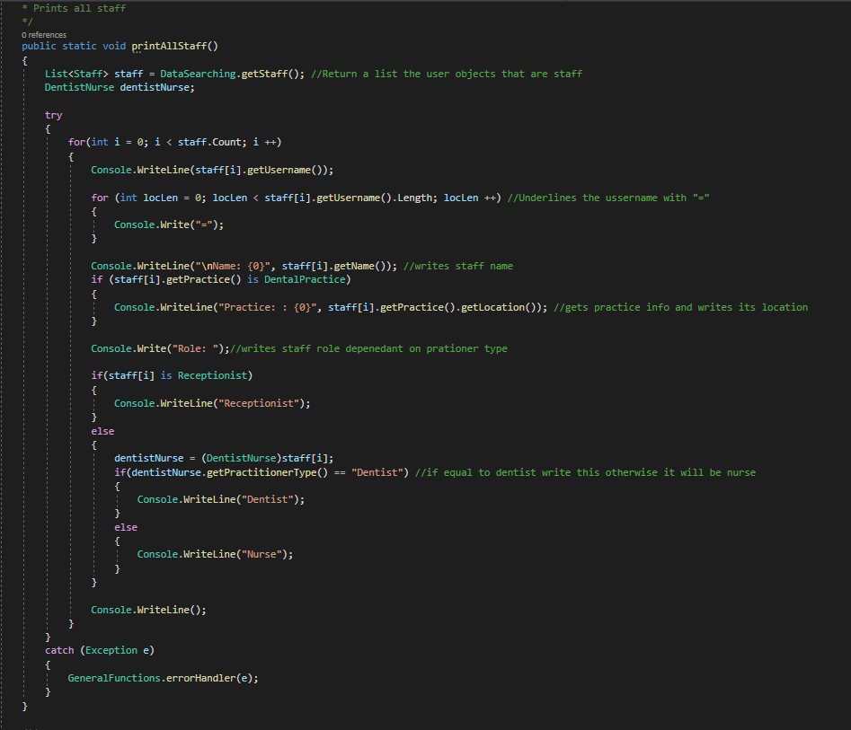

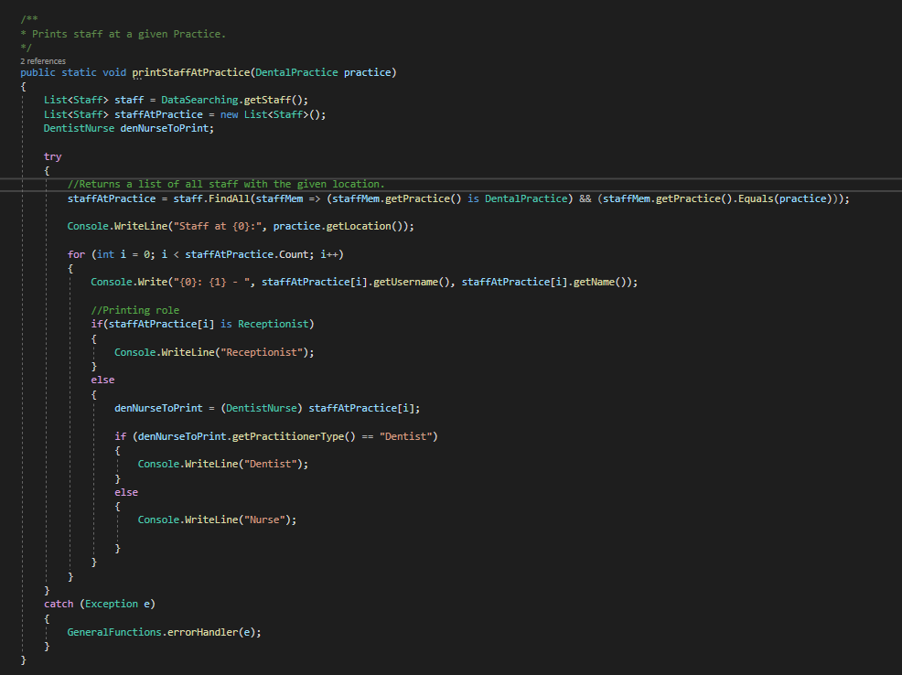

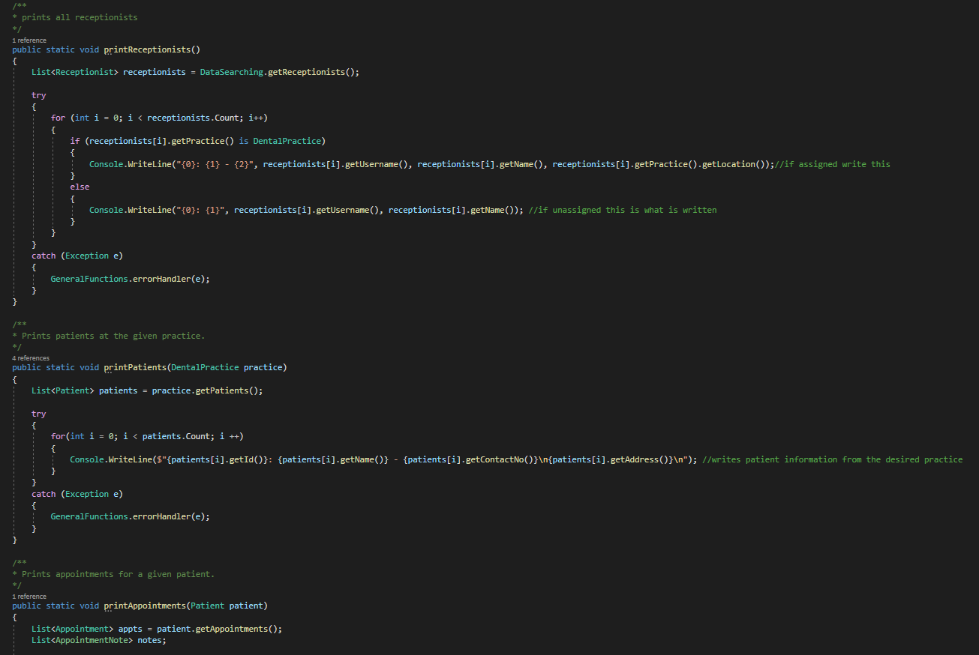

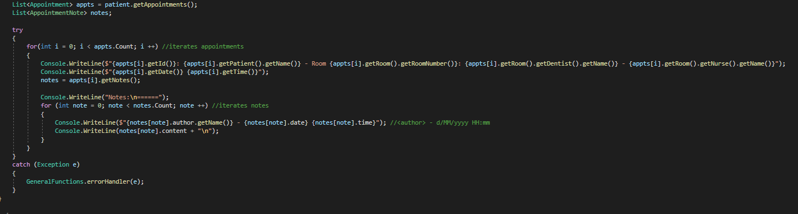

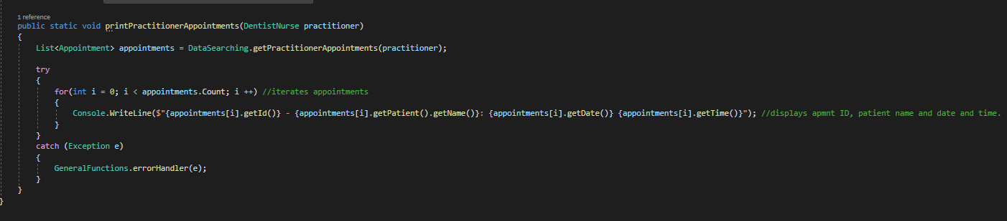

DataIO.cs

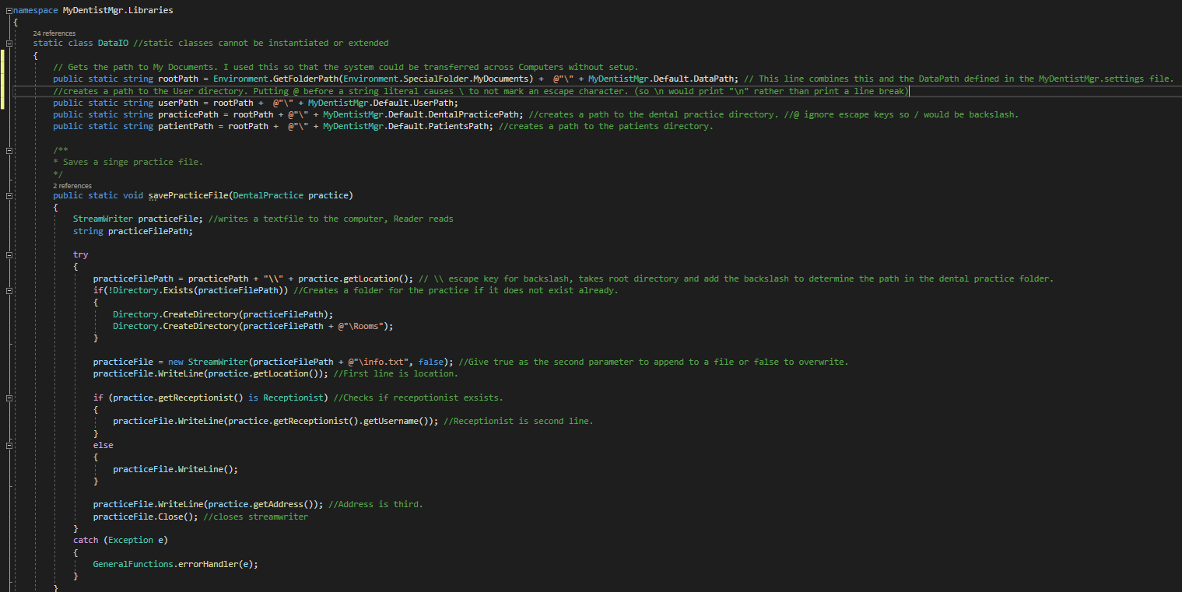

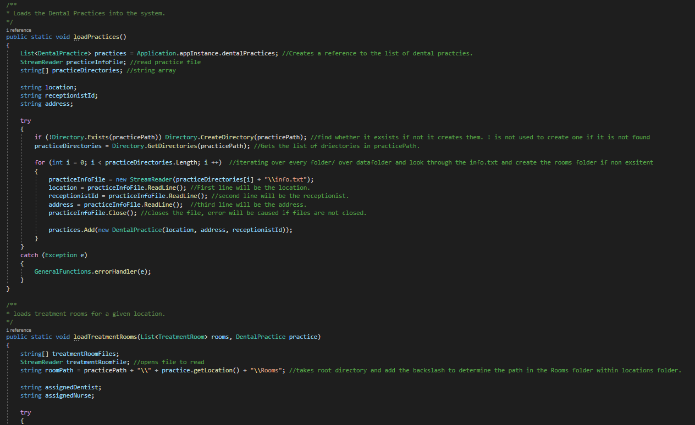

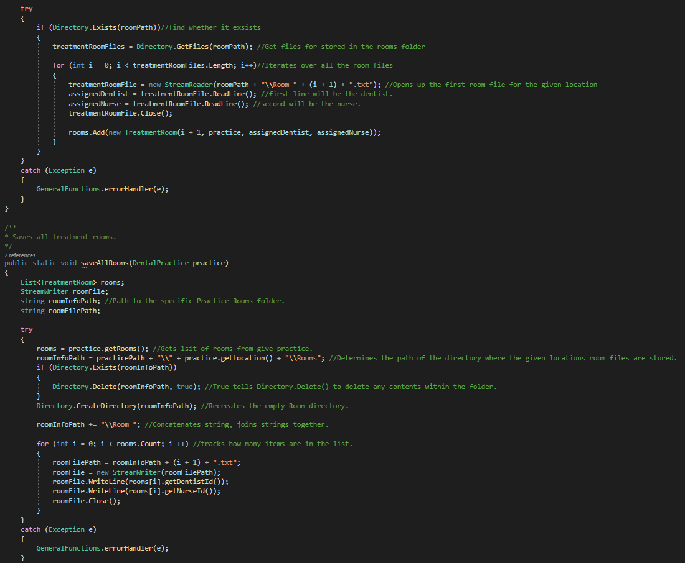

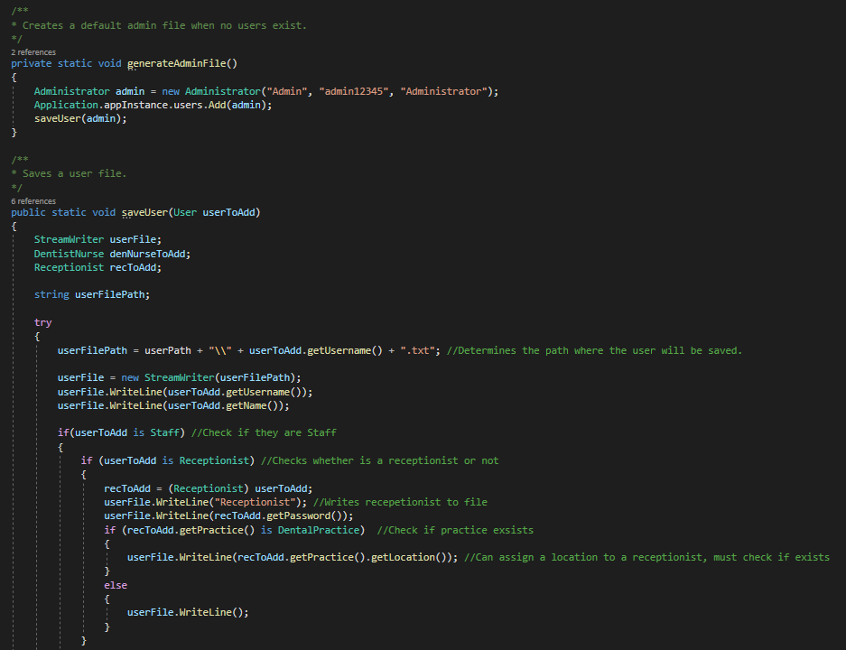

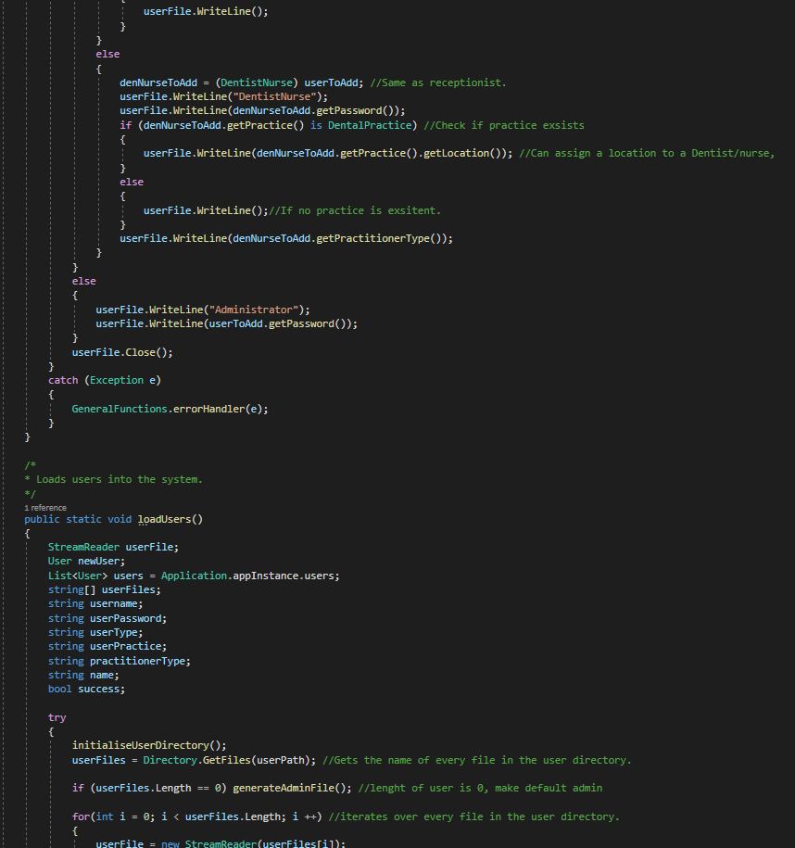

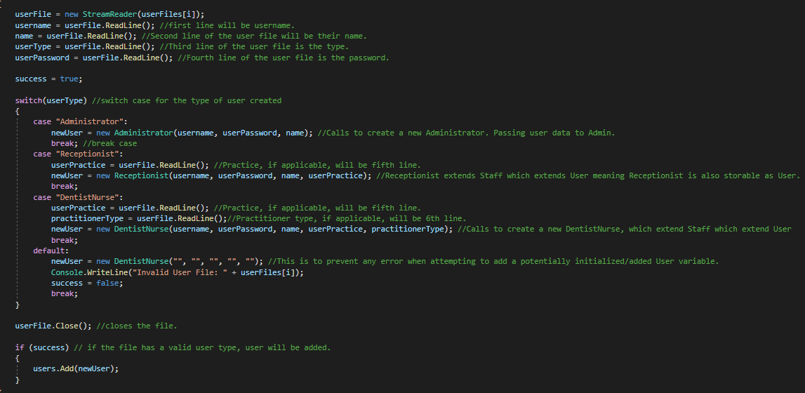

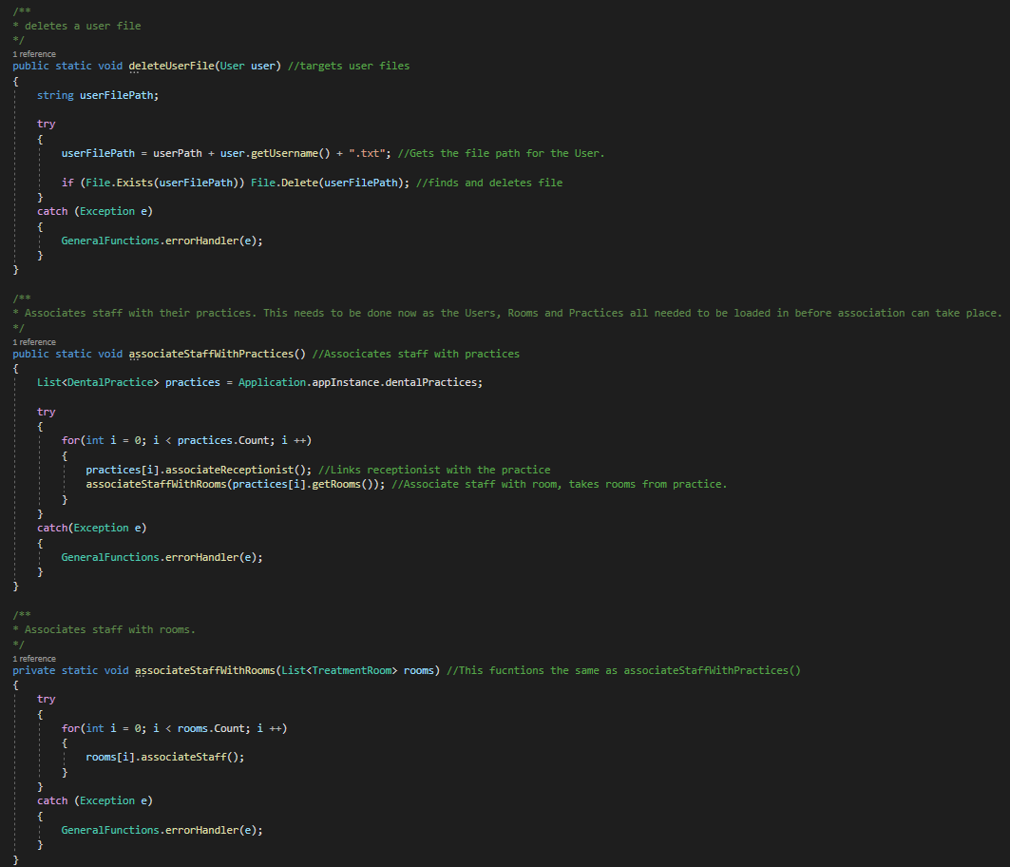

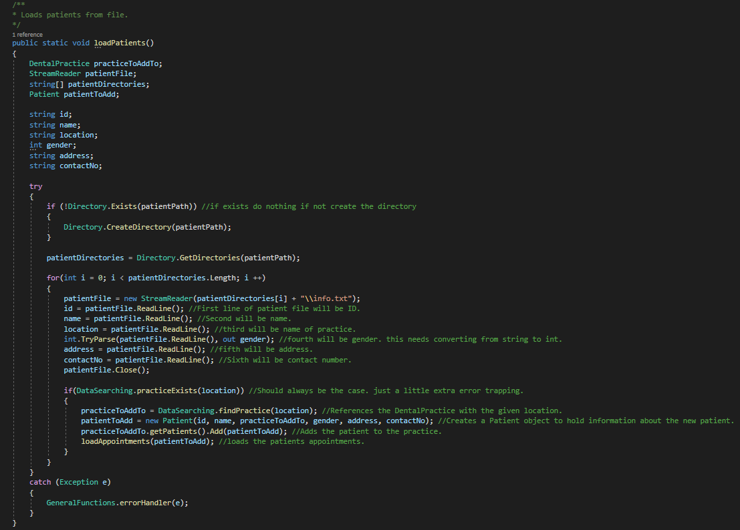

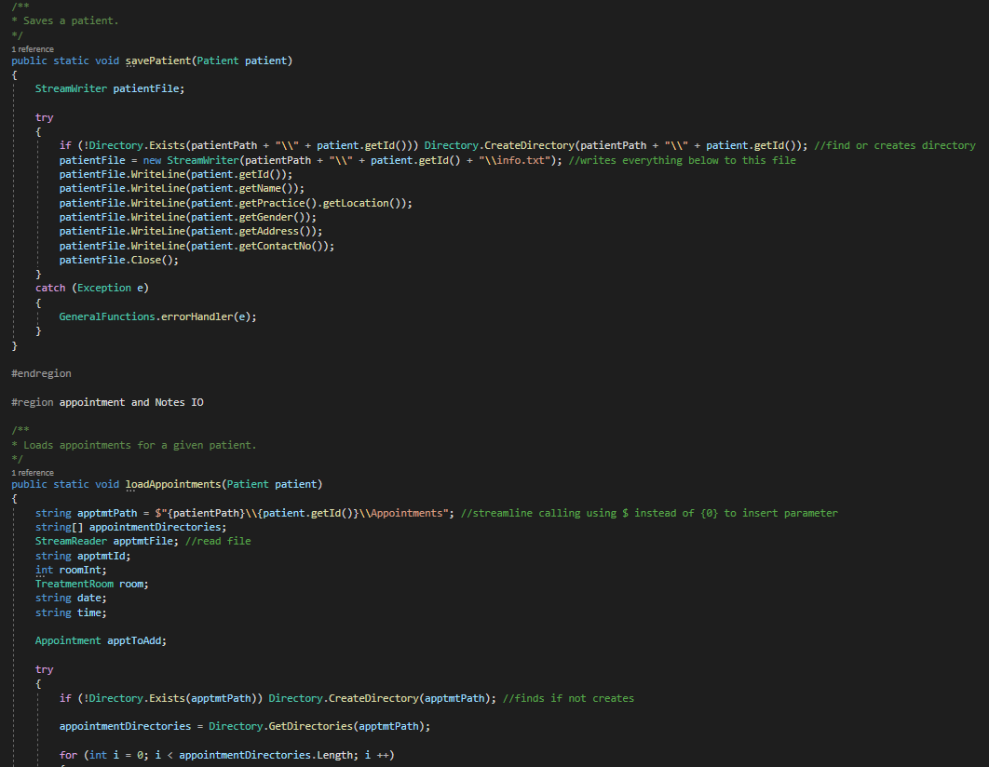

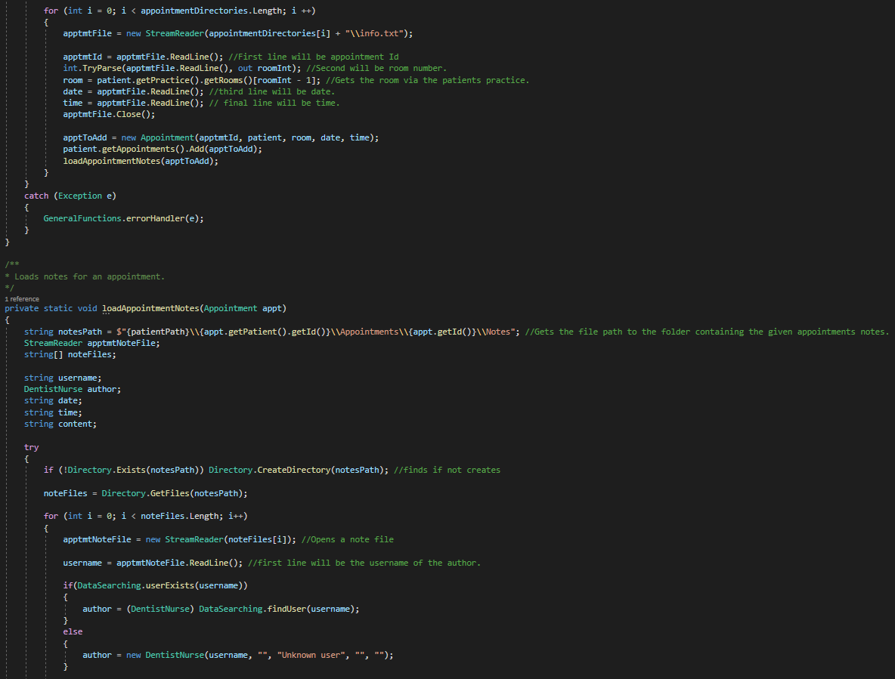

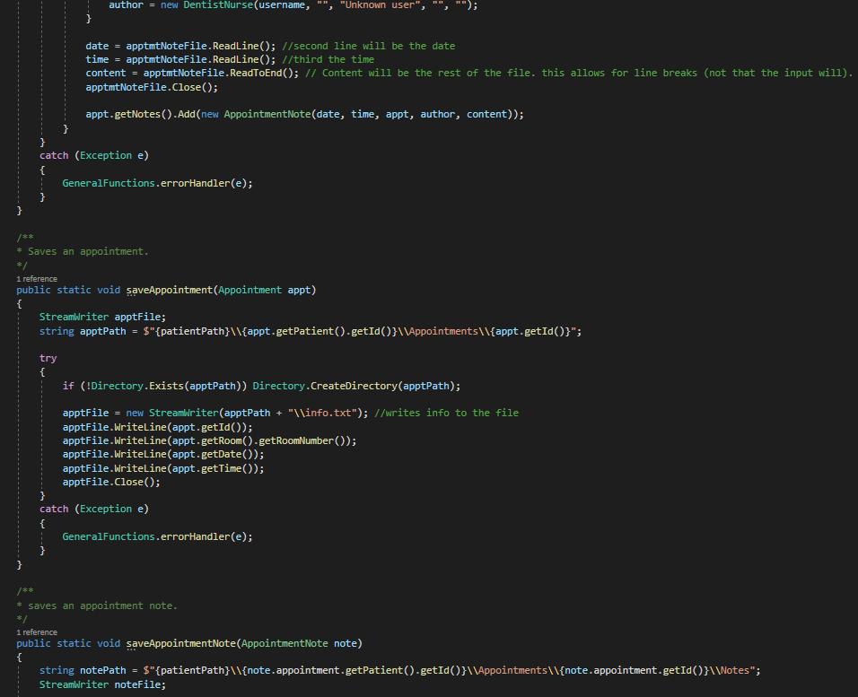

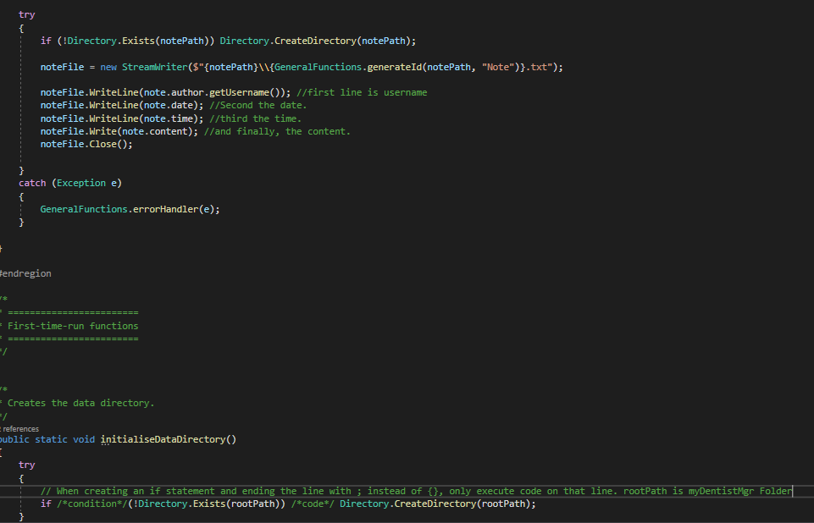

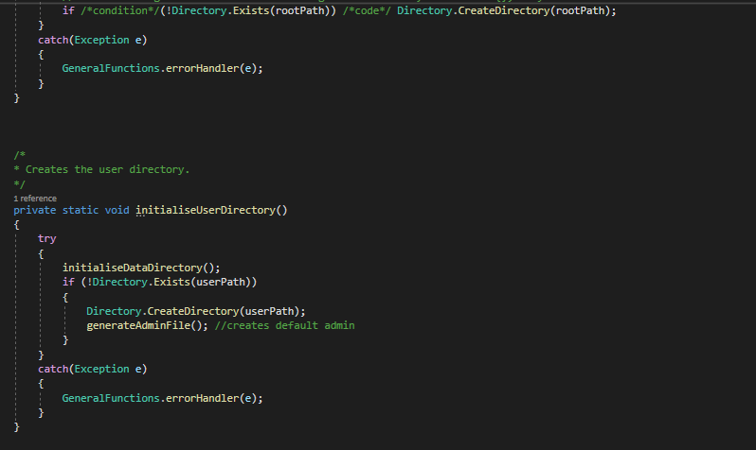

## TreatmentRoom.cs

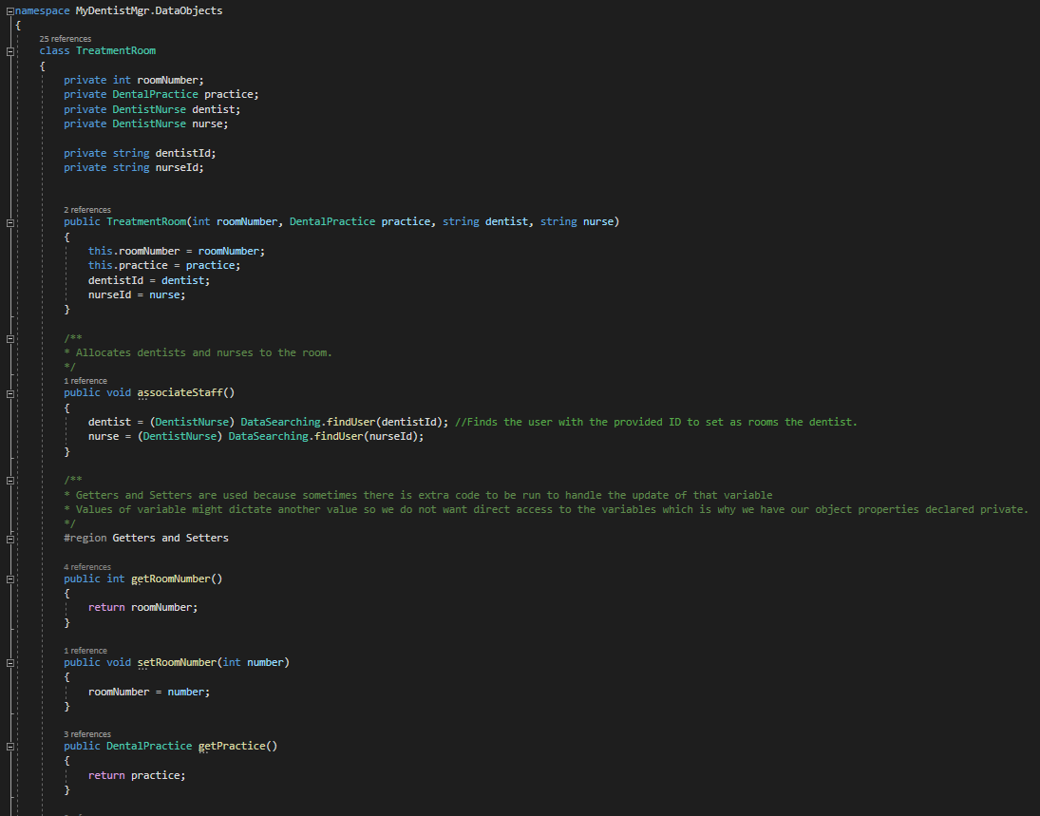

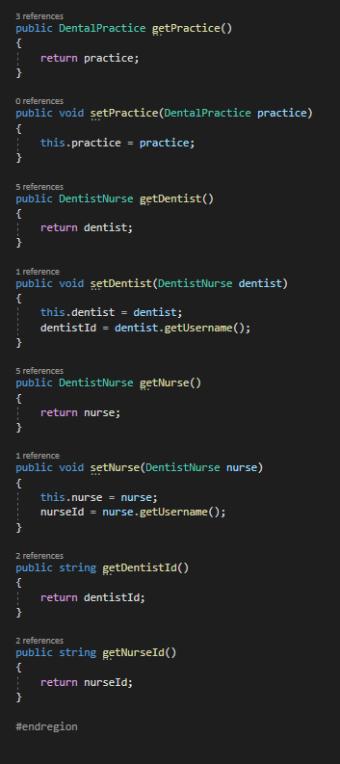

## Patient.cs

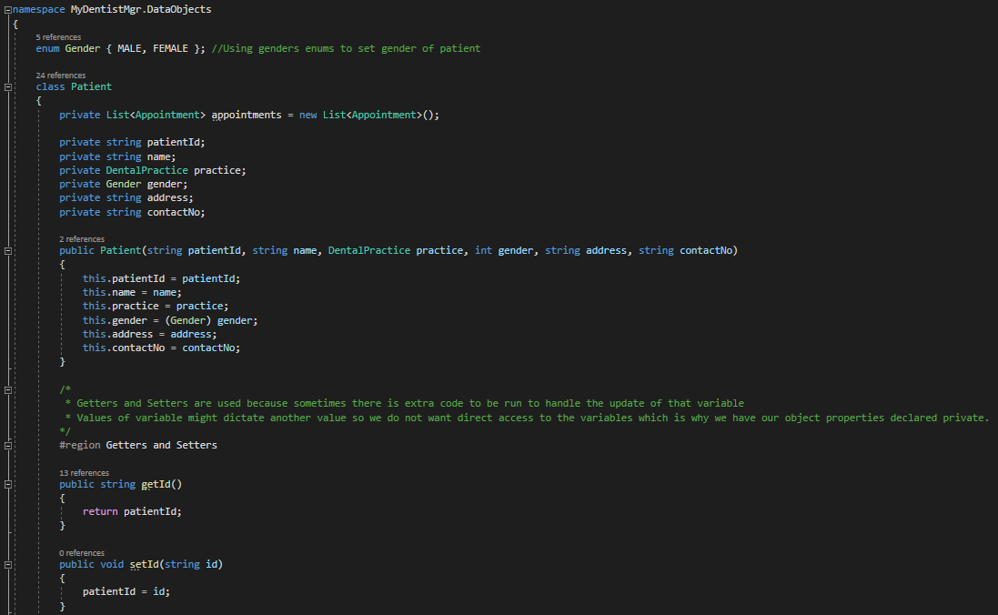

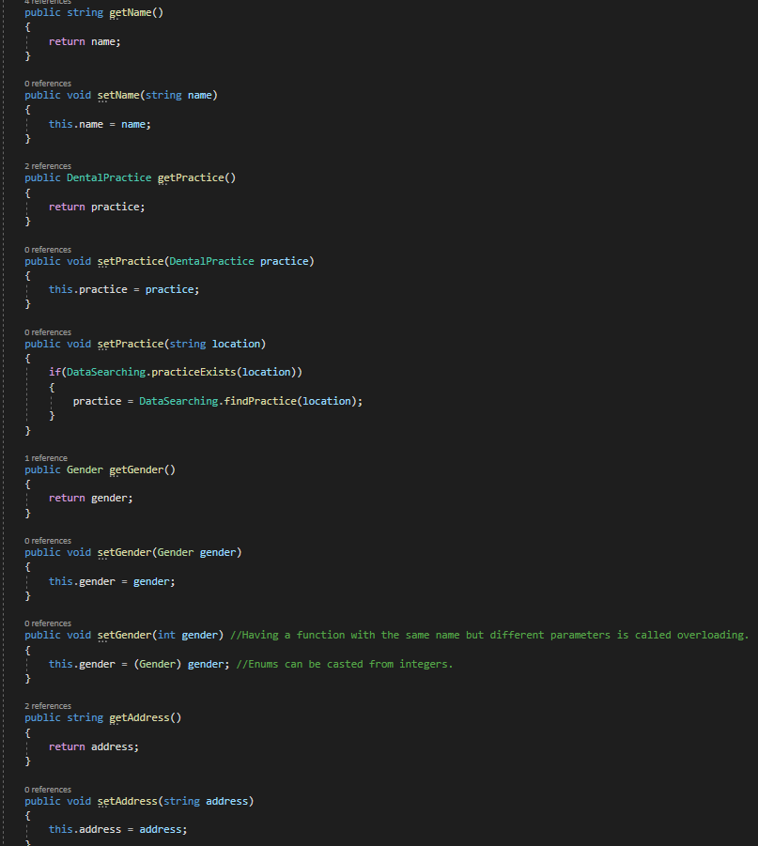

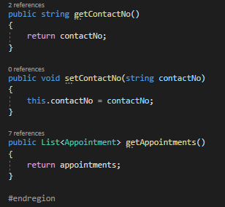

## DentalPractice.cs

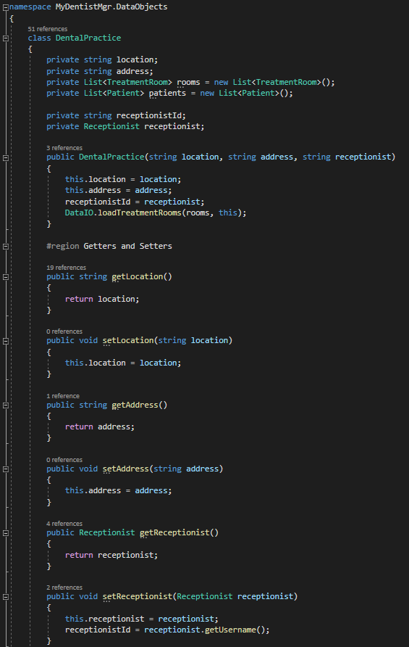

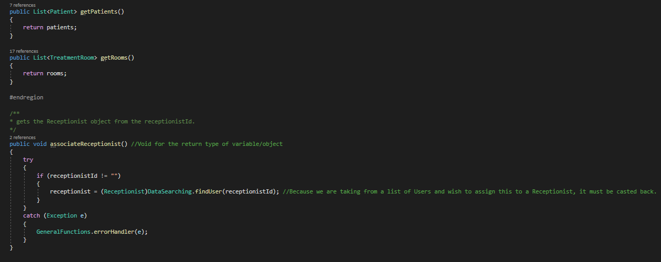

## Appointment.cs

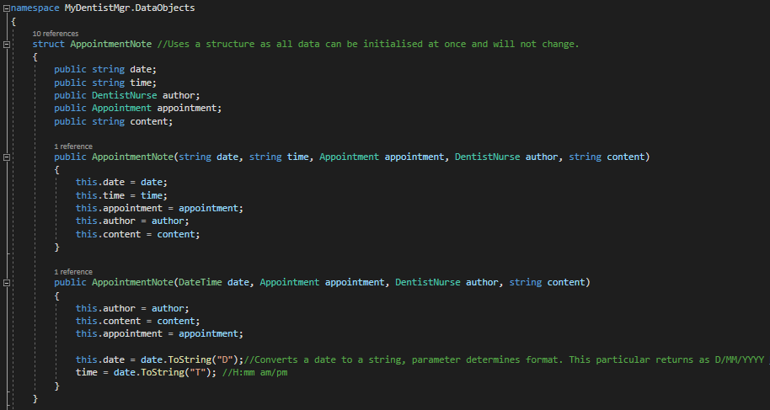

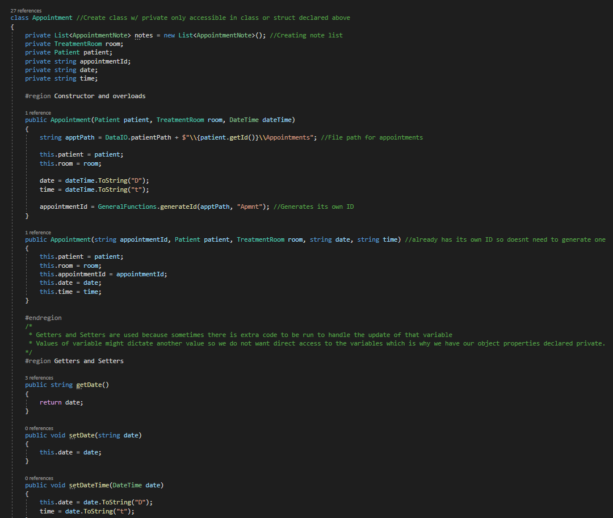

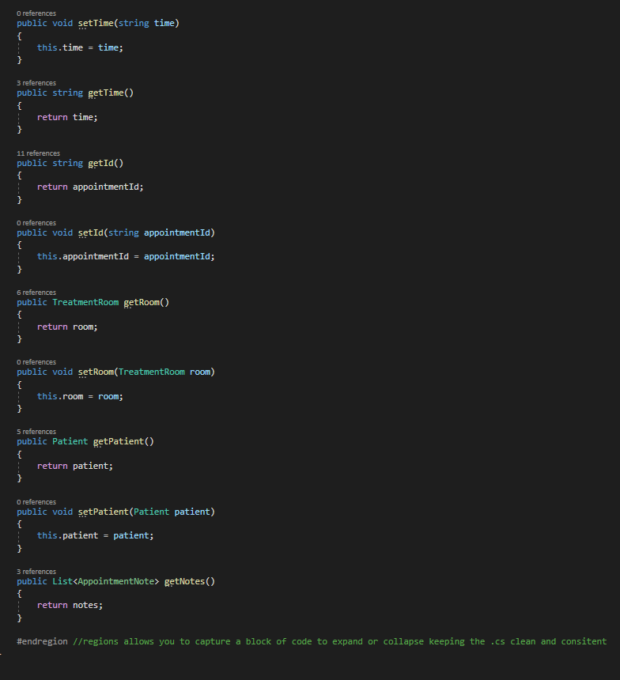

# Prototype functioning –

Admin

Login

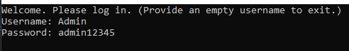

Main menu

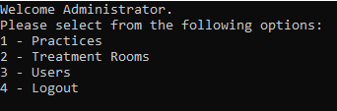

Practices

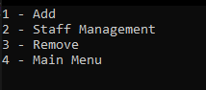

Practice location



Practice address

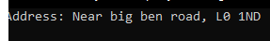

Practice add receptionist



Practice staff manager

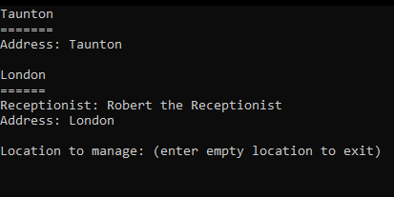

Practice staff manager add receptionist

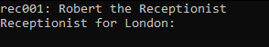

Treatment rooms

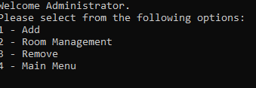

Treatment rooms add

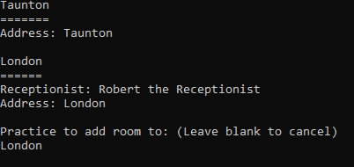

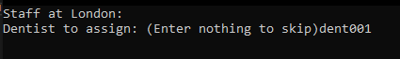

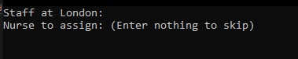

Room management

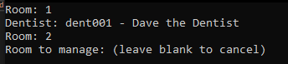

Users

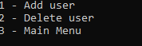

Add user

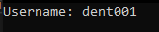





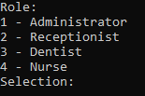



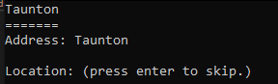

Delete User

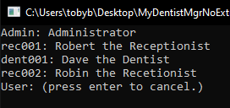

Deleted user

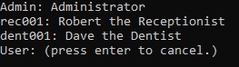

# Testing –

**Data Loading and Login**

Test: Run program

Expected: Login credentials should be requested.

Result 1: Runtime error: Could not find part of path. Forgot to create the actual data directory. Root path was not correctly calculated. (DataIO.cs, ln 16)

Modification 1: Created the Data directory. Modified the root path.

Result 2: Path Format not valid.

Modification 2: Added a break point on DataIO.cs at line 37. (Directory.GetDirectories(practicePath))

Result 3: Discovered that / should be \ in paths.

Modification 3: Changed all / in paths names to \.

Result 4: Working

Test: Provide invalid username/password

Expected: System will not allow login and request details again.

Result 1: Working

Test: Provide valid username/password.

Expected: System will login user and display their name and user type.

Result 1: Prevented login and stated credentials are invalid.

Modification 1: When creating new user objects, the username was baring set to the path of the user file meaning checking for a valid username was failing. This is now set to the username.

Result 2: Working

**Menu Navigation**

Admin

Test: Login as admin.

Expected: Admin menu to be displayed.

Result 1: Worked

Test: Select user menu.

Expected: User menu will be displayed.

Result 1: worked

Test: Select add user

Expected: User will be taken through the user adding steps.

Result 1: Location was printing receptionist objects rather than their name.

Modification: When printing locations in the DataPrinting.printPractices function, needed to get the name of the receptionist from the receptionist object.

Result 2: Error when saving user with no practice.

Modification: Performs a check when saving a user with no practice. Writes a blank line to file when not present

Result 3: works.

Test: Delete a user

Expected: All users will be printed, and user prompted for a user to remove.

Result 1: index error DataPrinting.printUsers.

Modification: Added check for practice before attempting to print it. Indexing when printing variables skipped an index ({0}: {2} instead of {0}: {1})

Result 2: works

Test: View Practice Menu.

Expected: Practice menu will be displayed.

Result 1: Worked

Test: Add a practice.

Expected: user will be prompted for new practice info.

Result 1: Error when creating due to searching for room directory before its created.

Modification: When loadPractices is called, added a check to see if the Room directory exists.

Test: Manage Practices

Expected: User to be prompted for a location to manage. List of locations should also be available.

Result: Worked

Test: Select practice

Expected: User will be given a list of all receptionists.

Result: worked

Test: Select receptionist.

Expected: When blank should cancel when user does not exist, user will be prompted again, when valid user should be taken back to the location to manage prompt.

Result: worked

Test: Add Room

Expected: User will be asked for a location and then given the option to assign staff to room.

Result: worked

Test: Enter information

Expected: Dentist and nurse for room should be optional to add. Changes will be reflected in room manager.

Result: worked

Test: Manage room

Expected: user will be given list of locations to manage rooms at. once a location is selected, available rooms will be displayed.

Result: worked

Test: Remove room

Expected: user will be requested for a location to remove a room from. once selected, list of available rooms will be printed.

Result: worked

Test: Choose room

Expected: The selected room will be removed, and room numbers re-ordered. (so, when there are 3 rooms and number 2 is deleted, number 3 will become number 2)

Result: Worked

**Users:**

Test: Patient mgmt.

Expected: Patient menu should be displayed.

Result: Works

Test: Add patient

Expected: user will be prompted for patient info and patient will be added.

Result: Works

Test: Remove patient

Expected: Patient will be deleted.

Result: Works

Test: Create Appointment

Expected: User will be able to create an appointment.

Result 1: Requested for a day twice and error on creation of date

Modification1: removed the random extra line requesting a day twice from GeneralFunctions.getDateTimeInput().

Result 2: worked

Test: Remove Appointment

Expected: User to select a patient to remove an appointment for. Appointments to be displayed and user to select appointment to remove.

Result 1: Error when fetching files.

Modification: when saving appointments, file path was using the patient name rather than ID. Fetching failed.

Result 2: appointments were not initialised in the patient class. This caused an error when attempting to print the available appointments.

Modification: Initialised the appointment list.

# Final Program code -

## Program.cs

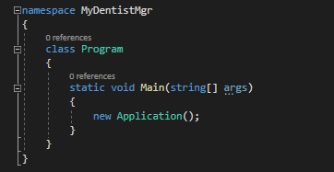

## Application.cs

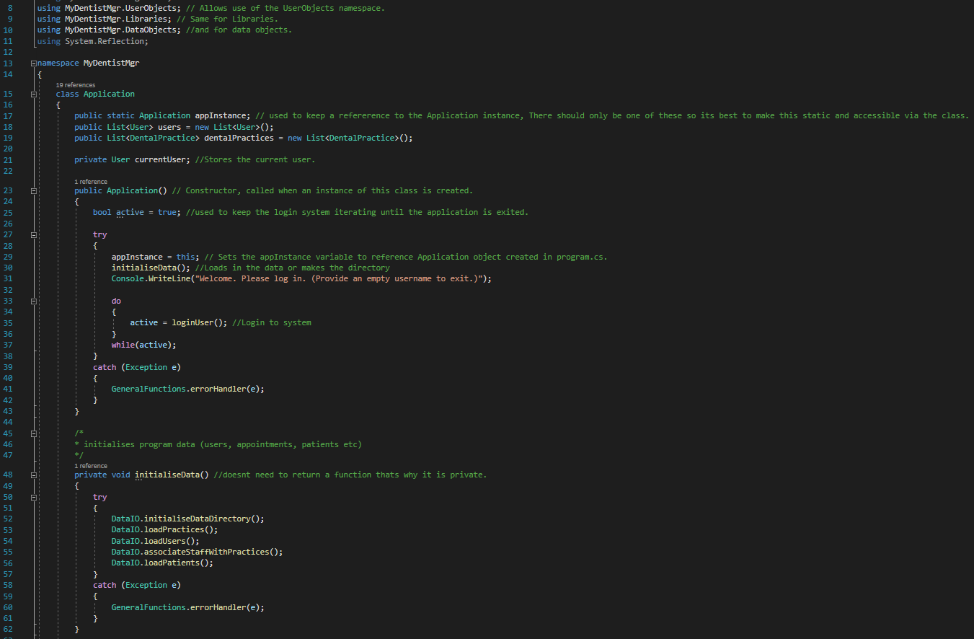

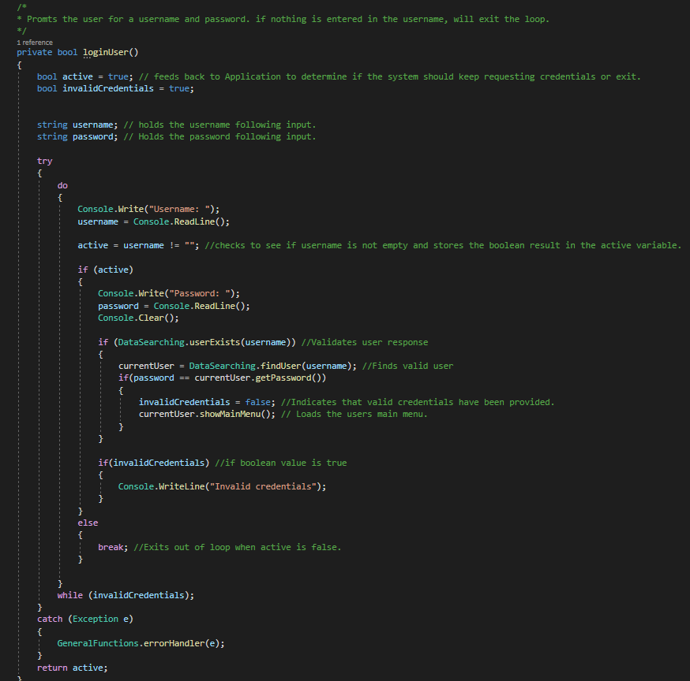

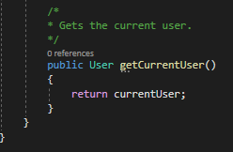

## User.cs

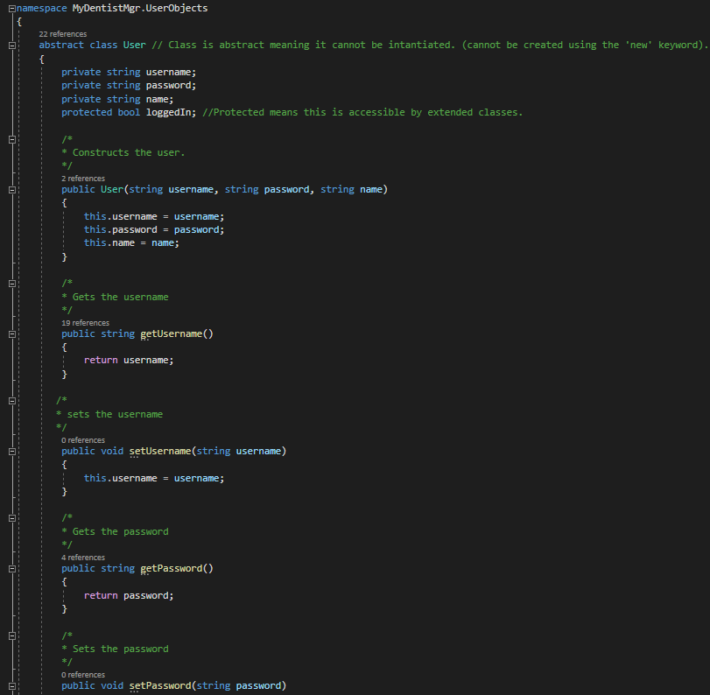

## Staff.cs

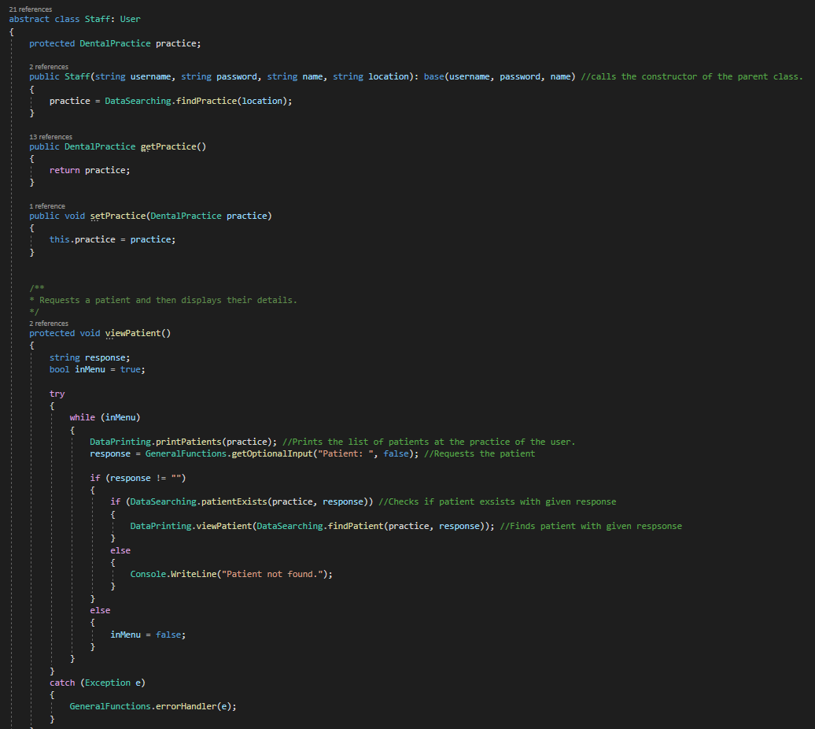

## Receptionist.cs

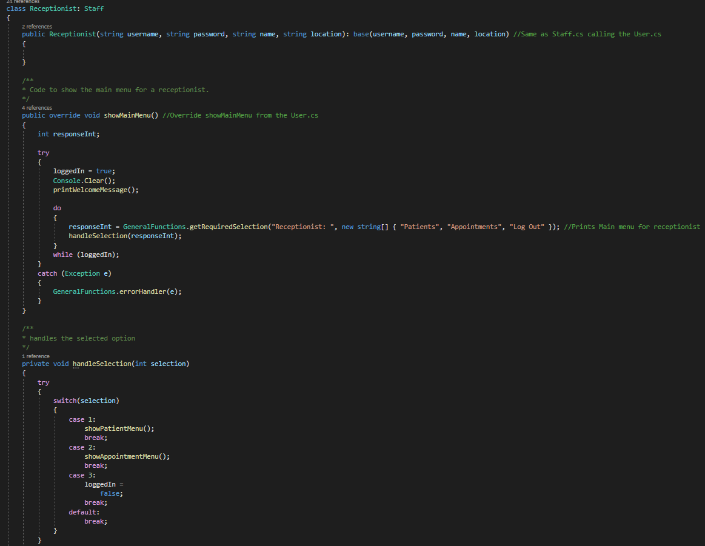

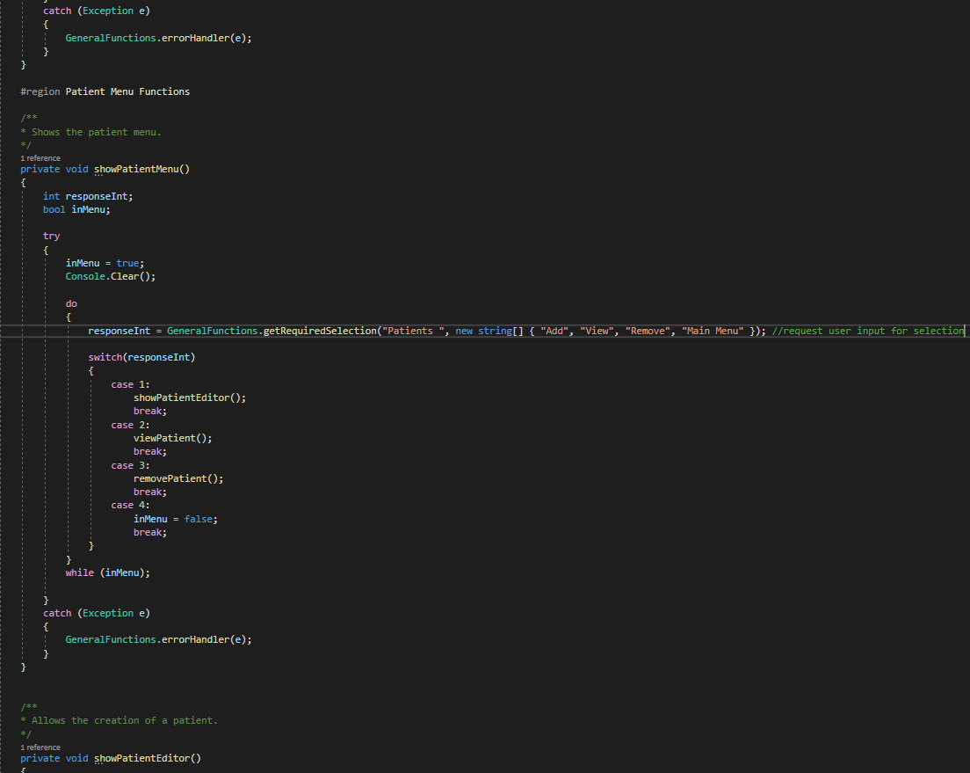

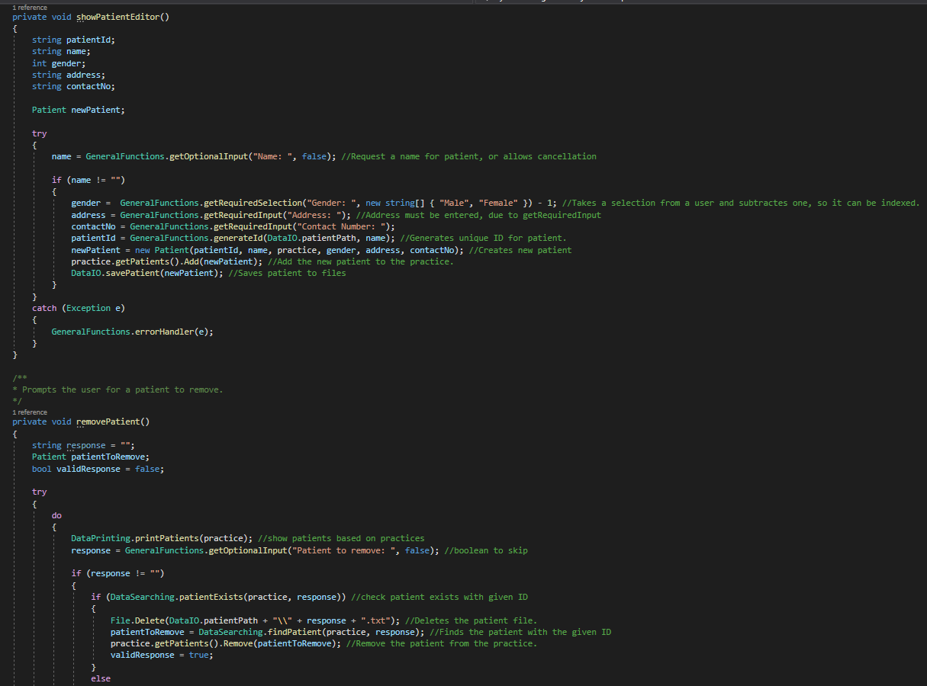

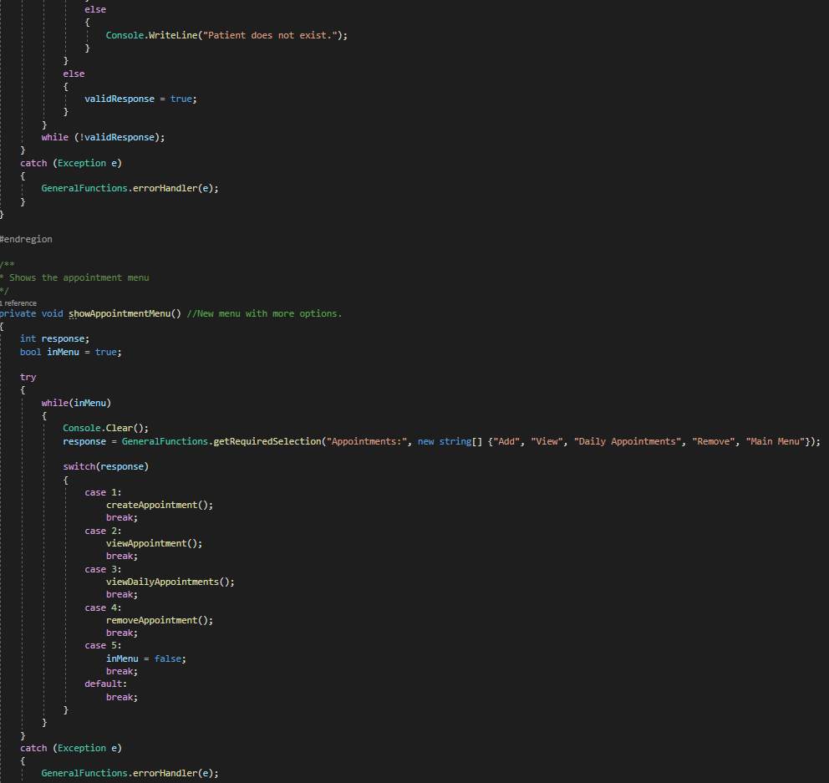

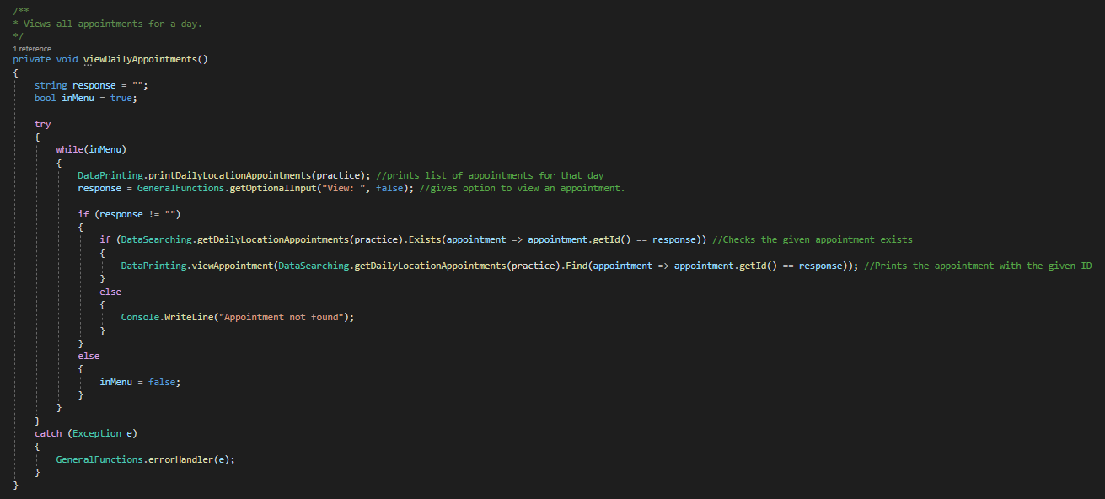

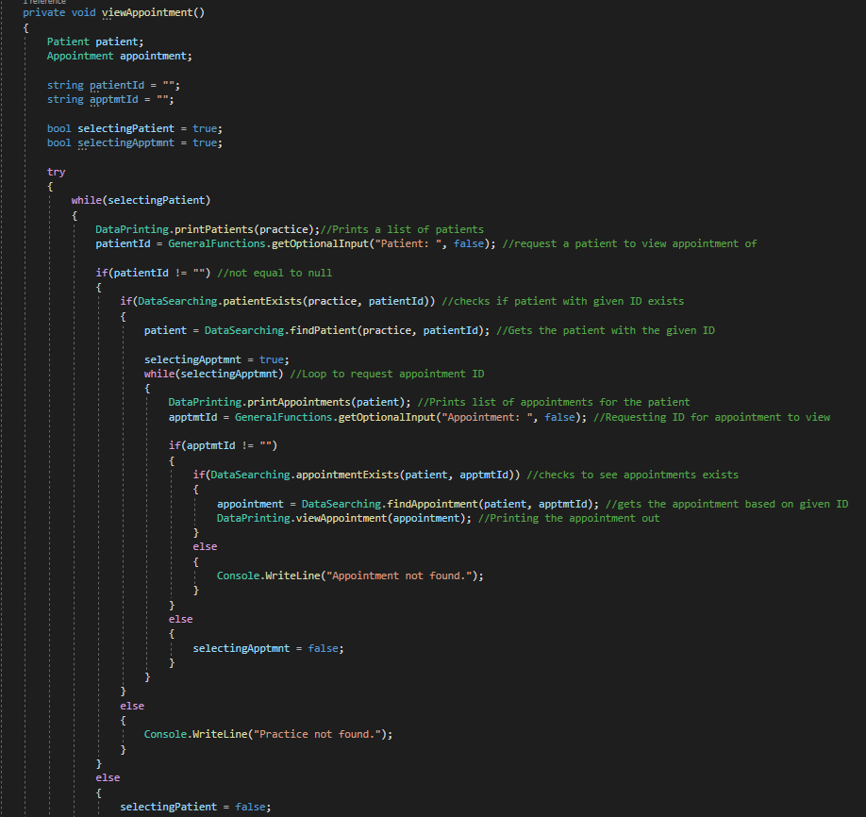

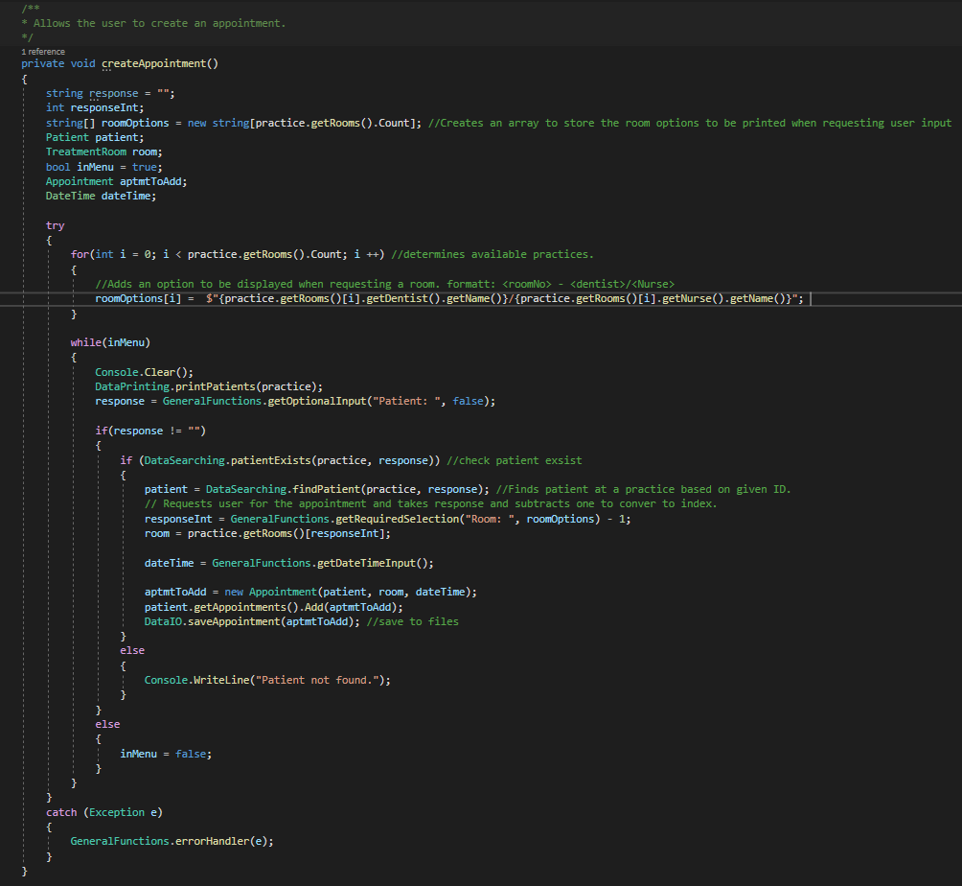

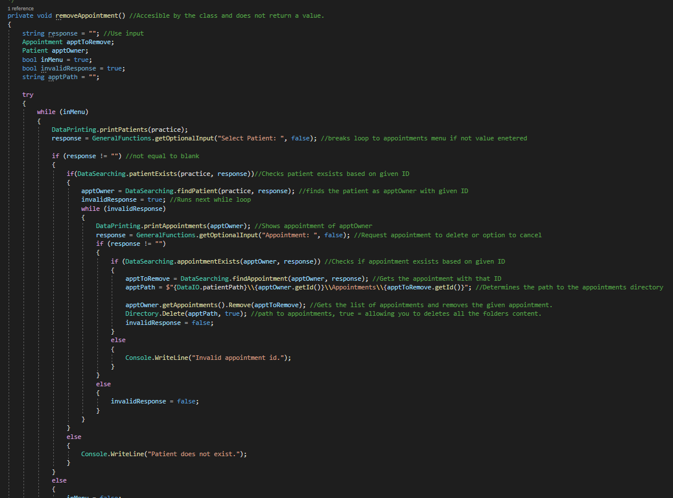

## DentistNurse.cs

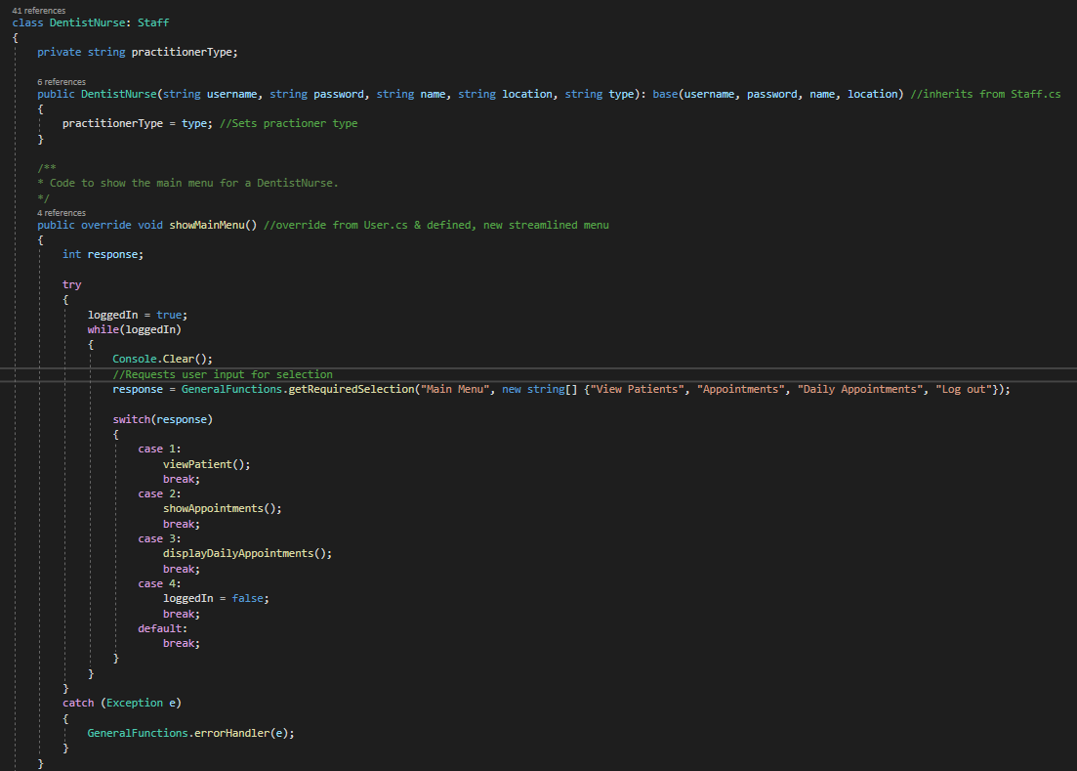

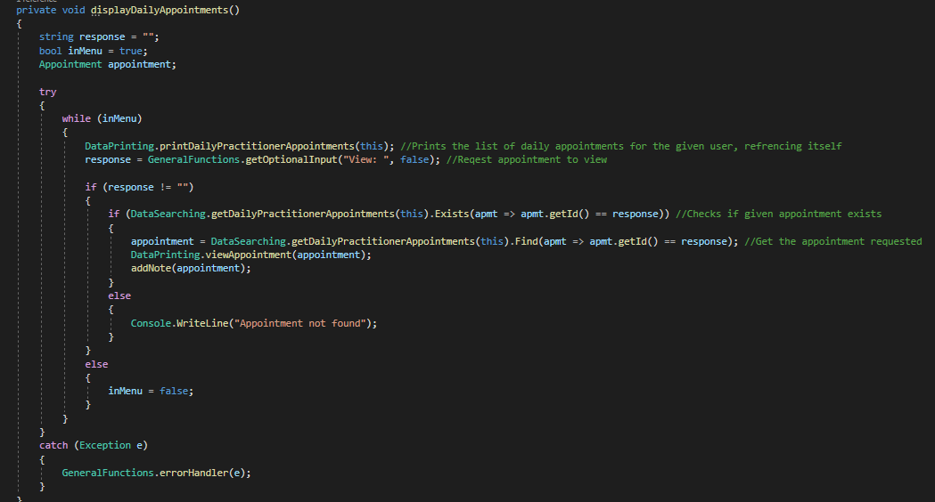

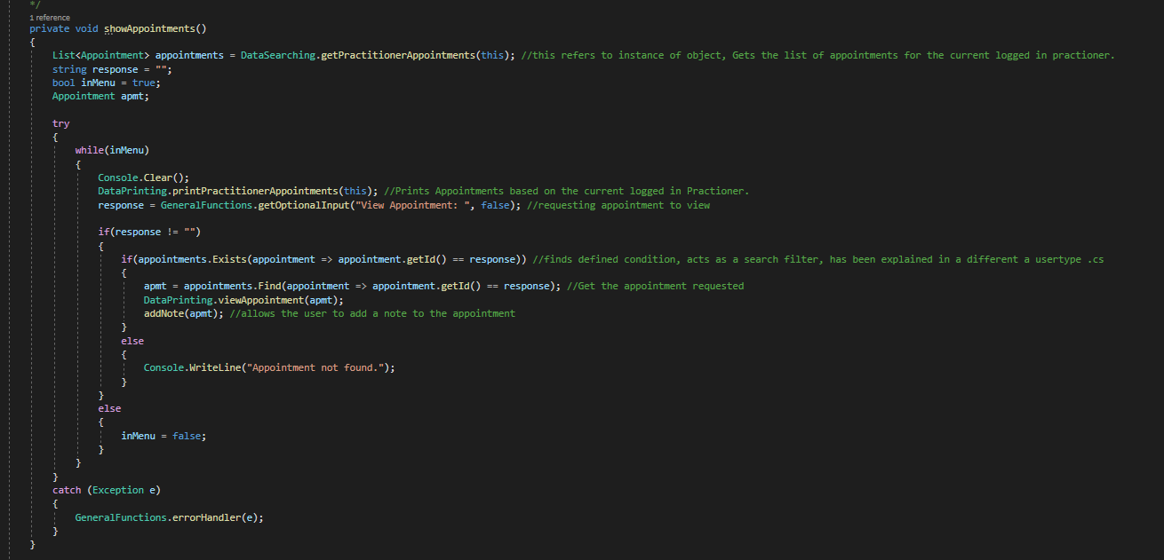

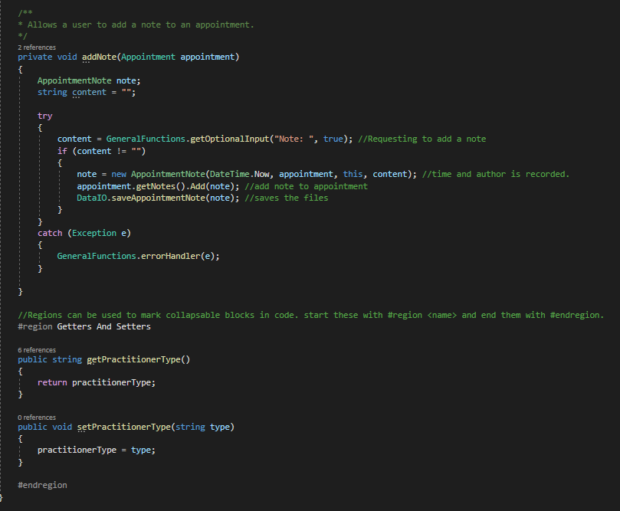

## Administrator.cs

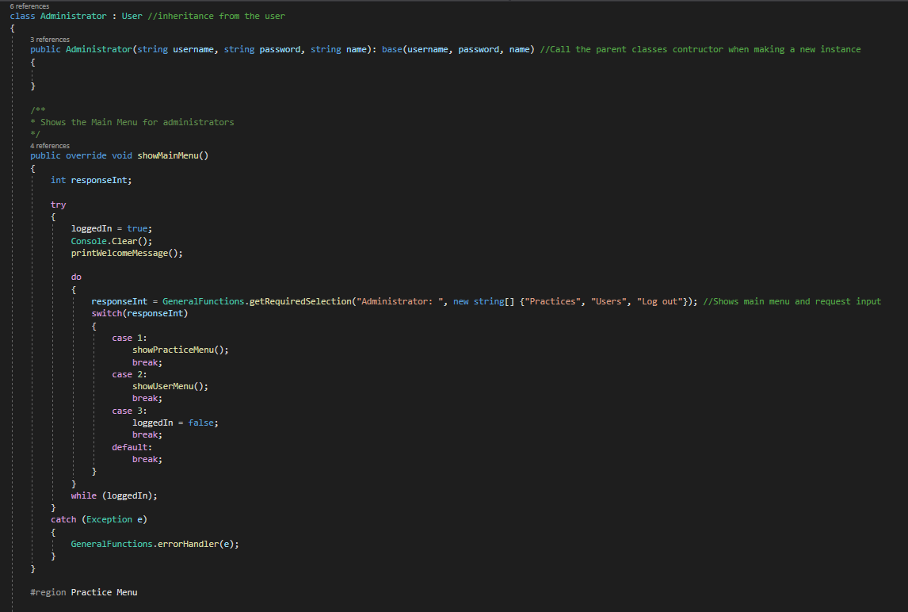

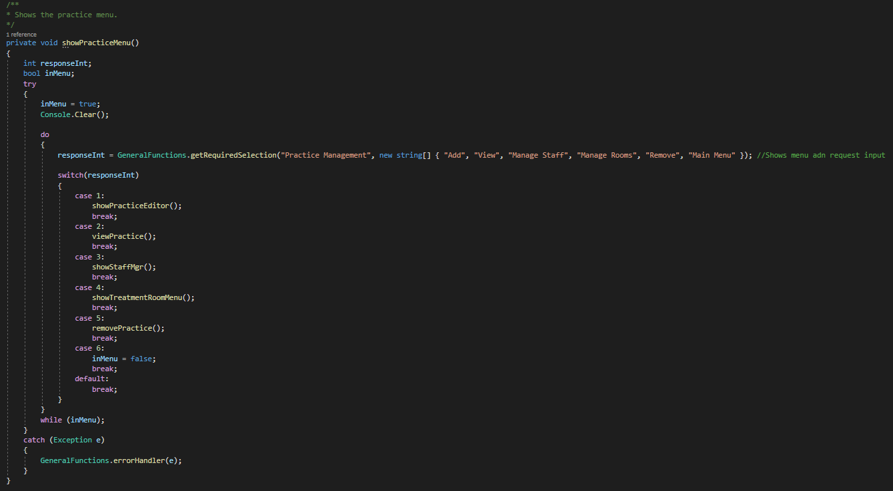

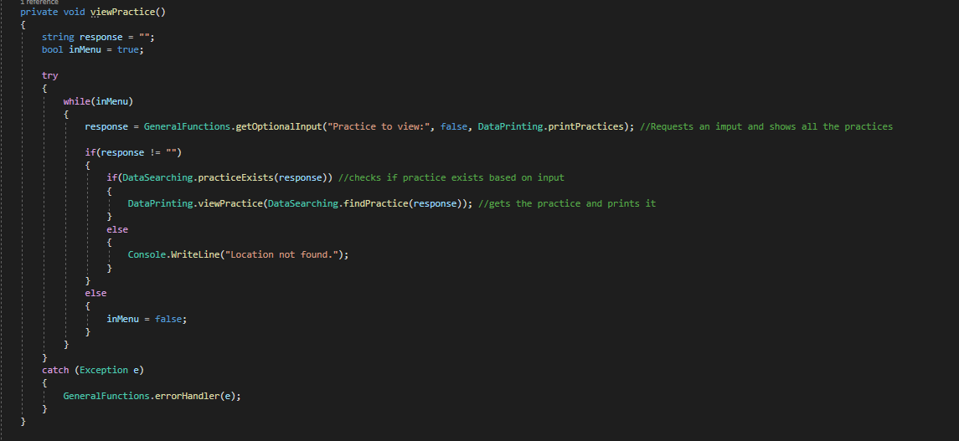

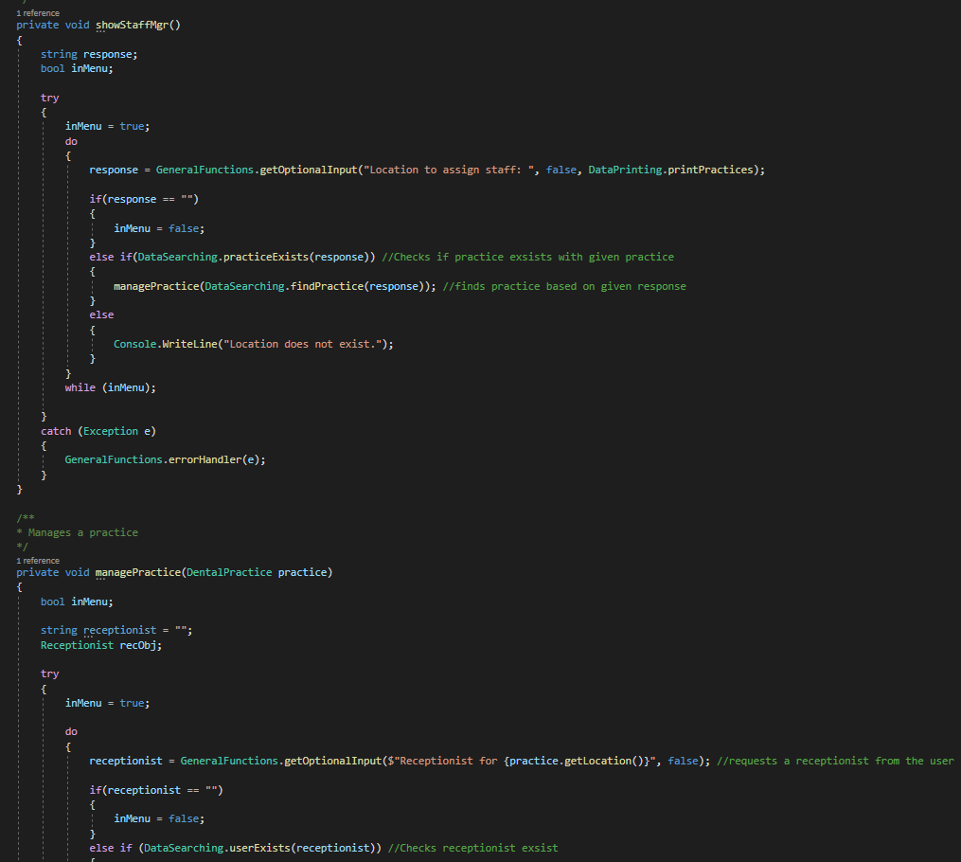

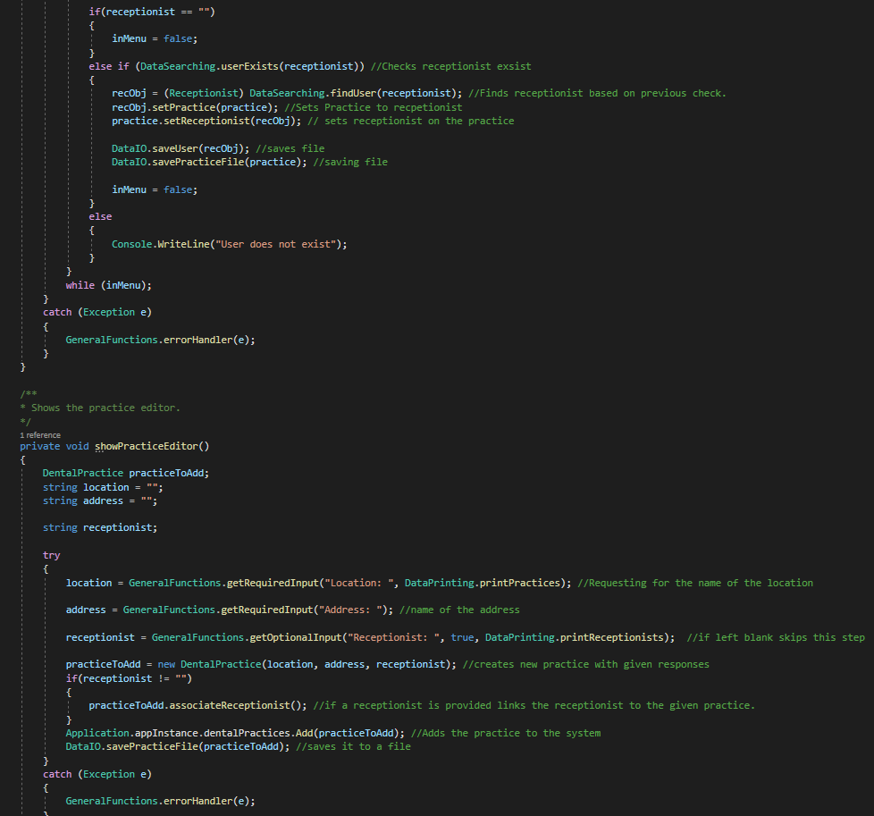

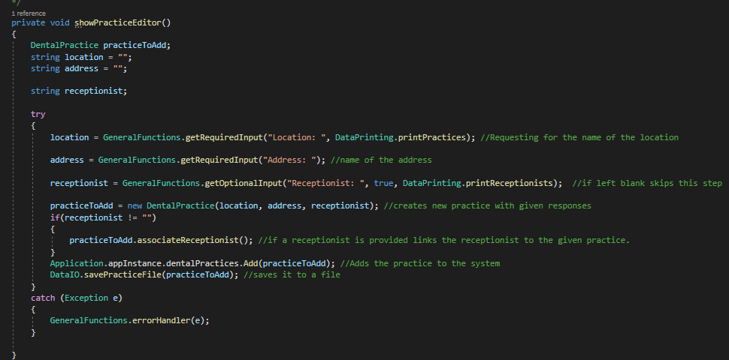

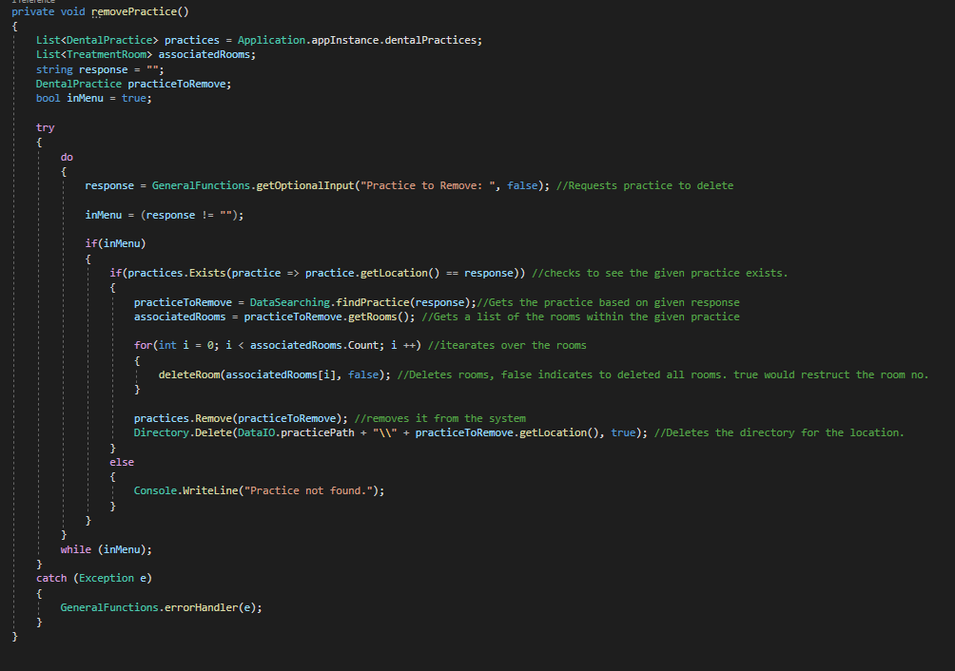

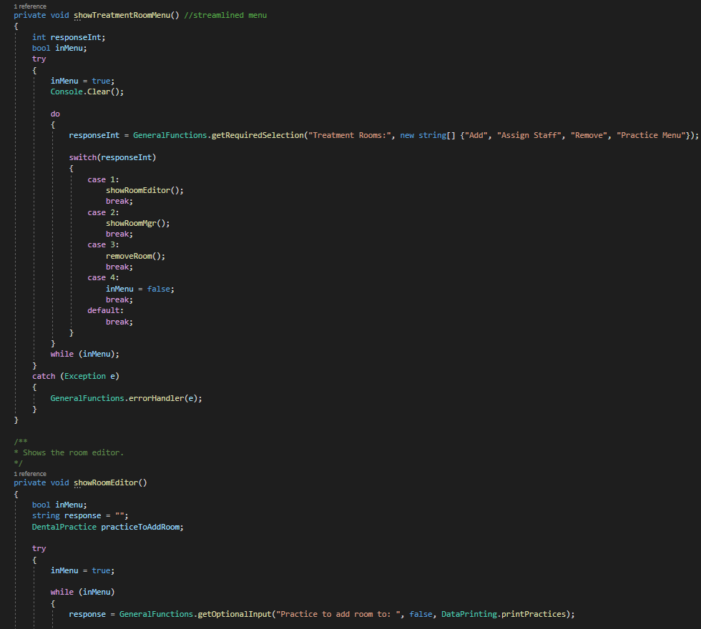

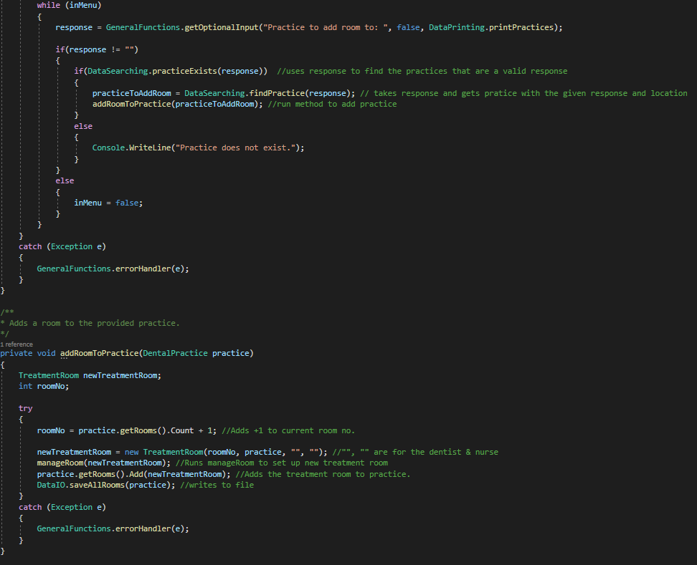

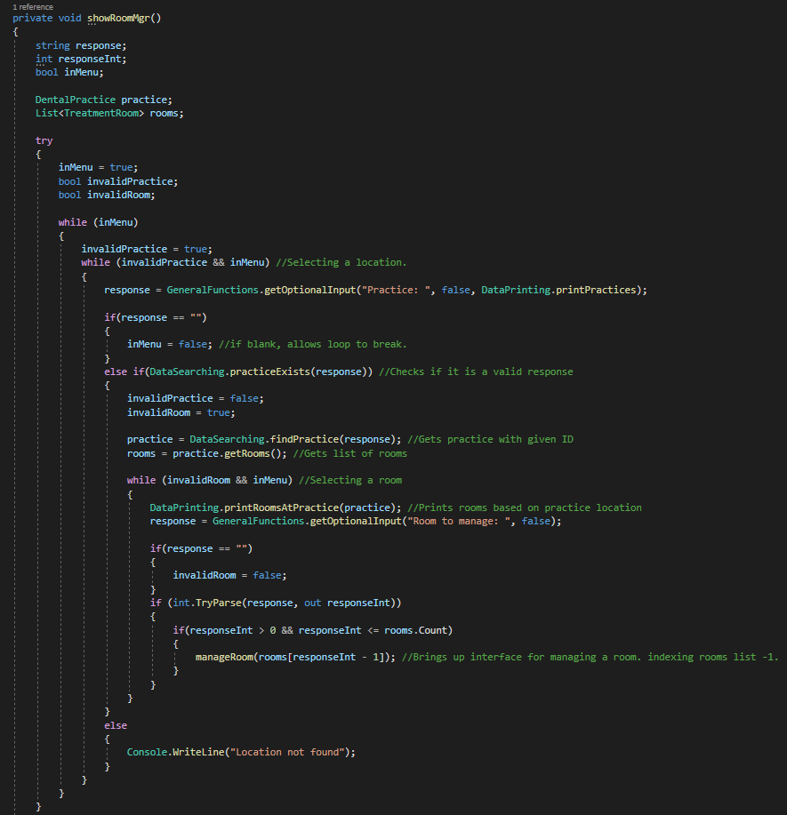

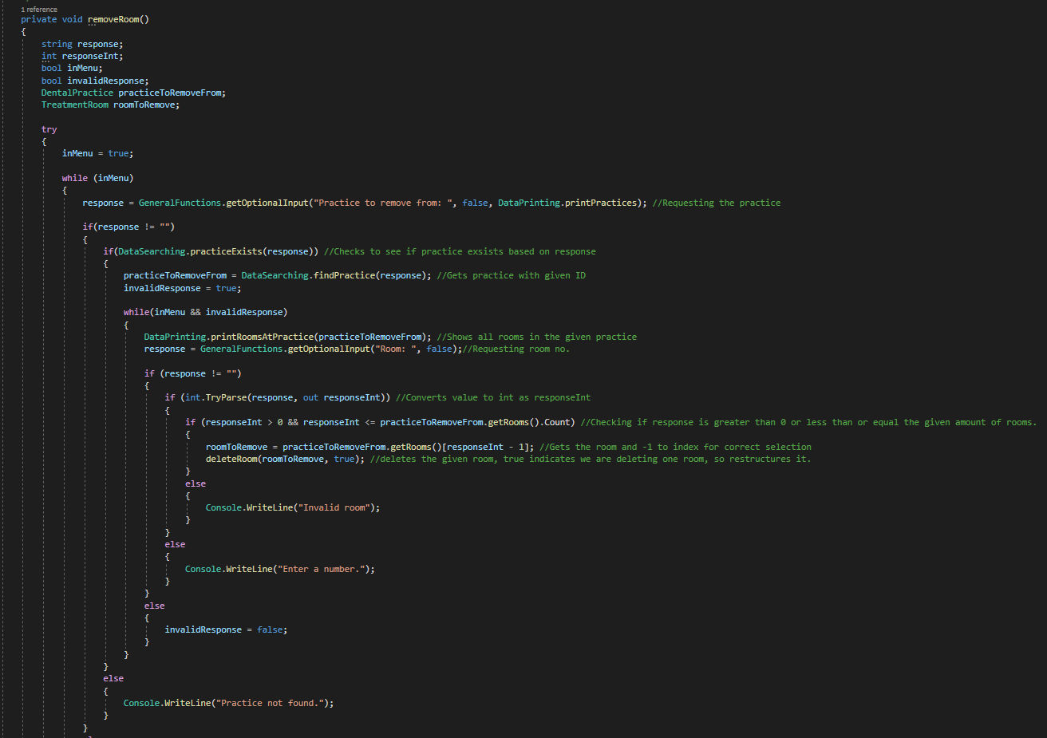

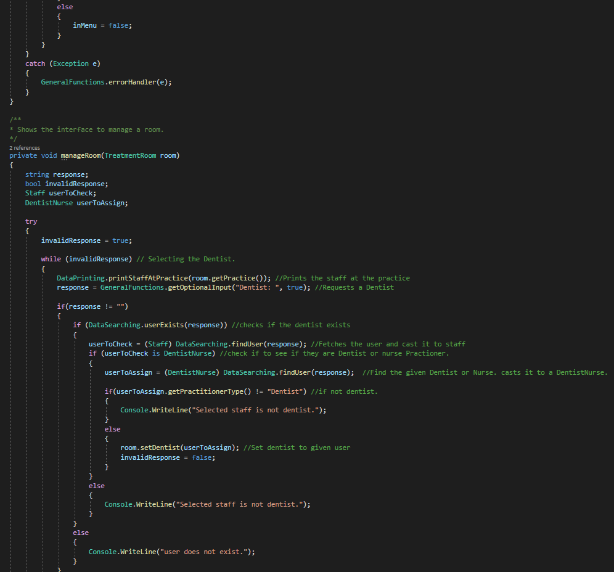

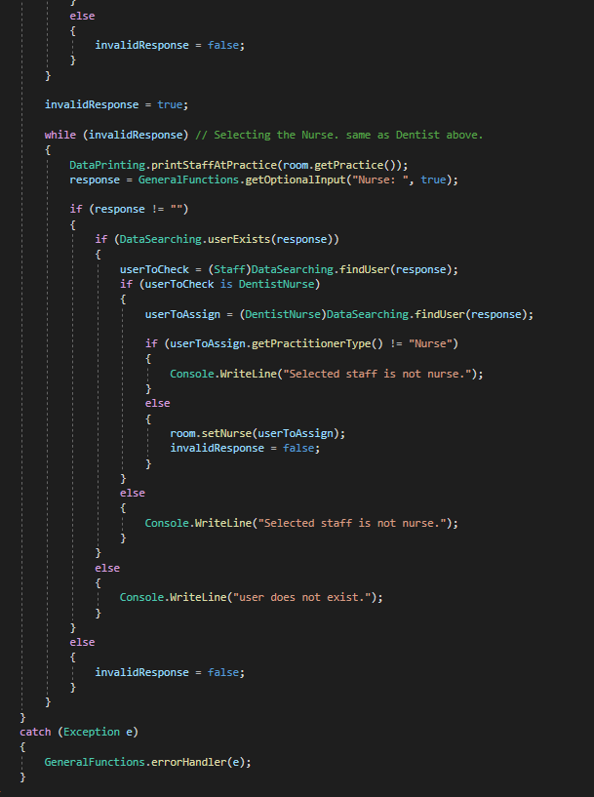

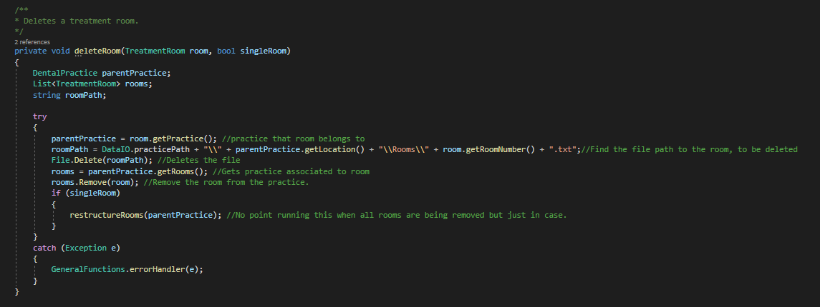

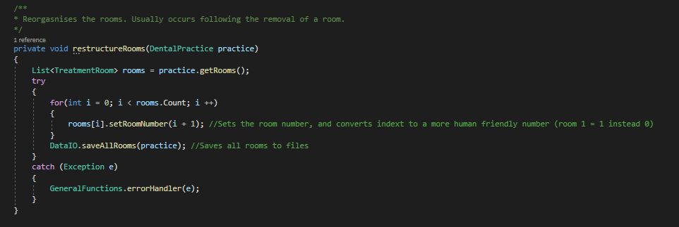

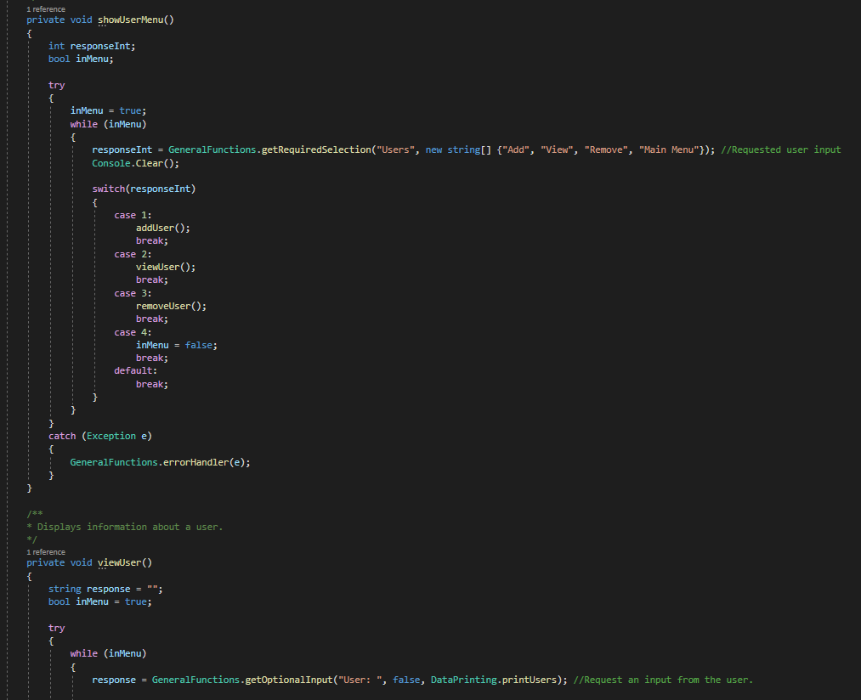

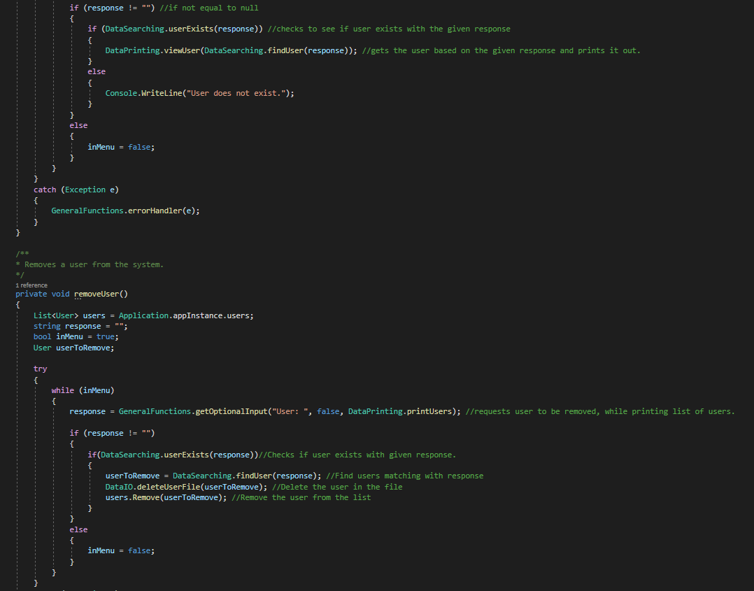

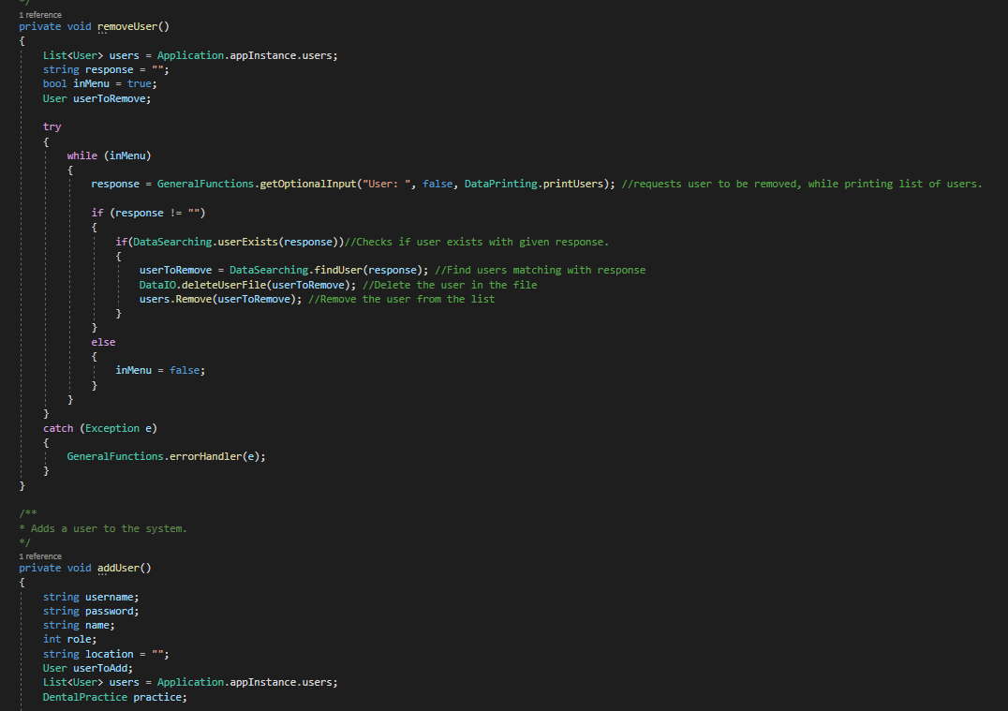

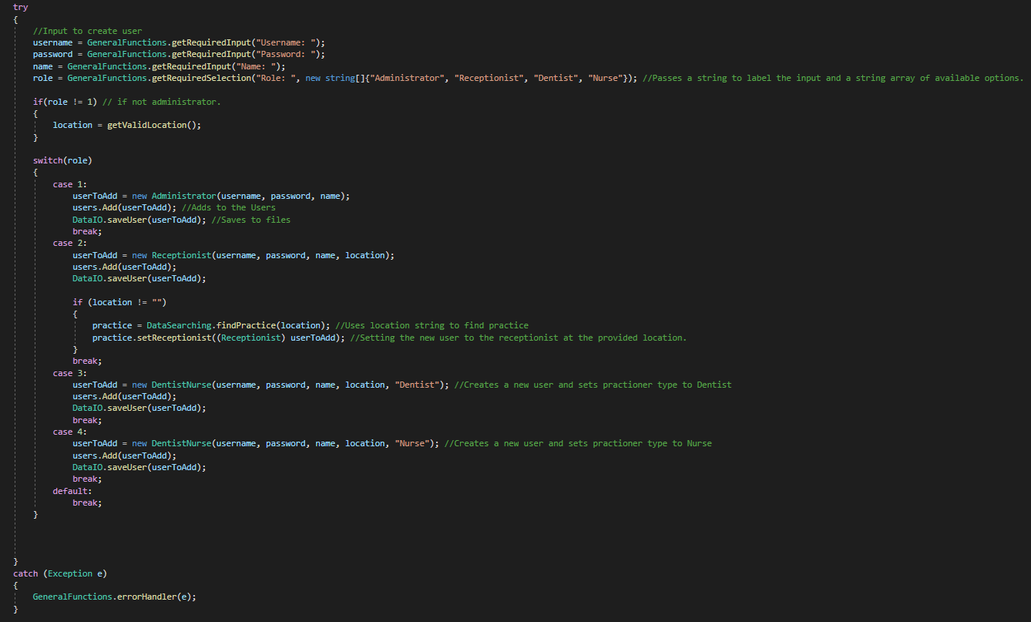

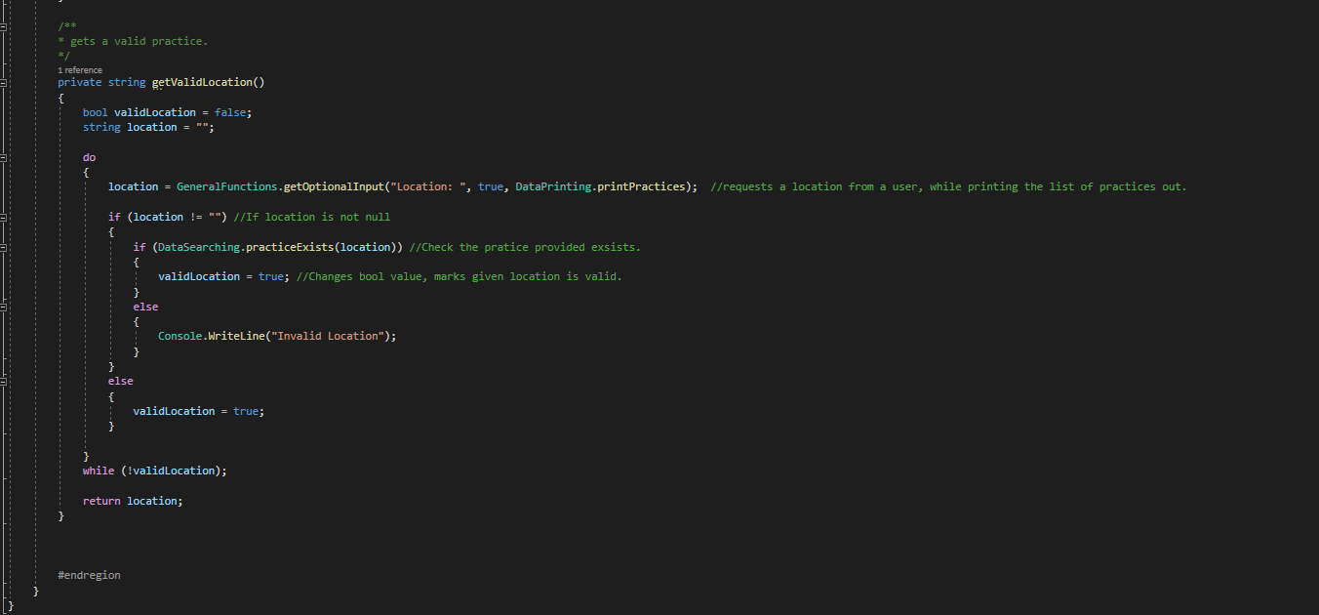

## GeneralFunction.cs

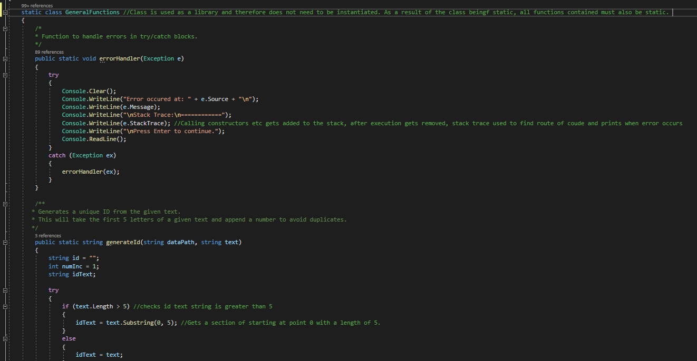

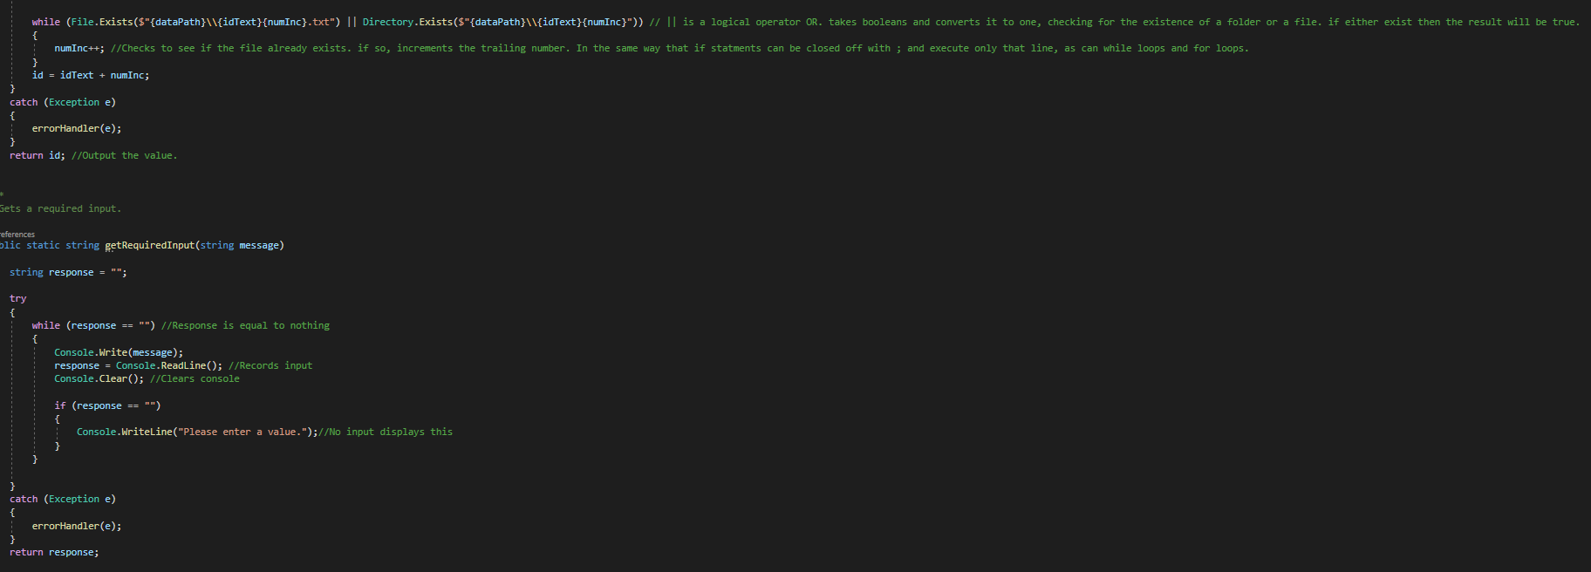

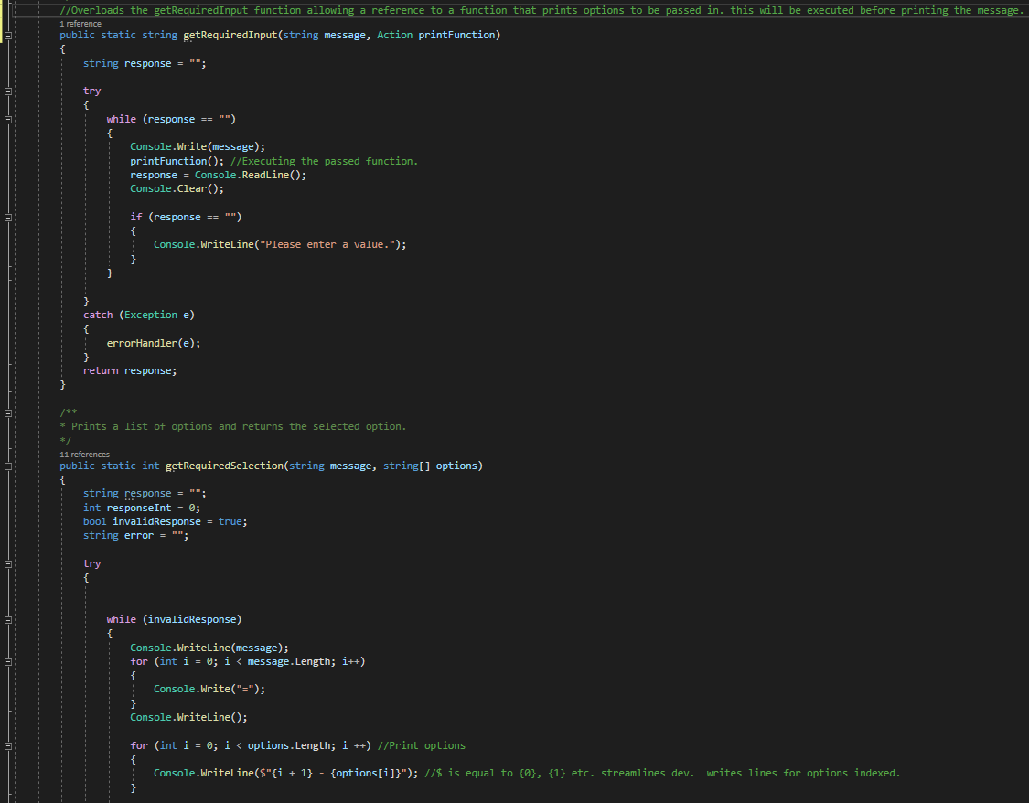

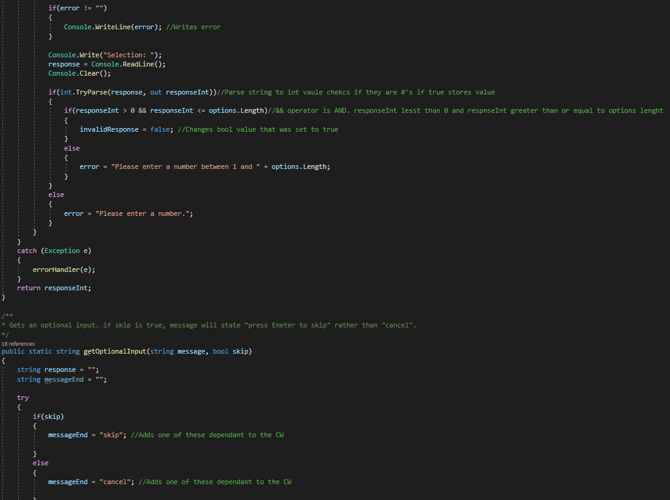

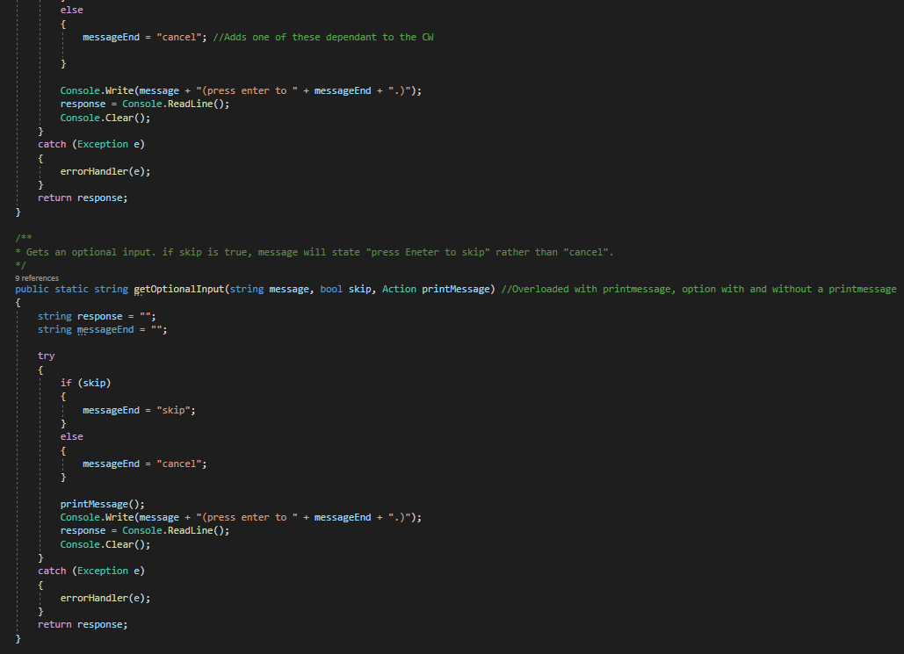

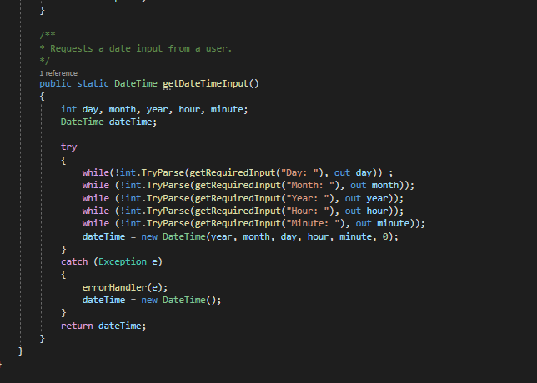

## DataSearching.cs

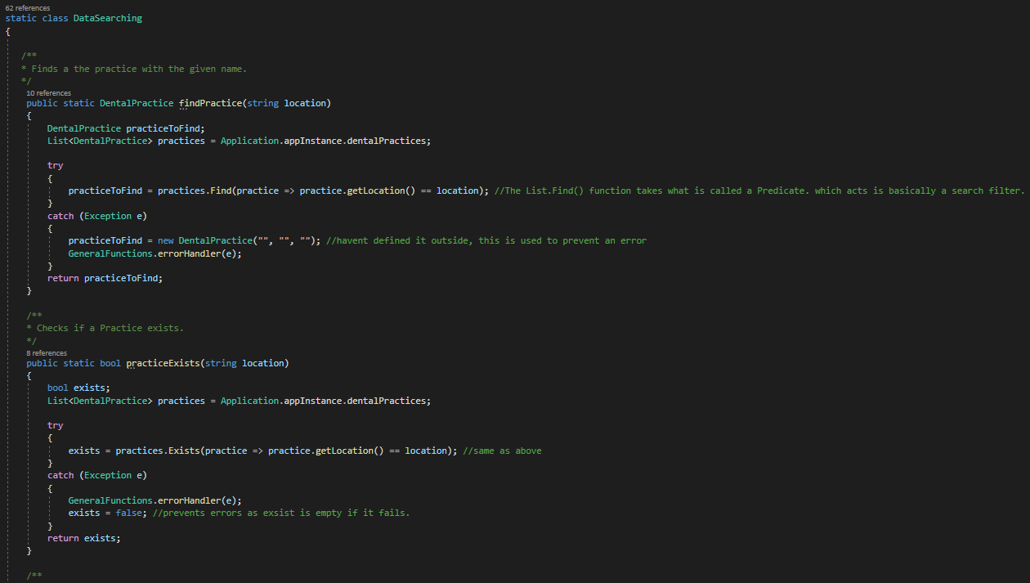

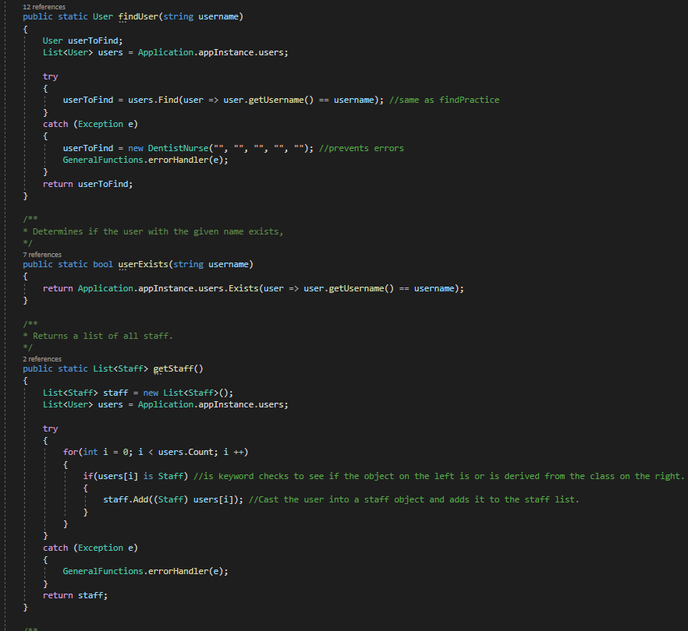

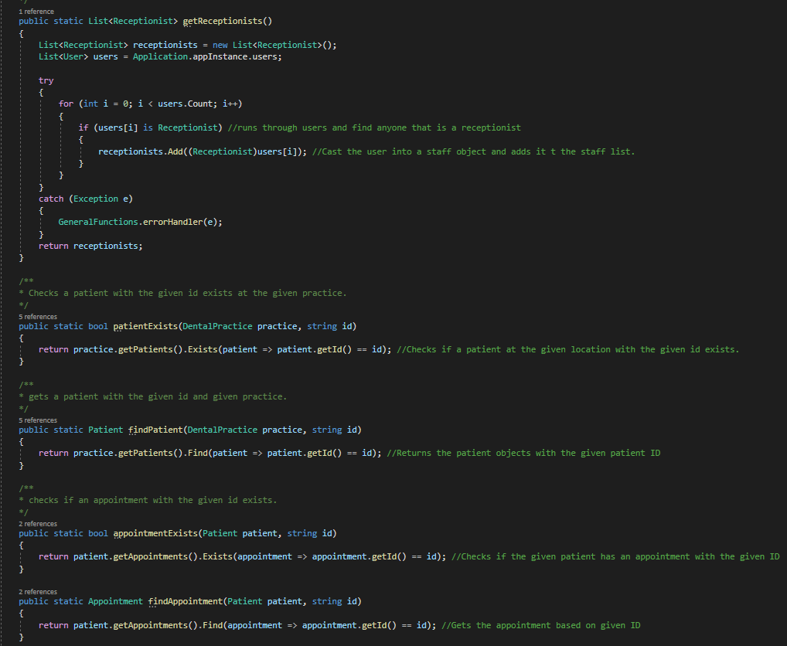

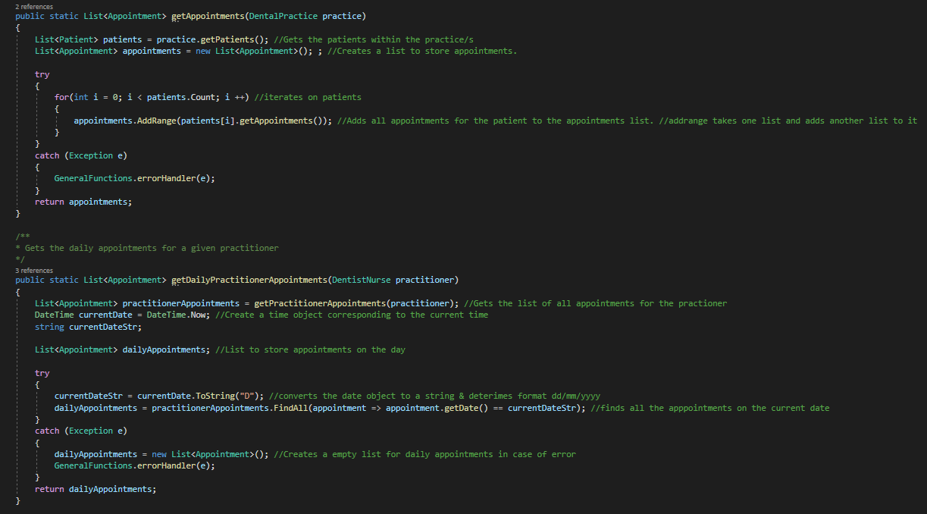

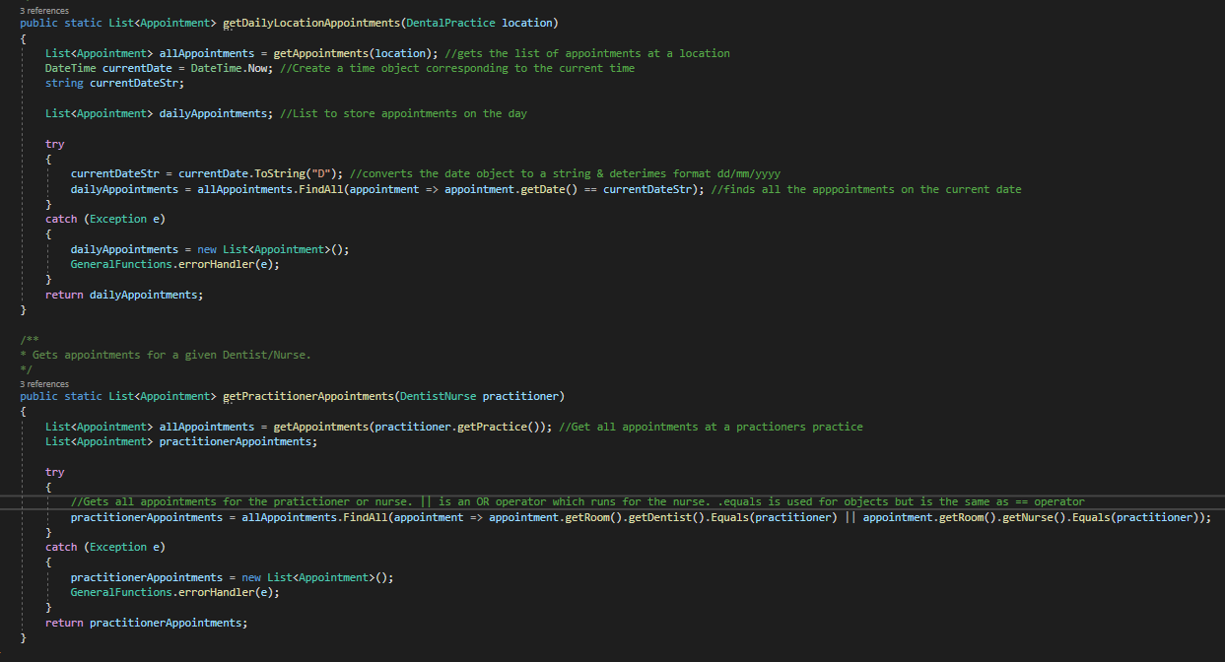

## DataPrinting.cs

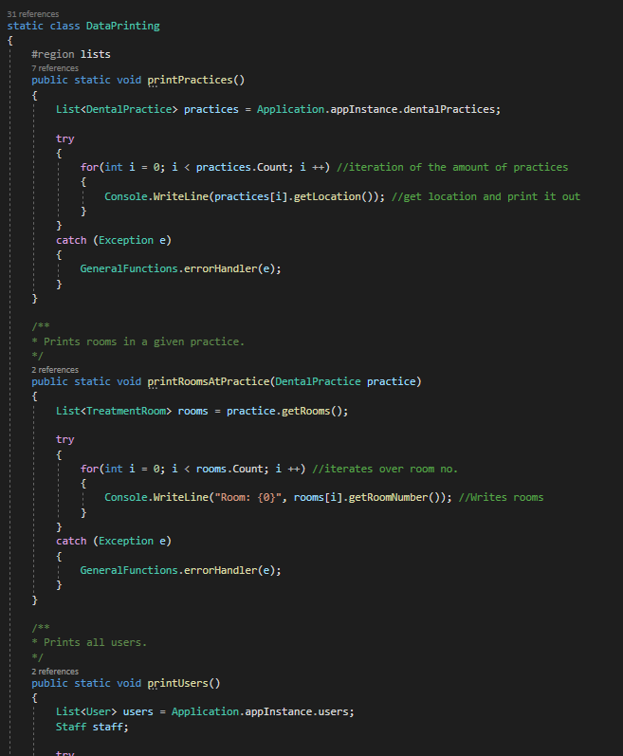

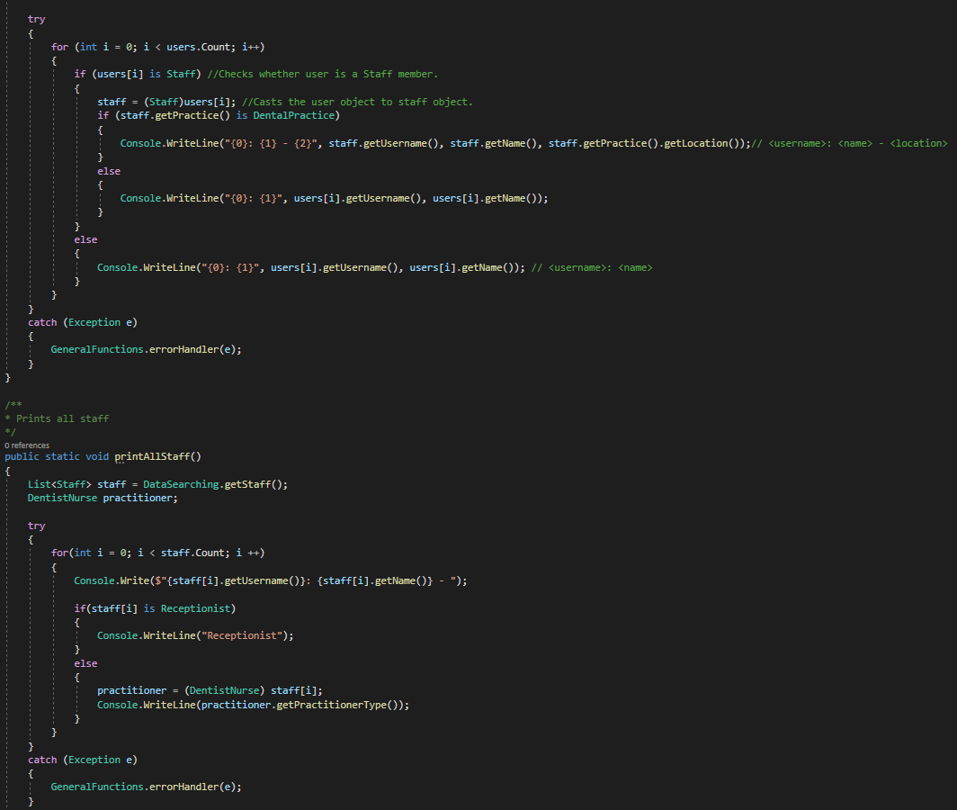

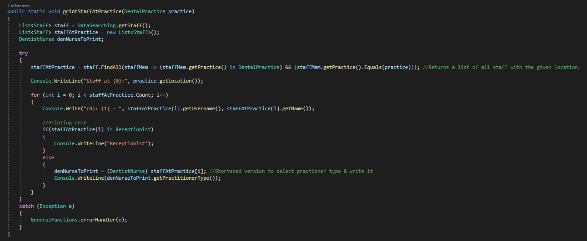

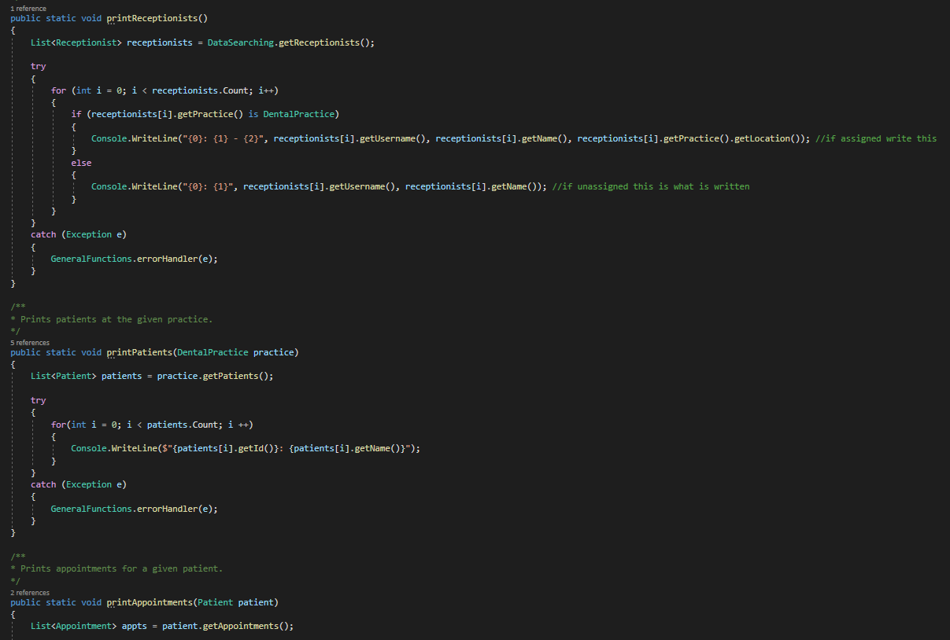

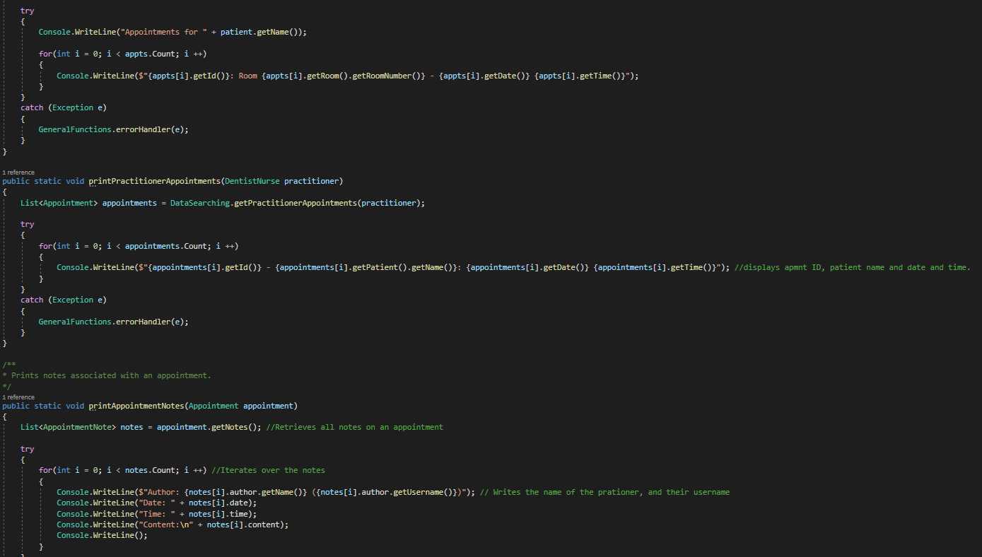

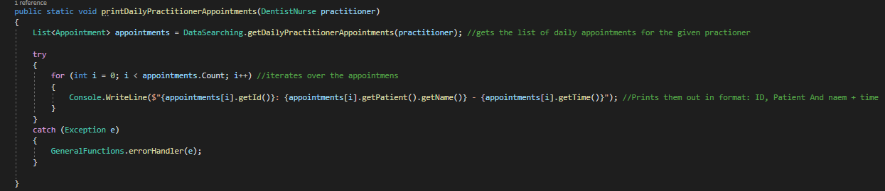

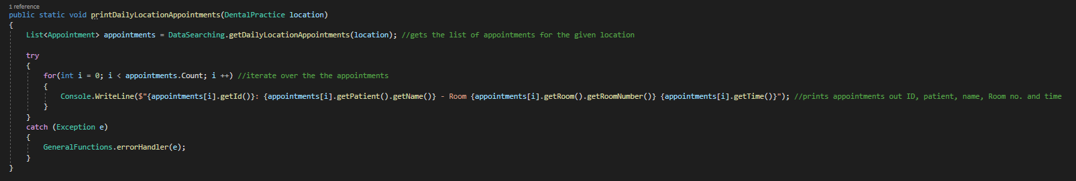

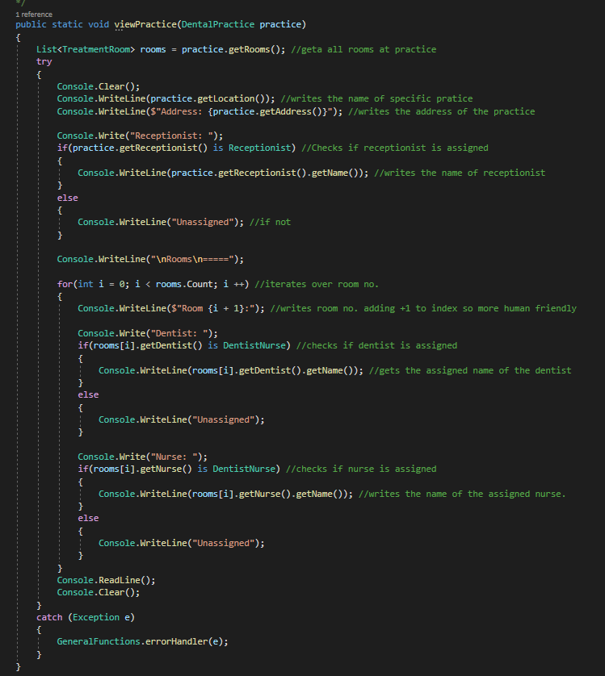

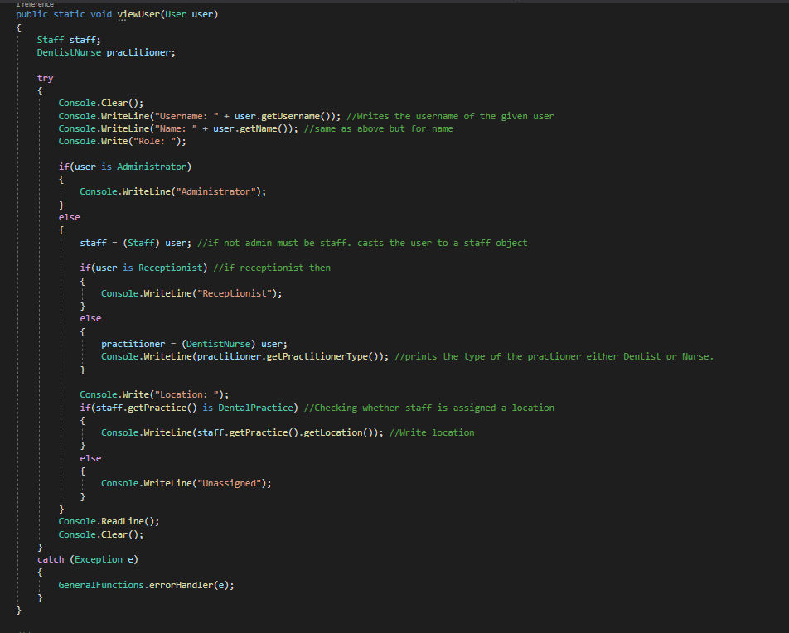

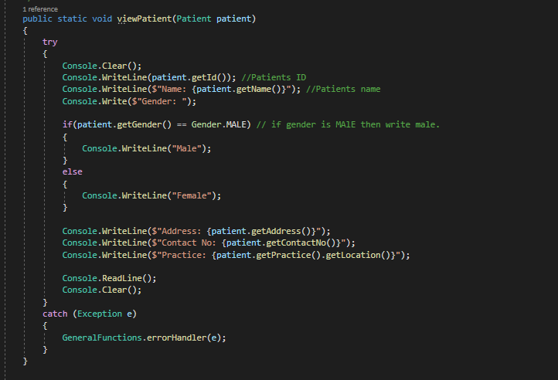

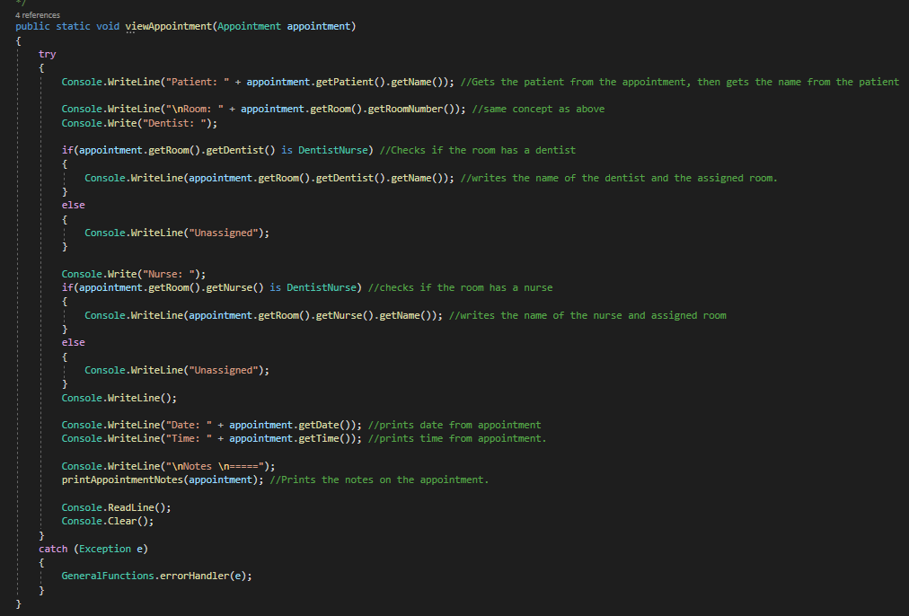

## DataIO.cs

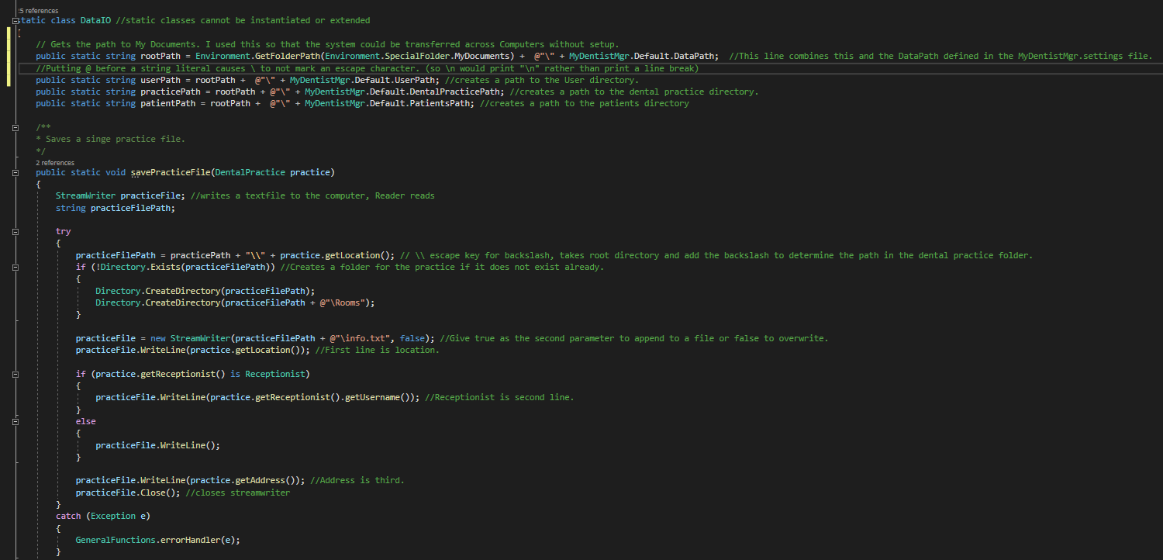

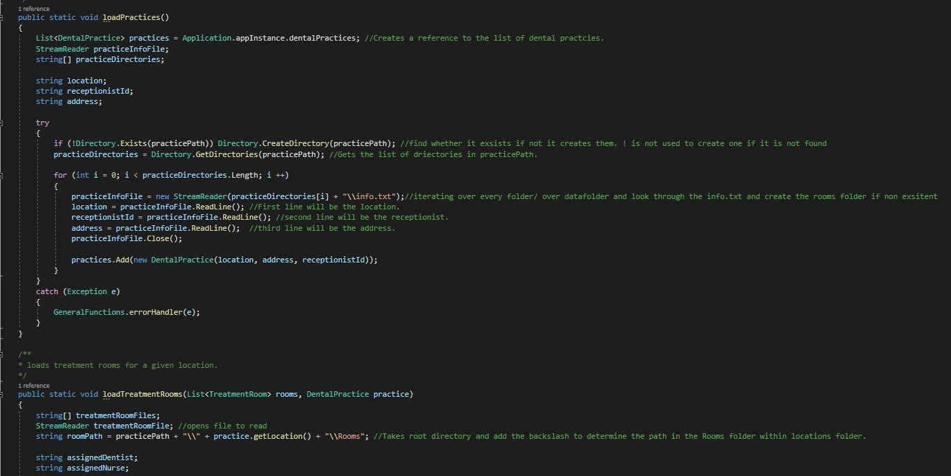

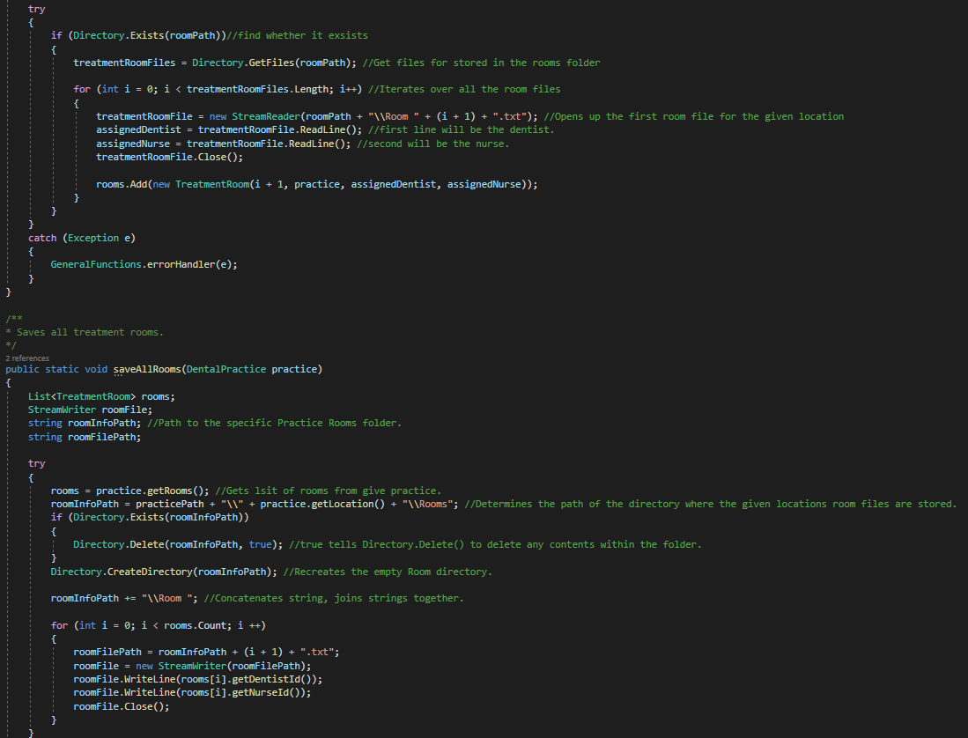

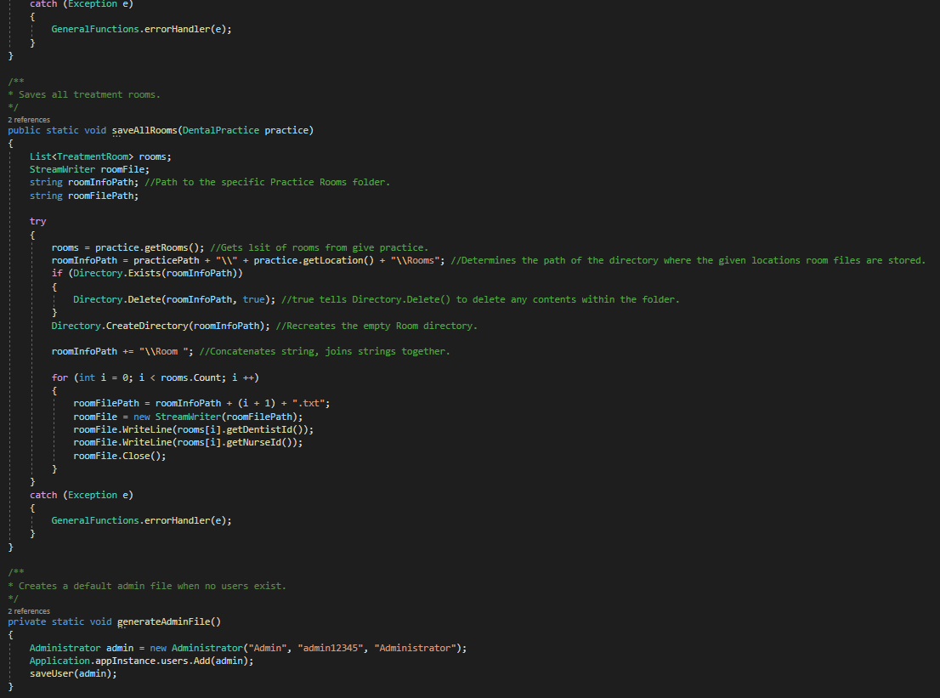

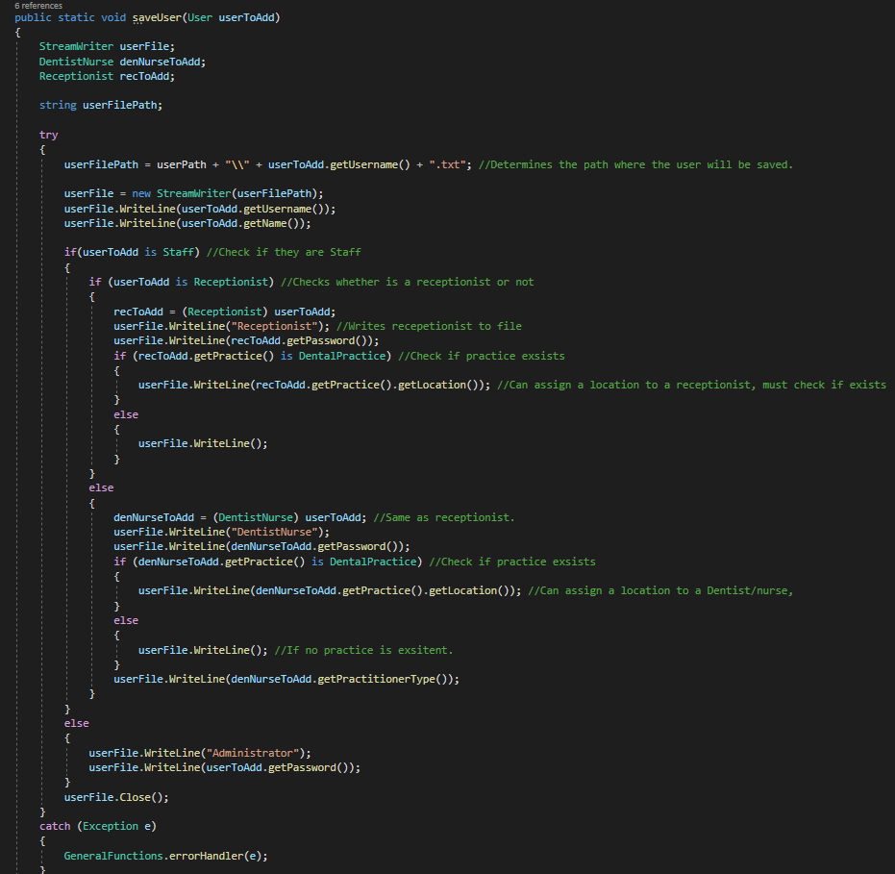

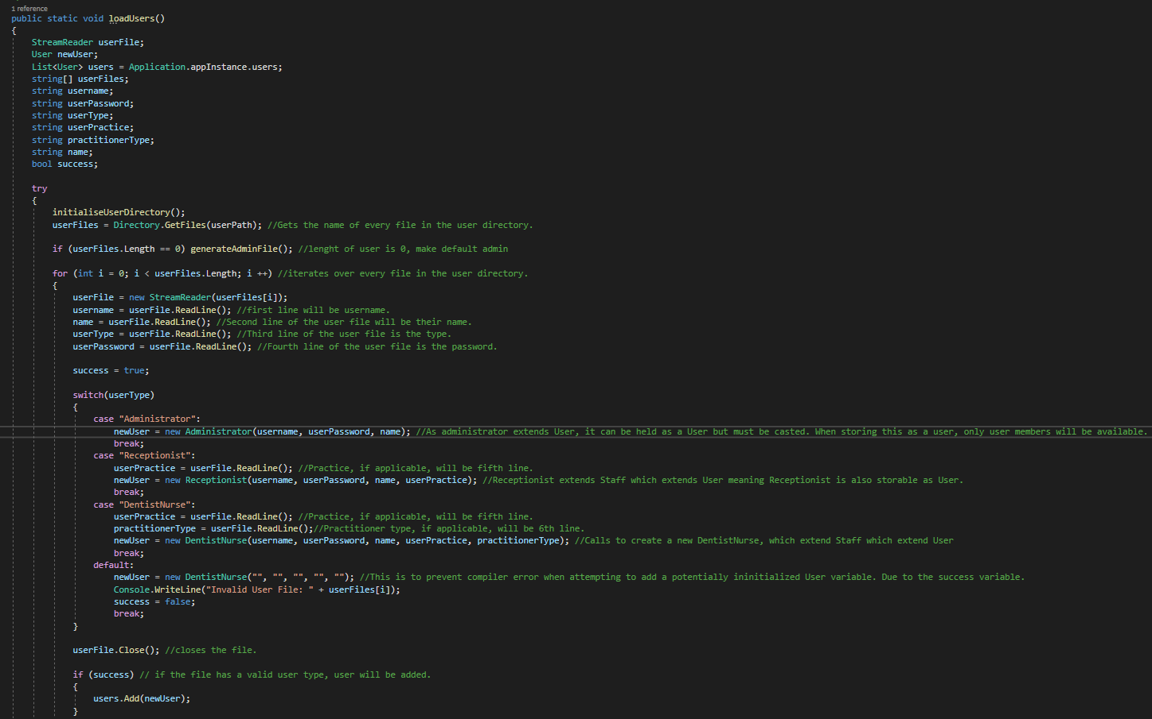

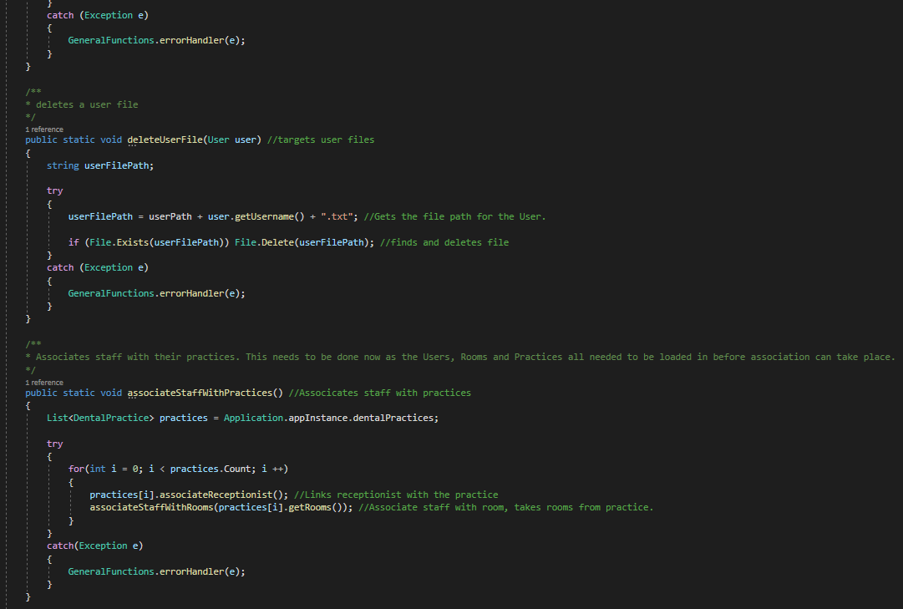

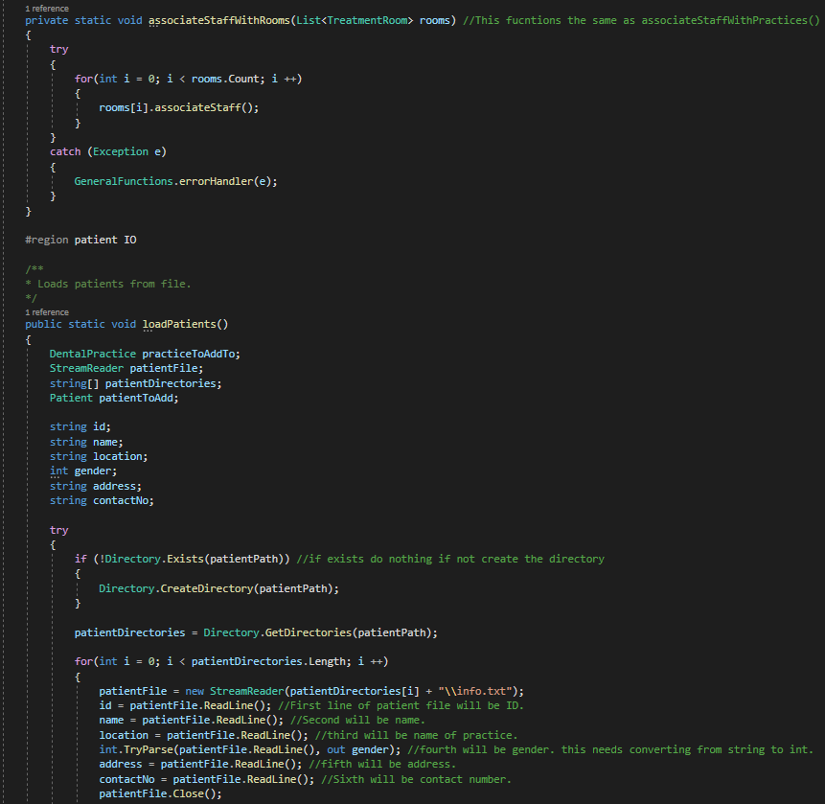

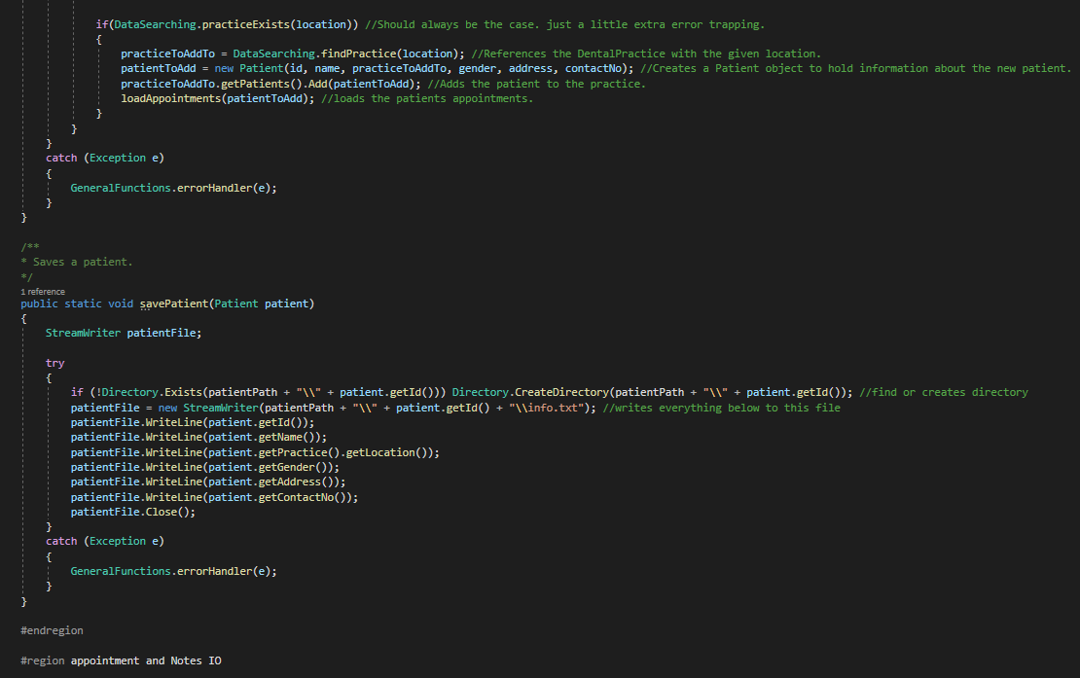

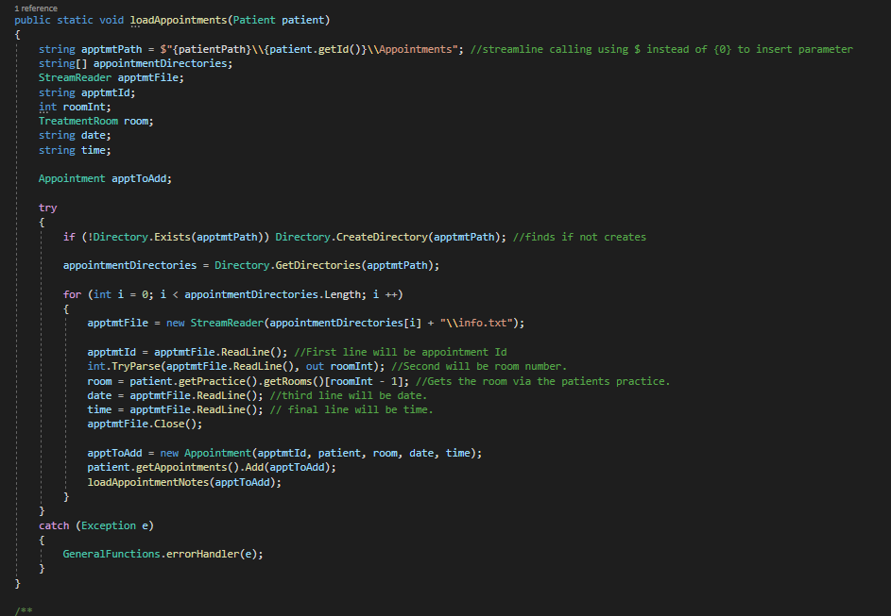

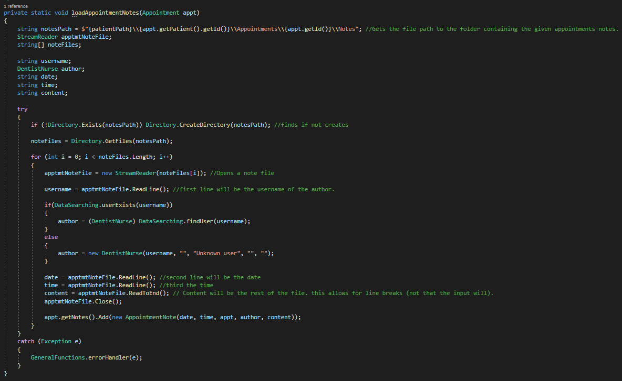

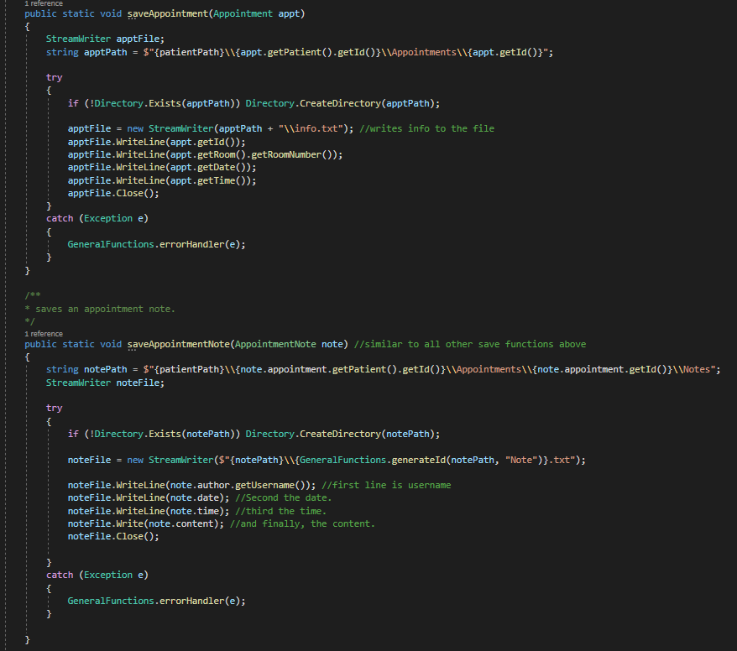

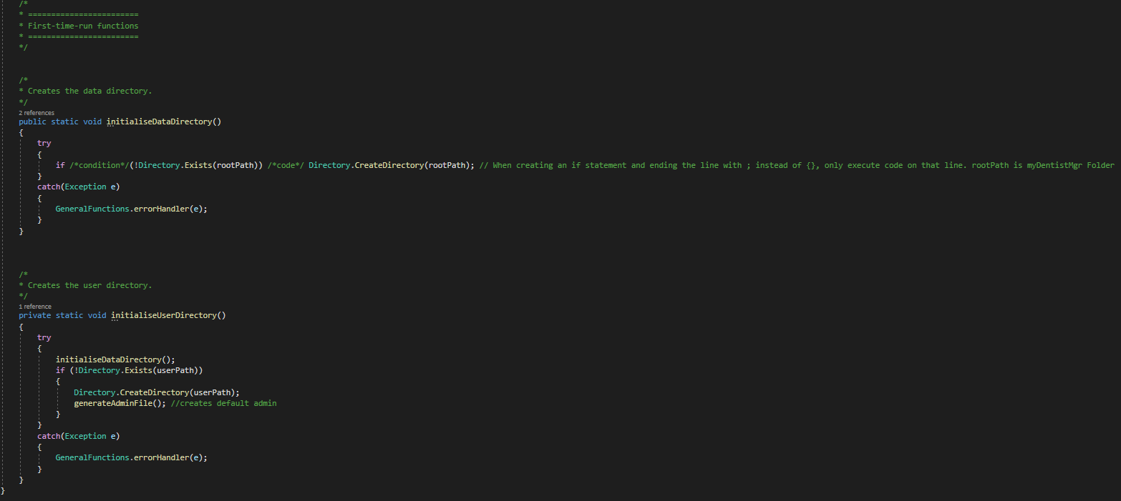

## TreatmentRooms.cs

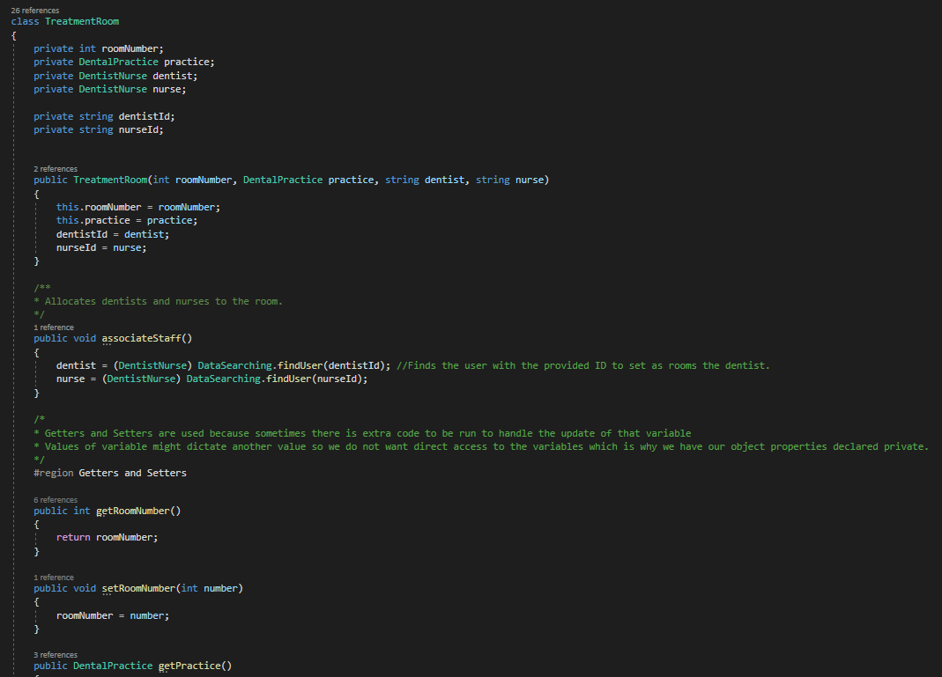

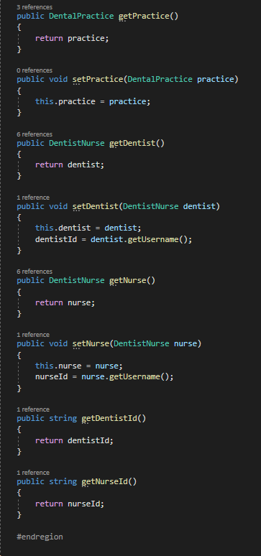

## Patient.cs

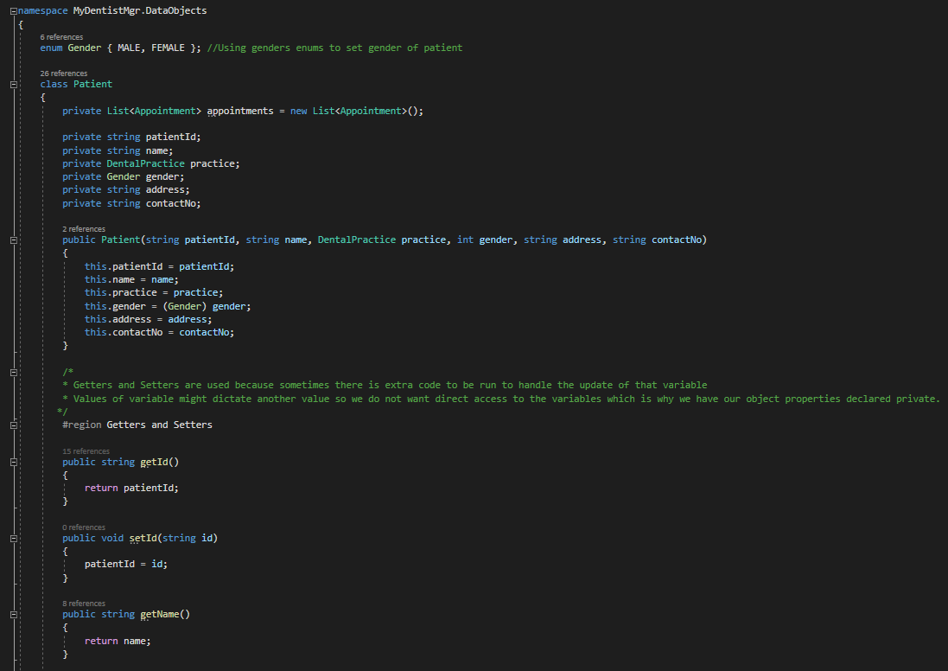

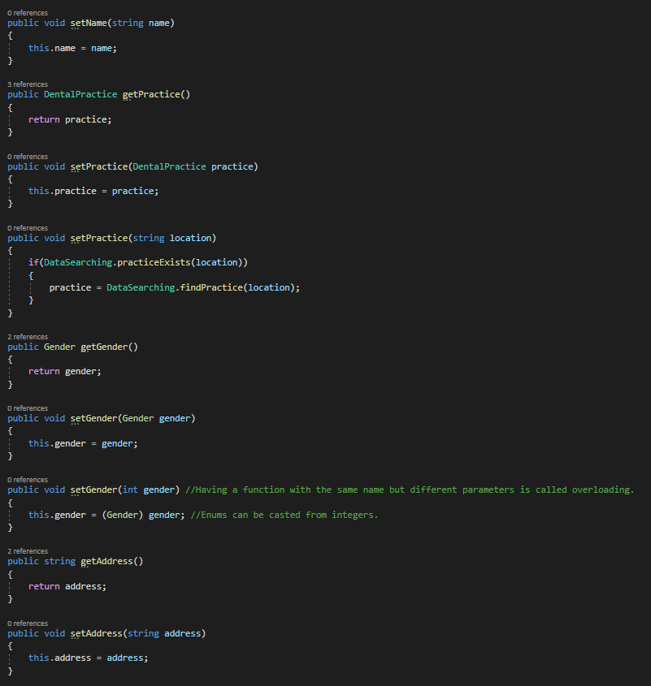

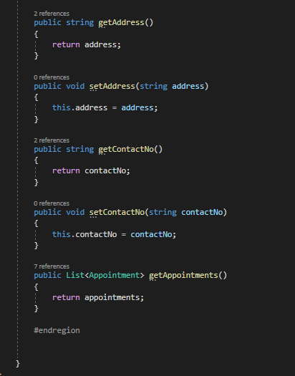

## DentalPractice.cs

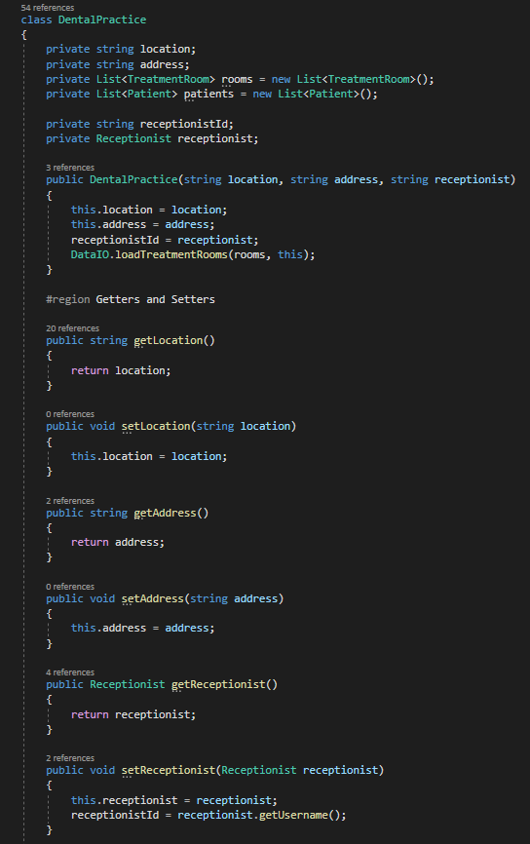

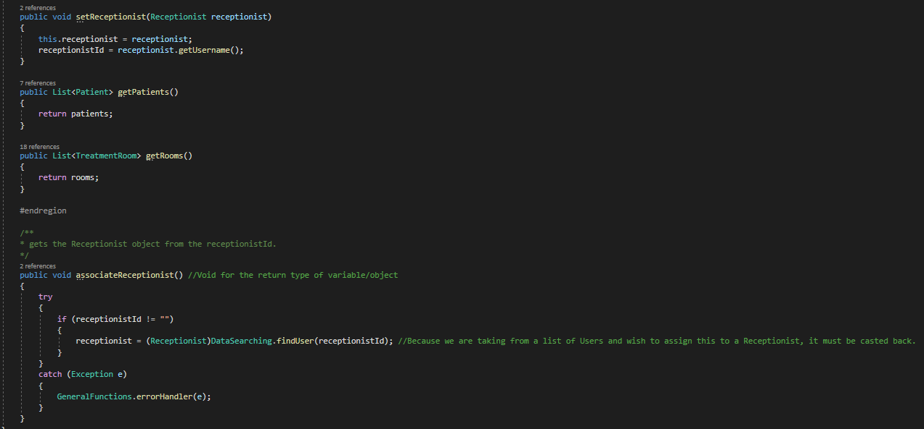

## Appointment.cs

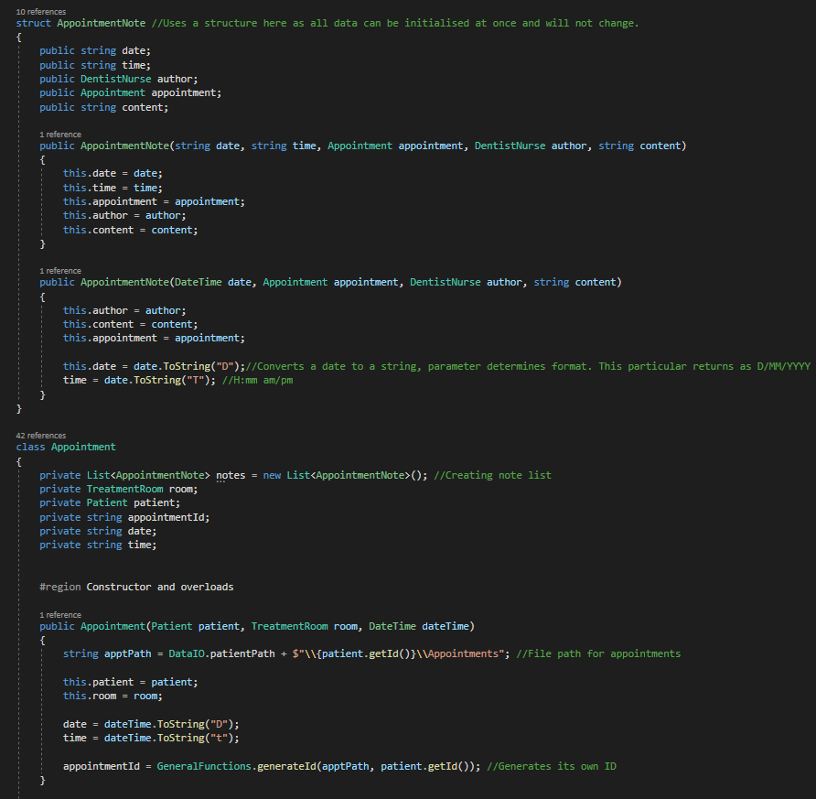

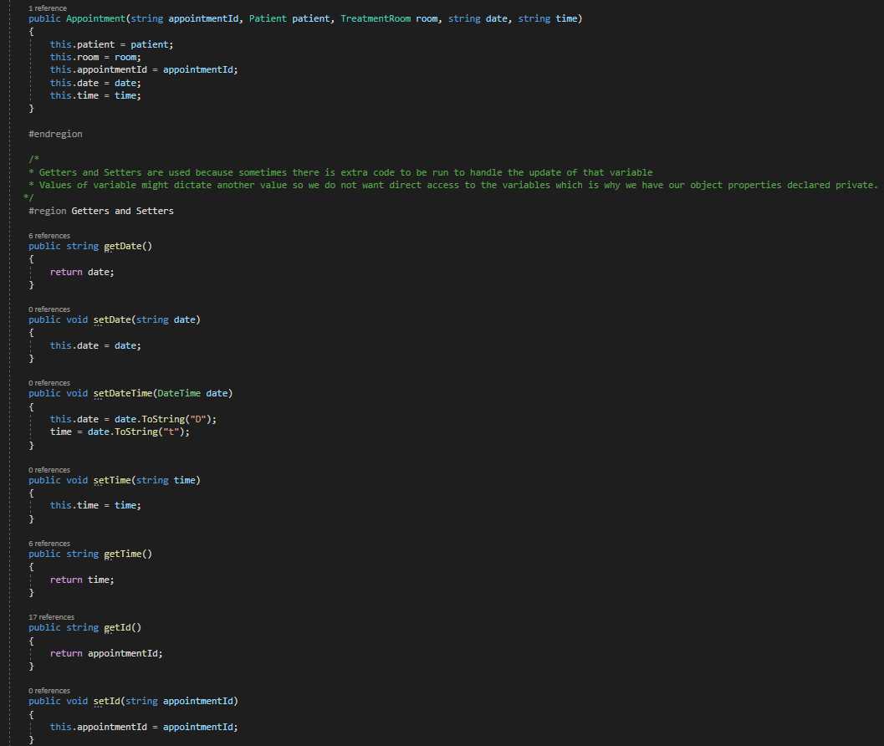

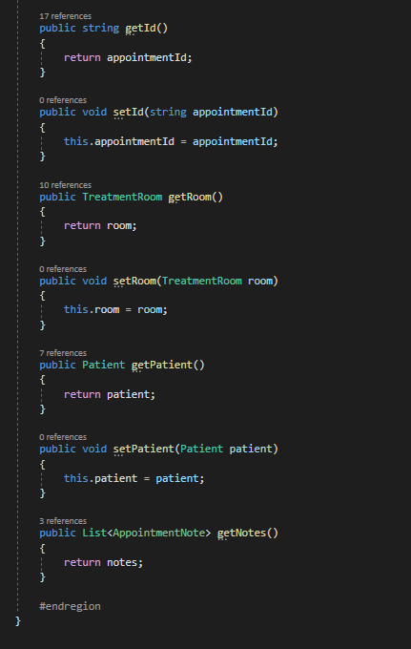

# Final program functioning/End user documentation.

## Admin



When loading the program for the first time, the default admin will be added and to log into it type “Admin” then hit “Enter”

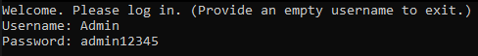

A Password input will also be required which is “admin12345”

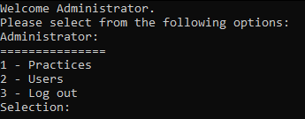

You are now logged into the admin and can navigate to the practices or user menu or log out.

### Practice menu

#### Add practice

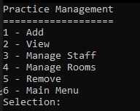

Pressing “1” will take you to the Practice Management menu, here you can add, view, remove practices. Furthermore Add, view, and remove staff and the same with rooms.

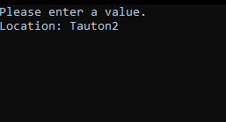

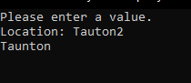

Adding a practice will ask for its location, once completed press “Enter” to submit (tauton2 already exists)



Add its address of practice

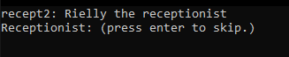

If you do not have a receptionist, you can skip but you can associate a receptionist to the new practice just type their username in i.e. recept2.



Back to the practice menu now.

#### Add room

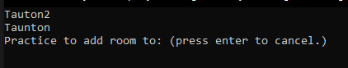

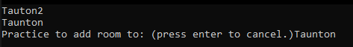

Type location to add room.

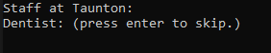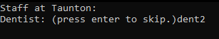

Once you decided on a location, it will be created and ask for a dentist to be added, just add their username.

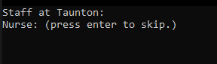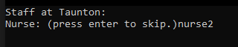

This will repeat to add a nurse as well.



Back to the practice menu now.

#### Add user

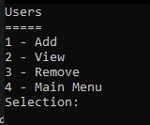

By selecting “2” you will go to the Users, here you can view, add, and remove users. On first start up the admin will be the only user.

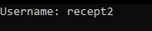

Press “1” to add a user and then input their username.

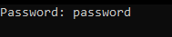

Input their password as well.



Give the new user a name too.

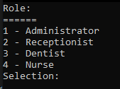

Then input the number matching the required role for the new user.

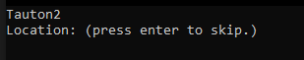

Add then to a location if suitable or can be done later.

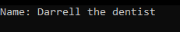

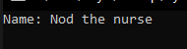

Repeat as many times as you want.



#### Remover user

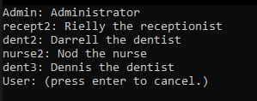

To remove a user, it will show all the users available, enter their username to delete them.

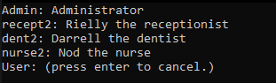

Once the user is deleted, the list updates.

#### View users

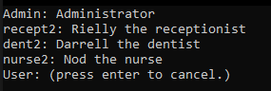

All users will be displayed, type their username to view them.

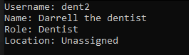

Here you can see all the information for that user, Press “Enter” to cancel viewing.

#### Manage staff



Select “3” to manage the staff.

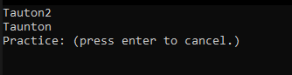

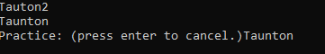

Select location of where you want staff to go.

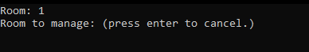

Select the room you wish them to be in.

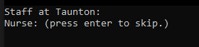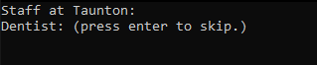

Add or skip a dentist or nurse.

#### View Practice

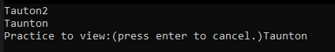

To view a practice, select view in the menu and input location.

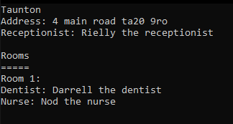

Here you will see all the information about the practice, press “Enter” to exit.

#### Remove Practice

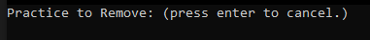

Type the location of the practice you want to remove.

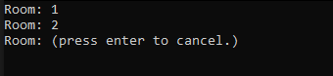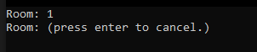

Select the room number you wish to delete i.e. 2, and it will be removed, and the display updated.

## Receptionist

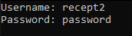

To login to the receptionist, use the correct username and password for them.

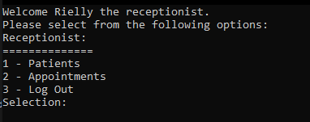

You will be greeted in the main menu and you can either select patients or appointments.

### Patients

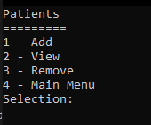

Receptionist menu for the patients.

#### Add patient

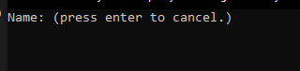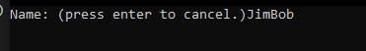

Here you add the name of the patient and can move on.

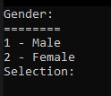

Select the patient’s gender with either 1 or 2.

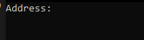

Then you can add their address.

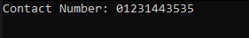

Finally, you add their contact number and that is everything to add a patient.

#### View patient

#### 

Select “View” in menu, the use their unique name in the system i.e. JimBo1

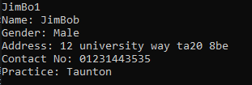

After doing that you will be able to see all patient info

### Appointment

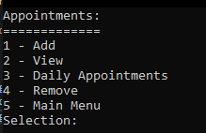

Appointment menu for the receptionist, Daily Appointments only show for the current day.

#### Add appointment

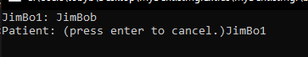

Input the unique name for the patient i.e. JimBo1

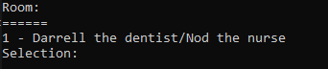

Select the room number for their appointment

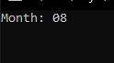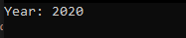

Then you will go through setting the day, month, and year of the appointment.

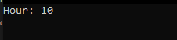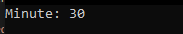

Then set the time for the appointment. Now the patient has an appointment within the system.

#### View appointments

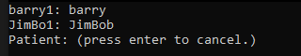

Input the patients unique name to find appointment details.

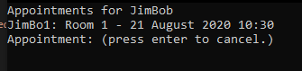

This will show all relevant information for the appointment.

### Dentist/nurse

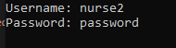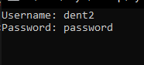

Login to either dentist or nurse.

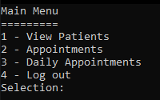

Here you can view patients that go to your practice.

#### View patient

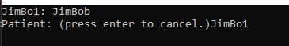

Enter the patients unique name to see all the patient’s details

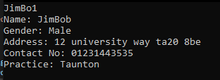

This allows you to see all their personal information

#### Appointment/Daily appointments

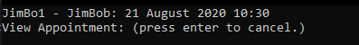

Enter the unique patient name to view appointment details

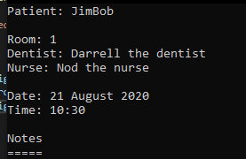

This allows you to see the patient, room and time and date alongside the practitioners.

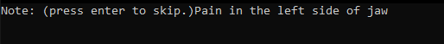

Press “Enter” and you will be able to add a note when you are a Dentist or Nurse.

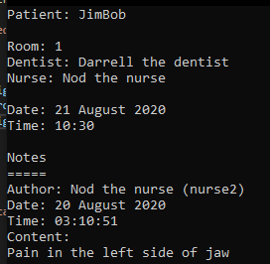

When viewing the appointment with the attached note, you can see it shows who made the note and the time it was made.

# Evaluate the suitability of implemented techniques considering the effectiveness of solution against the original requirements

Overall, the created solution is robust and functional and is fit for purpose, its able to store data locally and on the system memory while running but it is also very readable and easy to use.

This project has implemented a plethora of techniques from concatenating strings, to interpolating strings, stream read/writes and the creation of libraries to spread the code into multiple files to make it more accessible globally. In comparison to the prototype it has a simple UI, streamlined code and more functionality for each user.

The use of switch cases is done to increase the efficiency of the code opposed to writing long if-else statements to preforms the same task, which would then be repeated in this project making the readability of the solution lower, meaning it could be harder for other developers to pick the project up. (C# switch statement, 2019)

In comparison to the requirements the overall solution has achieved a lot of the criteria, you can use the admin to create and modify dental practice, receptionists can be assigned in dental practices, and dentist and nurse can be assigned to the rooms within the practices. Full control over user credentials. The solution also limits staff to seeing information relating to their own practice. Receptionist have control over patients and appointments within the assigned practice. Dentists and nurses can leave notes on a patient’s appointment, staff can view patient appointments and information. However, the only shortfall of this project is that it has not implemented banded tier pricing which is a larger requirement within the project which will affect its overall performance but still meets all the other most important requirements. Furthermore, in the final version of the project it has achieved extra functionality by providing a summarization of patient notes to staff and has an interface allowing for it displays the list of patients at the practice and allows the user to view them and appointments which allows for an increase of usability within the solution.

The solution also includes one of the most prolific design patterns in C#, which is known as the Singleton Design Pattern. This is used within the Application.cs to reference the application instance, the reason why it is static within this solution is to make accessible through the class opposed to an instance of it. When the Application object is instantiated, a reference to the created object is stored in the appInstance variable and this allows us access to the members of the Application where practices and users are stored. (Singleton, n.d.)

We have also used base to call the constructor of the parent class, this allows for the need of duplicate code within the extending classes (base keyword - C# Reference, 2015)

Interpolated strings have been implemented into the project to increase overall readability of the project, this allows us to use i.e. $” his name is {name}” instead of his name is {0}, name. In more complexed string this is greatly beneficial and is a very easy technique to implement. ($ - string interpolation - C# reference, 2019)

The solution uses static classes to create Libraries. These helped with the organisation of code and made code that was frequently used across the system easily accessible. static class were used because I do not want to extend or instantiate it. The GeneralFunctions class contains functions that didn't fit into the other libraries and are used heavily across the system. This included error handling, Generation of IDs and requesting input from the user. DataSearching.cs was used for validating inputs and contained functions to allow filtering of objects from lists based on the 'primary key'. DataPrinting.cs contained functions for listing and viewing records and DataIO.cs handled the saving and retrieval of data on files. (Static Classes and Static Class Members - C# Programming Guide, 2015)

# References –

$ - string interpolation - C# reference (2019) Docs.Microsoft.Com, [Online]. Available at https://docs.microsoft.com/en-us/dotnet/csharp/language-reference/tokens/interpolated.

base keyword - C# Reference (2015) Docs.Microsoft.Com, [Online]. Available at <https://docs.microsoft.com/en-us/dotnet/csharp/language-reference/keywords/base>.

C# switch statement (2019) Docs.Microsoft.Com, [Online]. Available at <https://docs.microsoft.com/en-us/dotnet/csharp/language-reference/keywords/switch>.

Singleton (n.d.) Refactoring.Guru, [Online]. Available at <https://refactoring.guru/design-patterns/singleton>.

Static Classes and Static Class Members - C# Programming Guide (2015) Docs.Microsoft.Com, [Online]. Available at <https://docs.microsoft.com/en-us/dotnet/csharp/programming-guide/classes-and-structs/static-classes-and-static-class-members>.

UML - Class Diagram - Tutorialspoint (n.d.) Tutorialspoint.Com, [Online]. Available at <https://www.tutorialspoint.com/uml/uml_class_diagram.htm>.

UML - Use Case Diagrams - Tutorialspoint (n.d.) Tutorialspoint.Com, [Online]. Available at <https://www.tutorialspoint.com/uml/uml_use_case_diagram.htm>.

UML Class Diagram (n.d.) Lucidchart.Com, [Online]. Available at <https://www.lucidchart.com/pages/uml-class-diagram>.